Dicto-comp / Dictogloss
LT 3.1
Example (1) – A Special Day for Andrew

Part 1: Listen to Andrew’s story and arrange the following pictures in the correct order.

1. b (example) | 2. | 3. | 4. | 5.

a  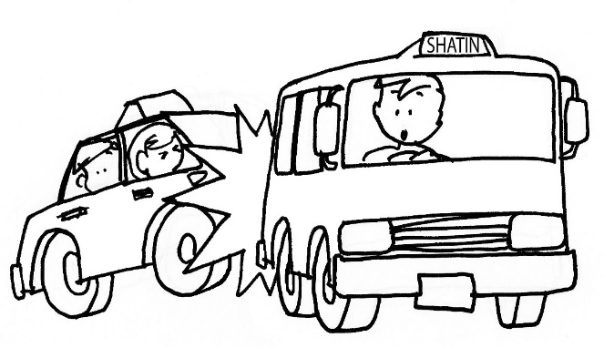 | b  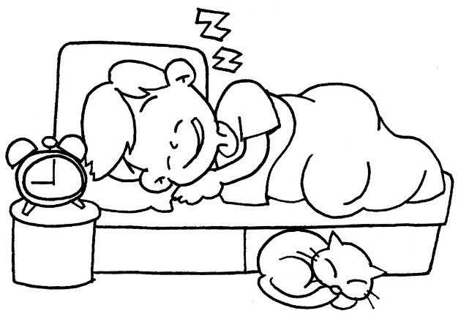
c   | d  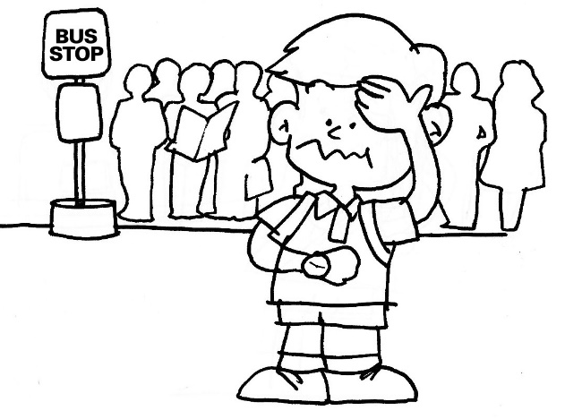
e
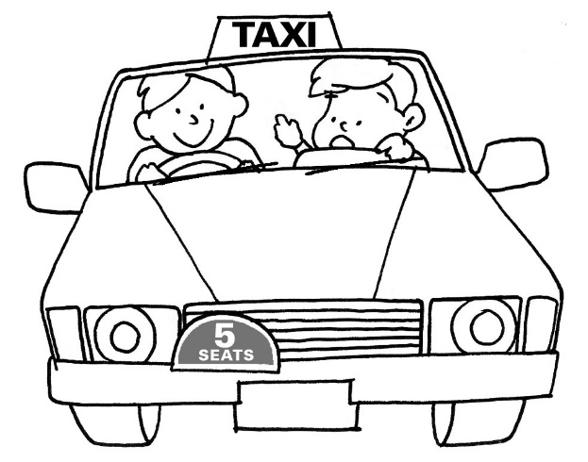

Part 2: Listen to Andrew’s story again. Write down the key words in the spaces provided.
LT 3.1

e.g.
- woke up late

Part 3: Work in pairs to revise the notes and help each other fill in any missing points.

Part 4: Write Andrew’s story in the spaces provided.
A Special Day for Andrew

Yesterday, Andrew woke up late. _______________________________
______________________________________________________________________________________________________________________________________________________________________________________________________________________________________________________________________________________________________________________________________________________________________________________________________________________________________________________________________________________________________________________________________________________________________________
____________________________________________________________________________________________________________________________

Answer Keys
LT 3.1

Part 1:
1. b (example) | 2. d | 3. e | 4. a | 5. c

Part 2:
- rushed to bus stop
- many people waiting

- took a taxi
- drove quickly

e.g.
- woke up late

- walked to school
- tired whole day
- loud noise
- accident
- crashed into a minibus

(Accept any reasonable answers)

Script

(Audio Clip No. 11)
A Special Day for Andrew
Part 1: Listen to Andrew’s story and arrange the following pictures in the correct order.
(Read aloud the text at normal speed)
Yesterday, Andrew woke up late. He rushed to the bus stop quickly. Many people were waiting there, so Andrew decided to take a taxi. The taxi driver drove quickly. After a few minutes, Andrew heard a loud noise! It was a car accident! The taxi crashed into the back of a minibus! Both cars broke down. He had no choice but to walk to school. He was tired for the whole day.

Part 2: Listen to Andrew’s story again. Write down the key words in the spaces provided.
(Read aloud the text at normal speed again)

