My Favourite Food
Worksheet B
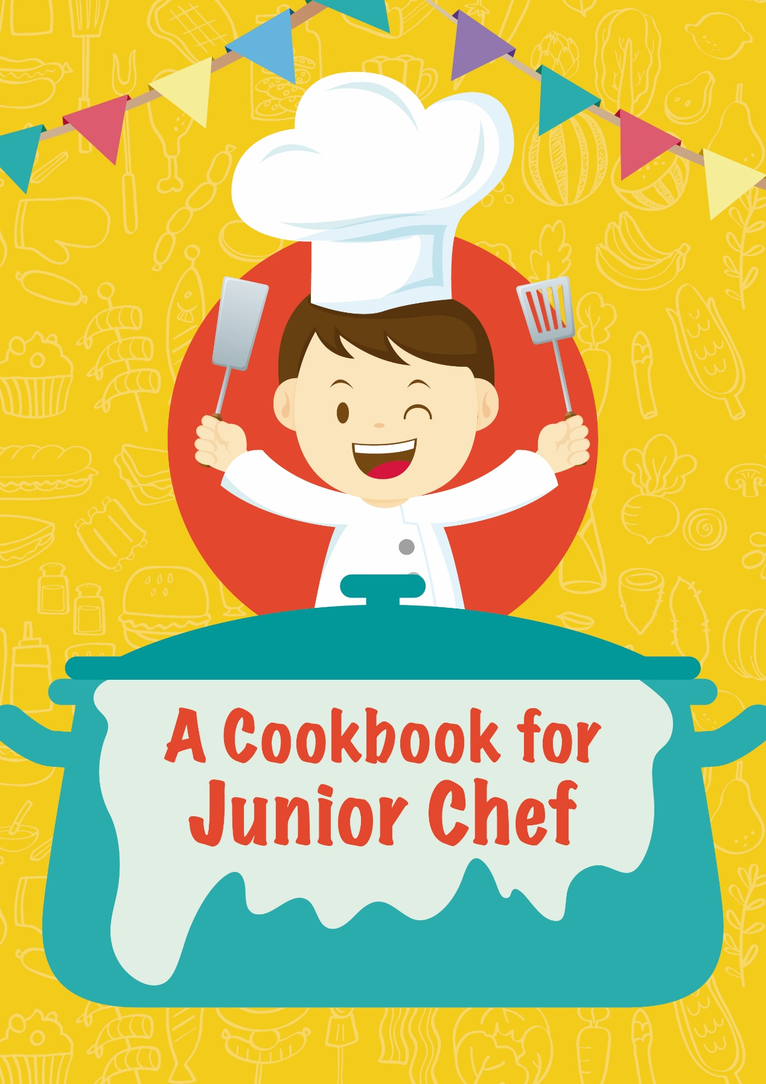

A. Read the two recipes.
Yummy Biscuit Recipe
Ingredients:
some biscuits cream chocolate chips sprinkles
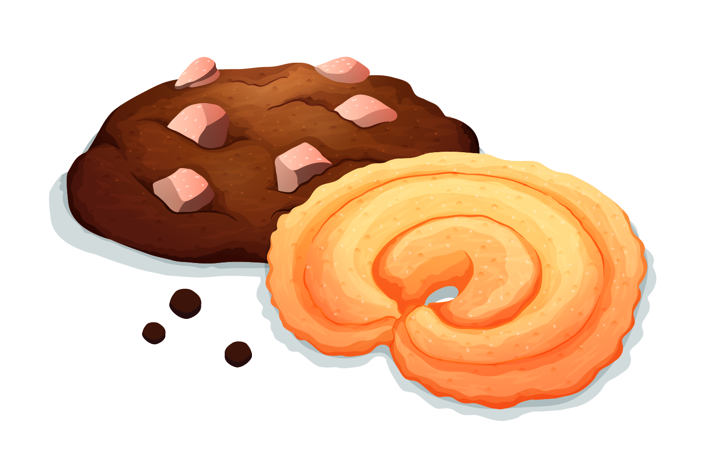
Steps:
- Take a biscuit and put it on a napkin.
- Spread the cream on the biscuit.
- Put sprinkles on the biscuit.
- Put some chocolate chips on the biscuit.
- Do the same on other biscuits.

Healthy Salad Recipe
Ingredients:  some lettuce  two tomatoes  a carrot  a cucumber  some olives  salad dressing | 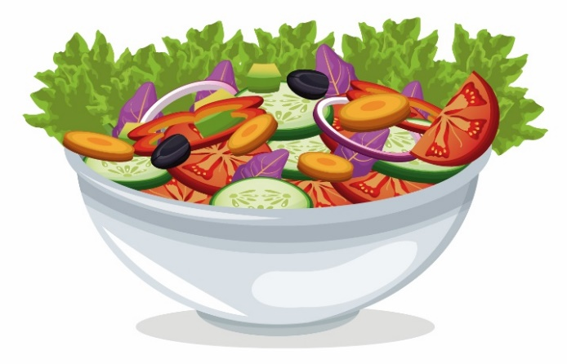
Steps:
- Wash all the vegetables.
- Tear the lettuce into small pieces.
- Cut the tomatoes into slices.
- Chop the carrot, olives and cucumber.
- Put all the vegetables in a salad bowl.
- Put on salad dressing and mix the ingredients together.

B. What makes a good recipe? Discuss with group members and finish the checklist below.
Content and Organisation: | Language:
The ingredients are ______________. | Use action _______ correctly.
The steps are ___________. | Spell the _________ correctly.
The recipe has a _______. | ---

C. In groups, prepare a sandwich recipe to enter a cooking competition.
_________ Sandwich Recipe
You may draw/show a picture: | Ingredients:  e.g. some butter
Steps (You may draw/show pictures.)
1 Spread the butter on the bread.  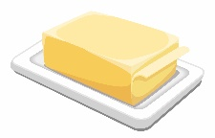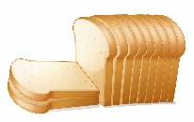 | 2  __________________ | 3  __________________
4  __________________ | 5  __________________ | 6  __________________

D. Prepare your own recipe for a snack to enjoy with friends.

__________________

__________________________ __________________________
__________________________ __________________________
__________________________ __________________________

- ____________________________________________________
- ____________________________________________________
- ____________________________________________________
- ____________________________________________________
- ____________________________________________________
- ____________________________________________________

Check your own recipe. Complete the checklist. Then, put a tick “” or cross “” in the boxes on the right.

Content and Organisation:
The ingredients are ______________.
The steps are ___________.
The recipe has a _______.
Language:
Use action _______ correctly.
Spell the _________ correctly.

