My Favourite Food
Healthy Snacks
Worksheet

- What do you eat at snack time? Use the following words to help you.
chicken wings | 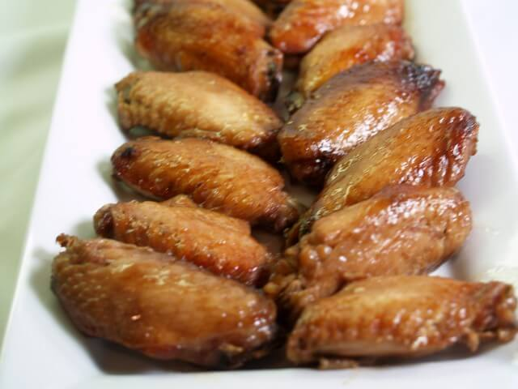 | toast | 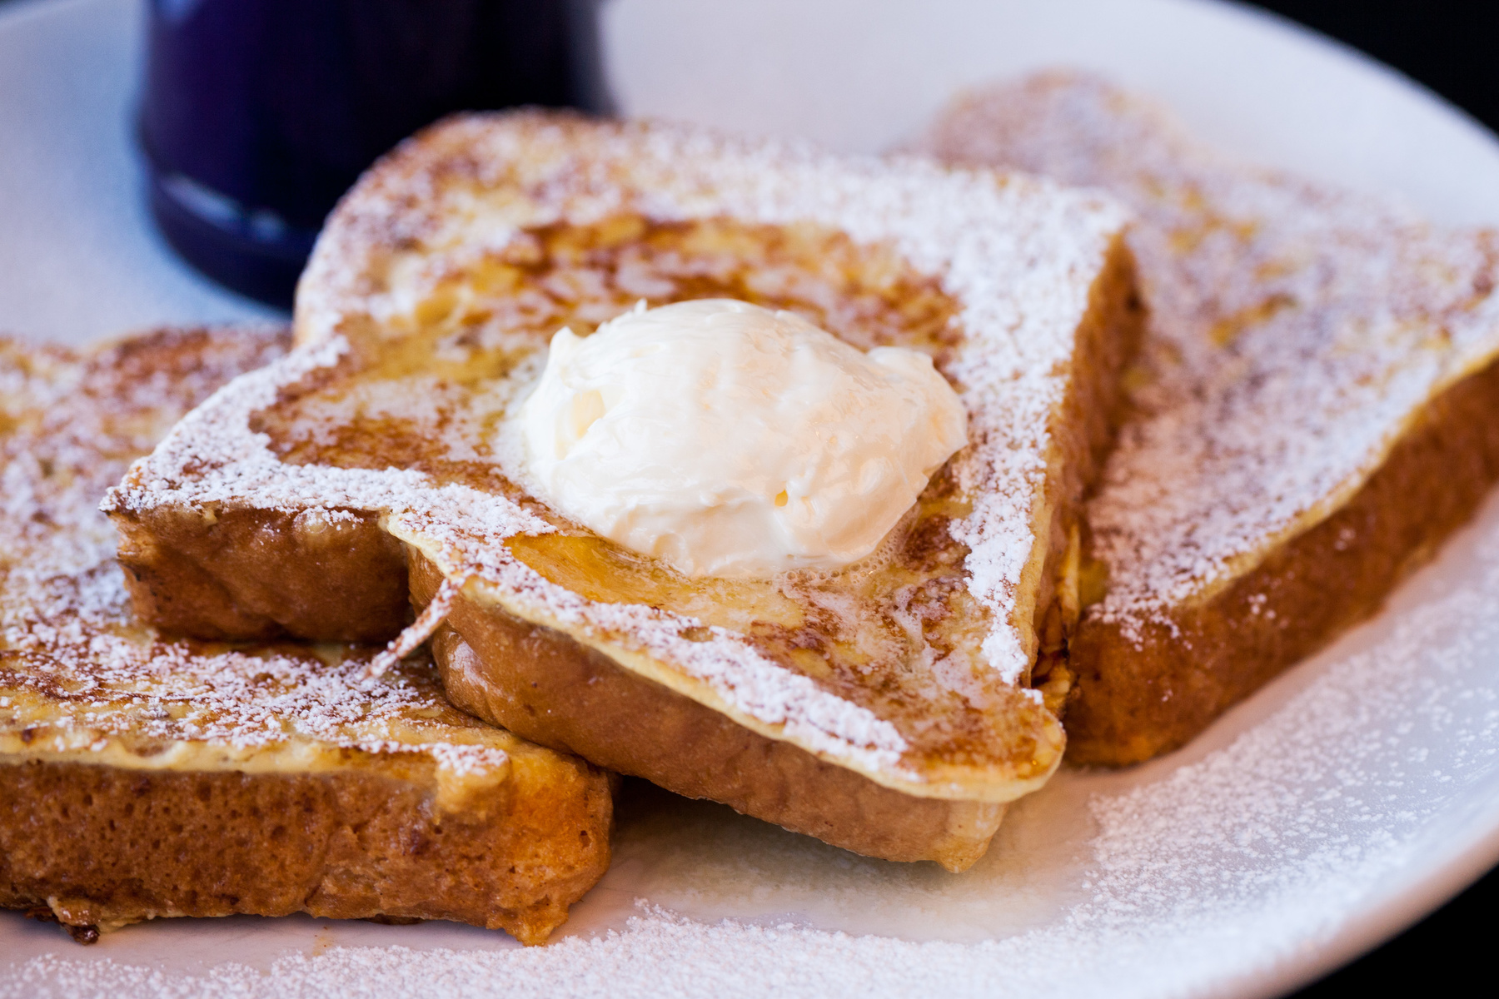
hamburger | 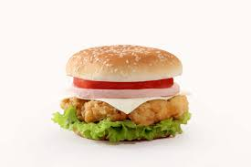 | fish balls | 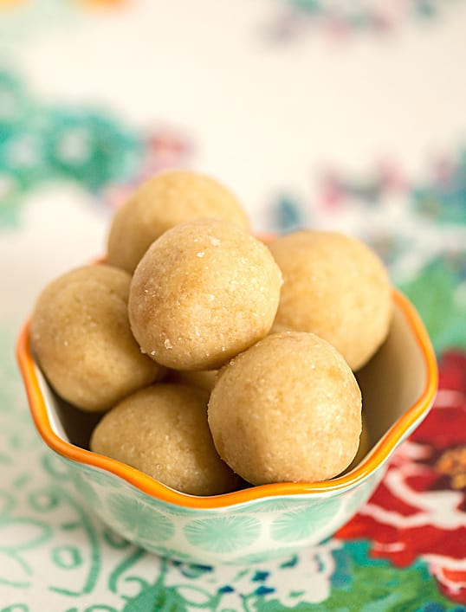
yogurt | 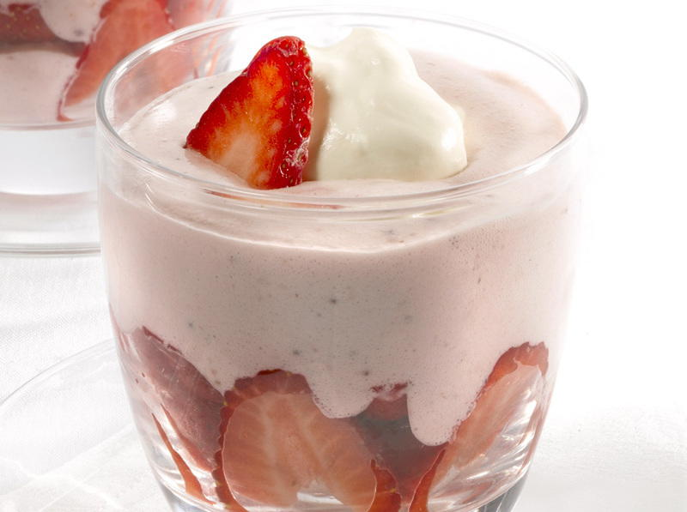 | potato chips | 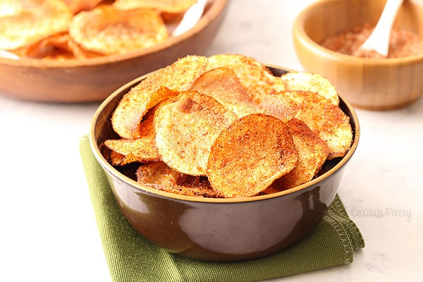
siu mai | 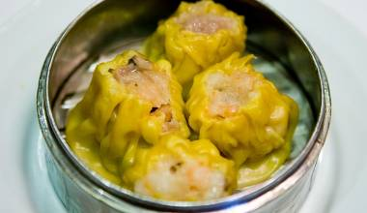 | French fries | 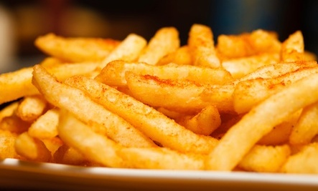

Write down four kinds of food you usually eat at snack time and
share with your partner. Follow the examples.

I like to eat fish balls too. They are yummy.

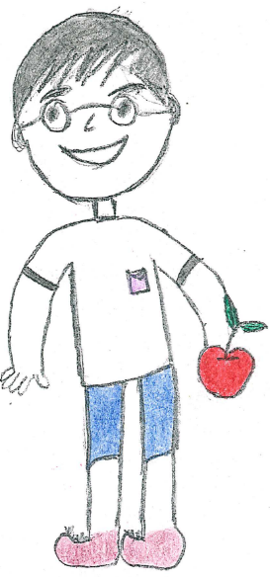
I’d like apples at snack time. They are sweet and juicy.

Worksheet p.2

- Read pages 2 and 4 of the leaflet “Healthy Snacks”. Put the snacks you eat under two groups in the table below.
Healthy Snacks | Unhealthy Snacks
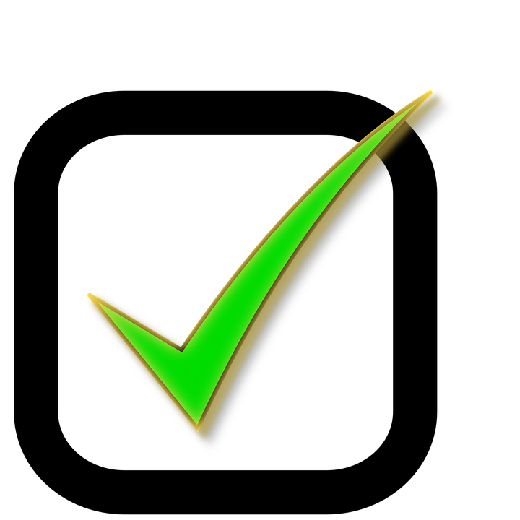 | 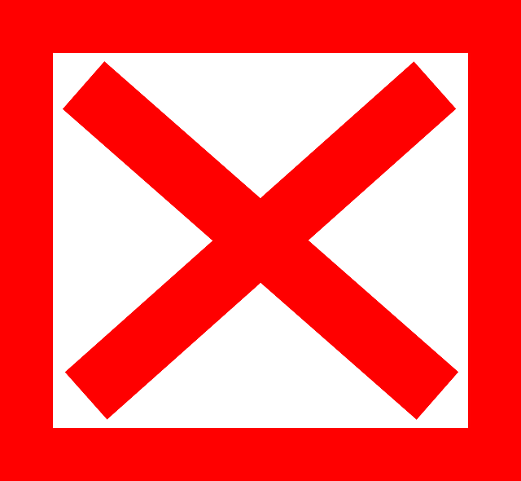

- 1) Design and label your “snack pyramid”. Draw one favourite healthy snack for each type of food.
- Talk about the benefits of healthy snacks with your partner.
Example 1:
Milk is an example of dairy product. It gives me energy and calcium.
Example 2:
Boiled eggs belong to the meat, eggs and nuts group. They can give me protein and vitamin D.

Dairy products
Meat, eggs and nuts
Vegetables
Fruits
Grains and cereals
oil, salt, sugar

Worksheet p.3

- The teachers are talking about some healthy snacks. Let’s read and find out their favourite snacks.
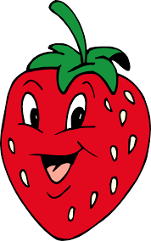
I like strawberries very much because they are sweet! They belong to the fruits group. I eat them two hours after lunch. They give me Vitamin C and help me stay healthy!


My favourite snack is cherry yogurt. It is a kind of dairy product. It provides calcium and it is low fat. I eat it at four o’clock in the afternoon. It’s delicious.
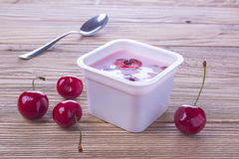


Read the leaflet Healthy Snacks for more ideas.

- Choose a healthy snack from your snack pyramid and fill in the table:
- What is the healthy snack?
- What group does it belong to?
- Why is it good for you?
- When do you eat it?
- How does it taste?
Draw your snack

Worksheet p.4

- Now, write about your favourite healthy snack and draw/stick a picture.
My favourite healthy snack

______________________________________________________________________________________________________________________________________________________________________________
____________________________________________________________________________________________________________________

Check your writing with your neighbour. Then, put a tick “” in the box on the right.
Checklist | 
1. What (Is it a healthy snack?)
2. What group does it belong to? (the food group)
3. Why
(Reasons for eating the snack, e.g. It provides vitamins and calcium.)
4. When (Time to eat the snack)
5. How (Taste of the snack)

