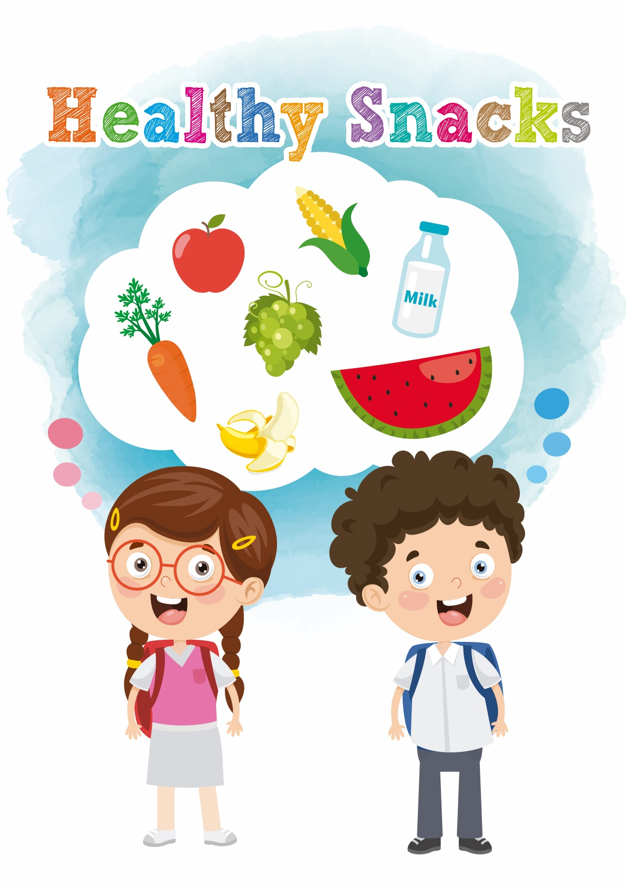
- give you water
- give you energy
- provide nutrients, such as vitamin C and calcium for you
Healthy snacks can

We should choose snacks that are “3 Low 1 High”, i.e. low fat, low sugar, low salt and high fibre.
How to choose snacks?
- Eat snacks between two meals.
- After eating the main meals, wait for 1.5 to 2 hours before eating snacks.
When do we eat snacks?
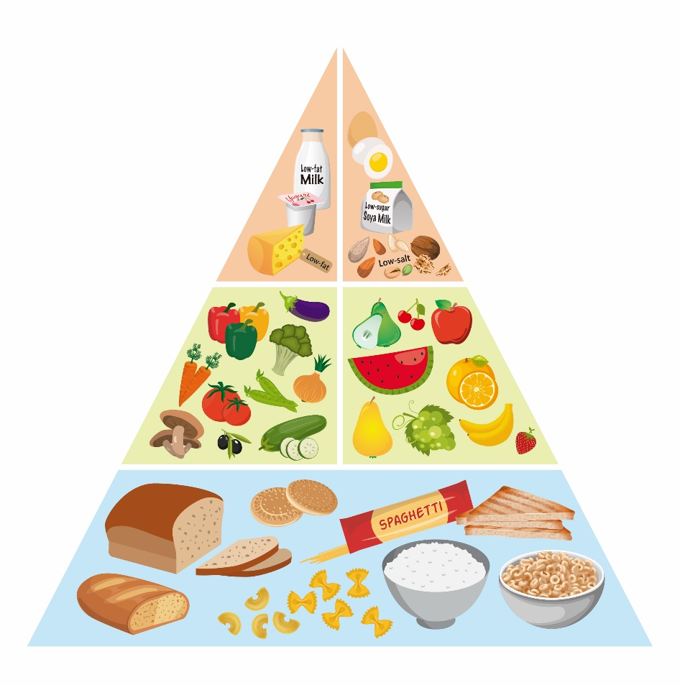
Do you still remember the Food Pyramid? There are five groups of snacks. They are grains and cereals, vegetables, fruits, meat and dairy products. Here are some healthy snacks:
Snacks to eat more

- fresh vegetables
- salad (with little dressing)
Grains and cereals
Examples:
- bread
- boiled corn or corn kernels
- low-fat cheese sandwiches
- high-fibre biscuits
- fresh fruits
- dried fruit without added sugar
- baked fruit chips
Fruits
Examples:
- boiled eggs
- low-salt nuts
- low-sugar soya milk
Meat, eggs & nuts
Vegetables
Examples:
- low-fat milk
- low-fat yogurt
Dairy products

- Food with a lot of sugar
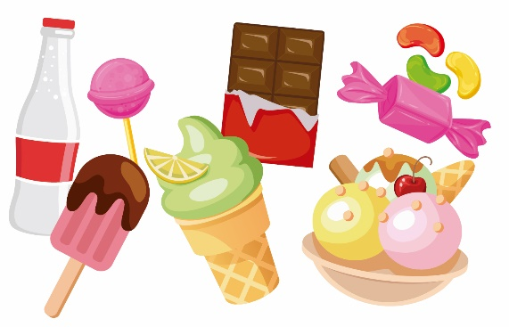 | - You may have toothache.  - You may gain weight easily.
- Food with a lot of fat or salt
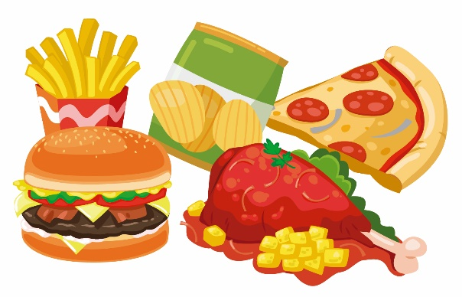 | - It is unhealthy. You may become over-weight. You may also have other health problems.
Snacks to eat less

