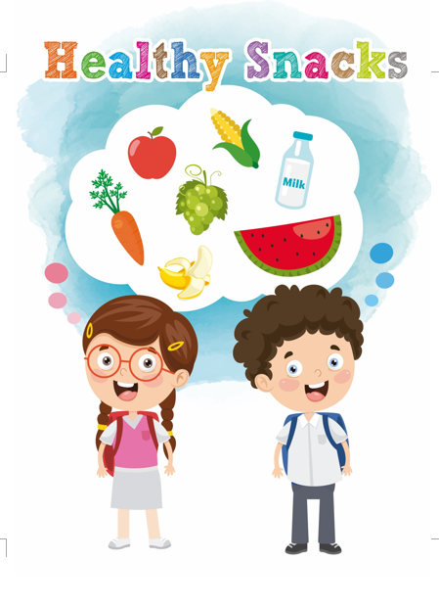 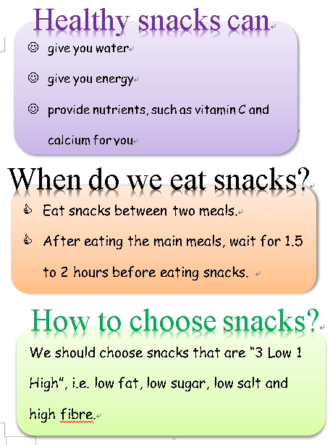

The title of a leaflet is usually the most eye-catching so as to draw the attention of readers.

**P.2**

**Cover**

The smileys and “thumbs up” symbols are used to tell readers the good points about eating healthy snacks.

Based on the illustrations, the leaflet is designed especially for children/students.

Examples of healthy snacks can be found in the thinking bubble. Students can be asked to name examples of healthy snacks.

**Leaflet “Healthy Snacks”**

**(Teacher’s notes)**

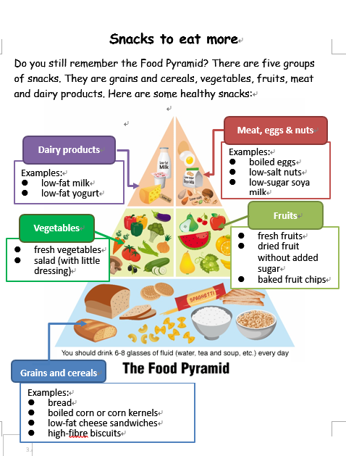 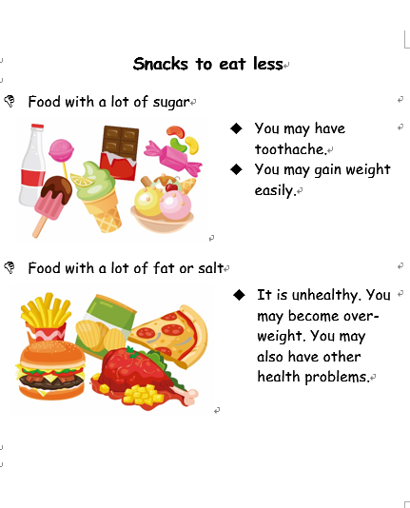

The heading/sub-headings are usually in bold print or highlighted to attract readers’ attention.

The good point of using a food pyramid to show examples of healthy snacks is that it is **easier to remember** because

* it helps connect students’ past experience
* the different food groups help students to organise information in a more systematic way.

**P.4**

**P.3**

The “thumbs down” symbols on page 4 are used to tell children that these food items are unhealthy. Pictures are used to make the leaflet more eye-catching to students.

Problems of eating snacks with a lot of sugar: toothache, gain weight

Problems of eating snacks with a lot of fat or salt:

unhealthy, overweight, other health problems