**Teacher’s version**

**Loving Our Friends**

**Context**

It is Friendship Month in the school. The “Big Brothers and Big Sisters” Group is organising different activities to promote the message of “Loving our friends”. One of the activities is the **“Friend of the Month”** election. Read the poster to find out more about it.

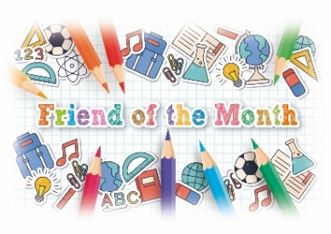**Poster – “My Friend Rocks!”**

My Friend ROCKS!



Background

Do you have a super friend?

Do you want to do something special to thank him/her?

Nominate your best friend to be “Friend of the Month” for December!

 

How to join

★ Design an A4 poster about your friend.

★ Tell us why your friend deserves to be crowned “Friend of the Month”.

★ Send the poster to bigbrothersandsisters@happyschool.edu.hk on or before 18 December 20xx.

Prizes

The two students who receive the largest number of votes in the election will win

★ a trophy; and

★ two tickets for a movie of their choice.

Make your poster **interesting** and **attractive**!

**Note Sheet on “Friend of the Month” election**

Your English teacher, Ms Kwan, wants you and your classmates to nominate your best friends to join the election. She has prepared a note sheet for the class to know more about the election. Help her complete the note sheet.

Way to submit your poster: by email

No. of winners: 2

Note Sheet

Name of Activity: “**Friend of the Month**” **election**

for the month of December

2. two movie tickets

Prizes

1. a trophy

What to include in the poster:

1. who your best friend is
2. the good qualities of your best friend

Organiser:

The “Big Brothers and Big Sisters” Group

Size of the poster: A4

**Loving Our Friends**

**Poster – “Be a GOOD FRIEND”**

Ms Kwan has designed a poster and a worksheet to help the class know more about the qualities of a friend. Read the poster and complete the worksheet.

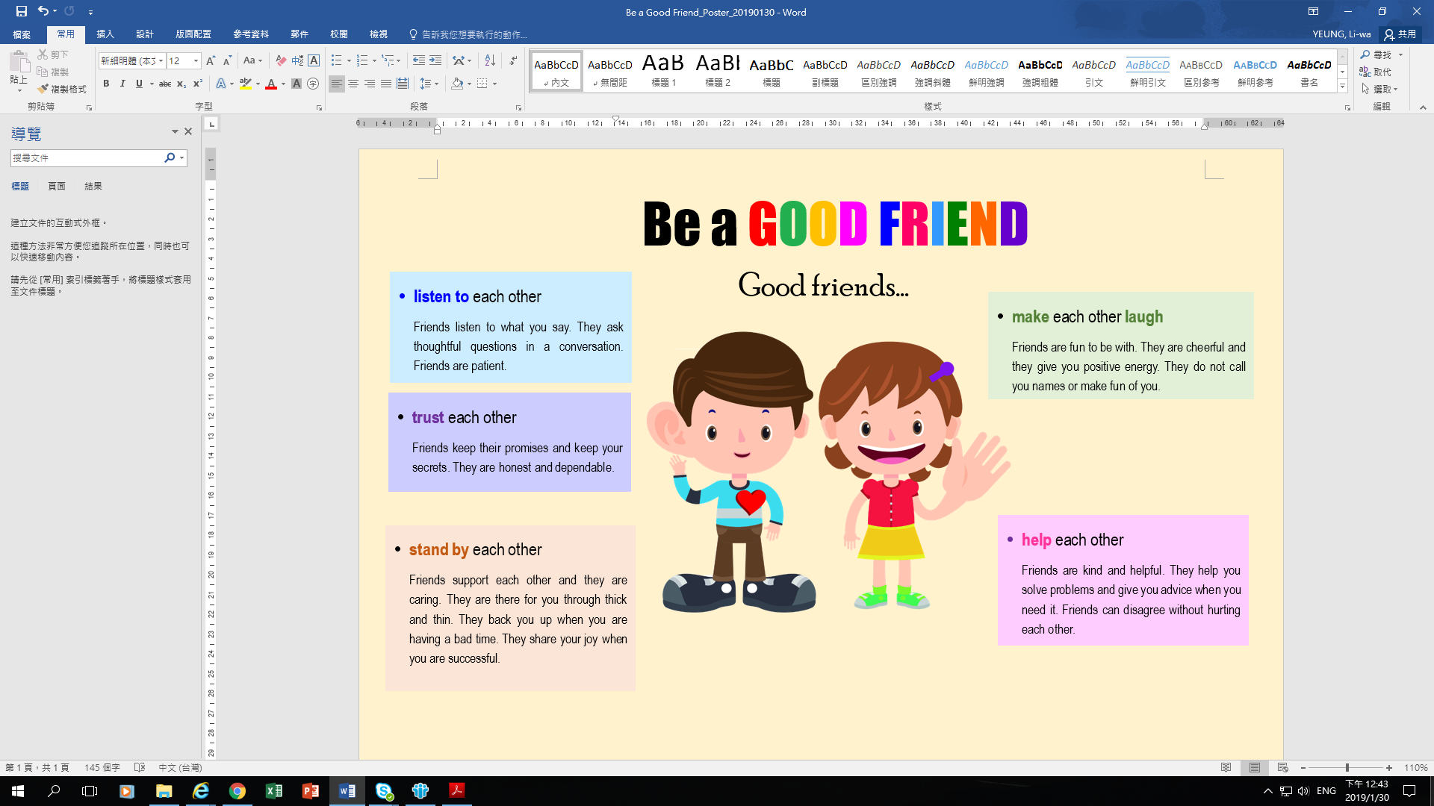

**Loving Our Friends**

**Worksheet on the Poster – “Be a GOOD FRIEND”**

1. What are the qualities of a friend? Match the things friends do to each other with the pictures.

|  |  |  |  |  |  |
| --- | --- | --- | --- | --- | --- |
|  | Listen to each other | ⚫ | ⚫ (i) |  |  |
|  | Trust each other | ⚫ | ⚫ (ii) |  |  |
|  | Stand by each other | ⚫ | ⚫ (iii) |  |  |
|  | Make each other laugh | ⚫ | ⚫ (iv) |  |  |
|  | Help each other | ⚫ | ⚫ (v) |  |  |

1. How should we treat our friends? Complete the sentences below about what we should and should not do to our friends.

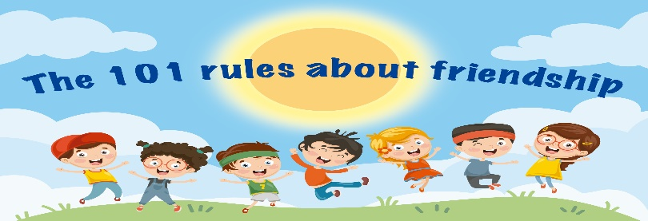

❑ Ask thoughtful questions when your friends share their problems with you.

❑ Keep the secrets shared by your friends.

❑ Always cheer your friends up and give them positive energy.

❑ Never make fun of your friends even when they do something silly.

❑ Help your friends solve problems but not to create new ones for them.

…

**★ The Golden Rule ★**

**Be there for your friends through thick and thin, i.e. support your friends through good and bad times.**

🗶 Do not __________________________________.

🗶 Do not __________________________________.

.............

1. Do you think it is all right to disagree with your friend? Why or why not?

Any acceptable answers.

1. Circle the adjectives used to describe the qualities of a friend in the poster. Put them in the “Friendship Flower” below. 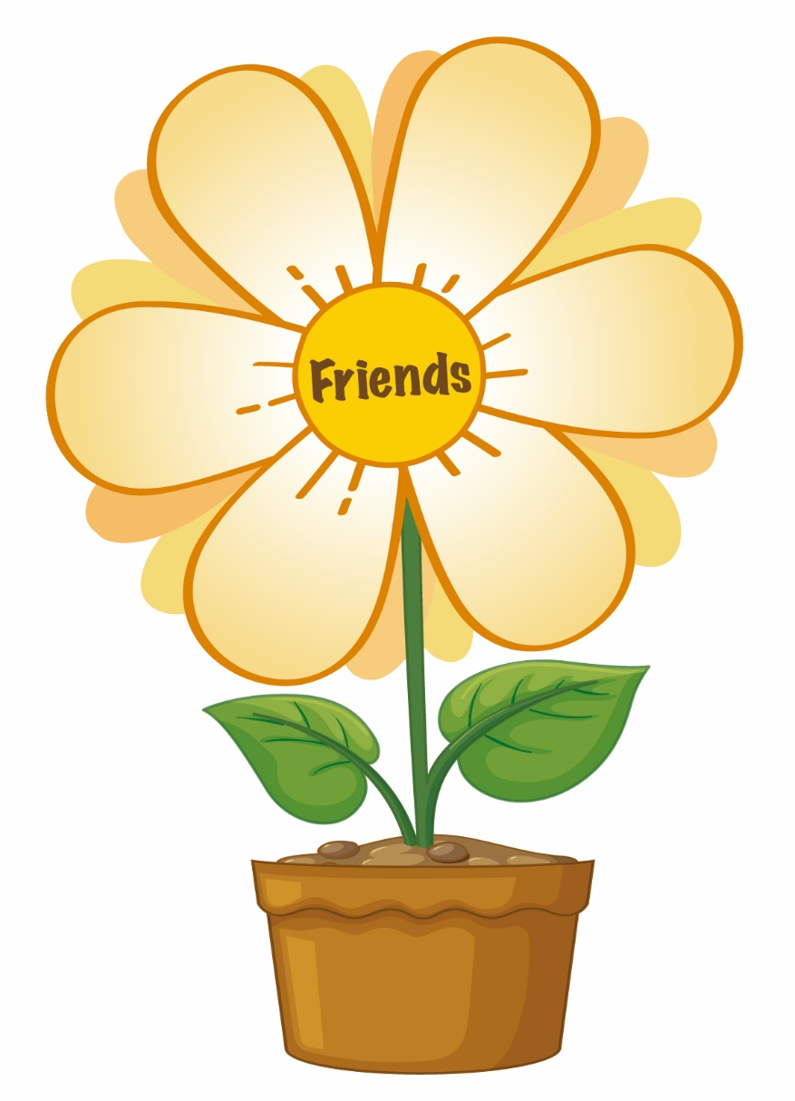

[從文件中擷取絕佳的引文或利用此空間來強調重點，藉此吸引讀者的注意力。若要將此文字方塊放置在頁面的任一位置，請進行拖曳。]

helpful

kind

cheerful

caring

dependable

patient

|  |
| --- |
| Can you think of other adjectives to describe a friend? Put them in the box below.  Suggested answers: understanding, supportive, considerate, reliable, sincere, generous  **Loving Our Friends** |

**Designing a poster about your best friend**

You decided to nominate your best friend to be “Friend of the Month”. Read the poster about the election again and design the poster. Use the mind map below to generate and organize your ideas.