Be a GOOD FRIEND

Good friends…

* **listen to** each other

Friends listen to what you say. They ask thoughtful questions in a conversation. Friends are patient.

* **make** each other **laugh**

Friends are fun to be with. They are cheerful and they give you positive energy. They do not call you names or make fun of you.

* **stand by** each other

Friends support each other and they are caring. They are there for you through thick and thin. They back you up when you are having a bad time. They share your joy when you are successful.

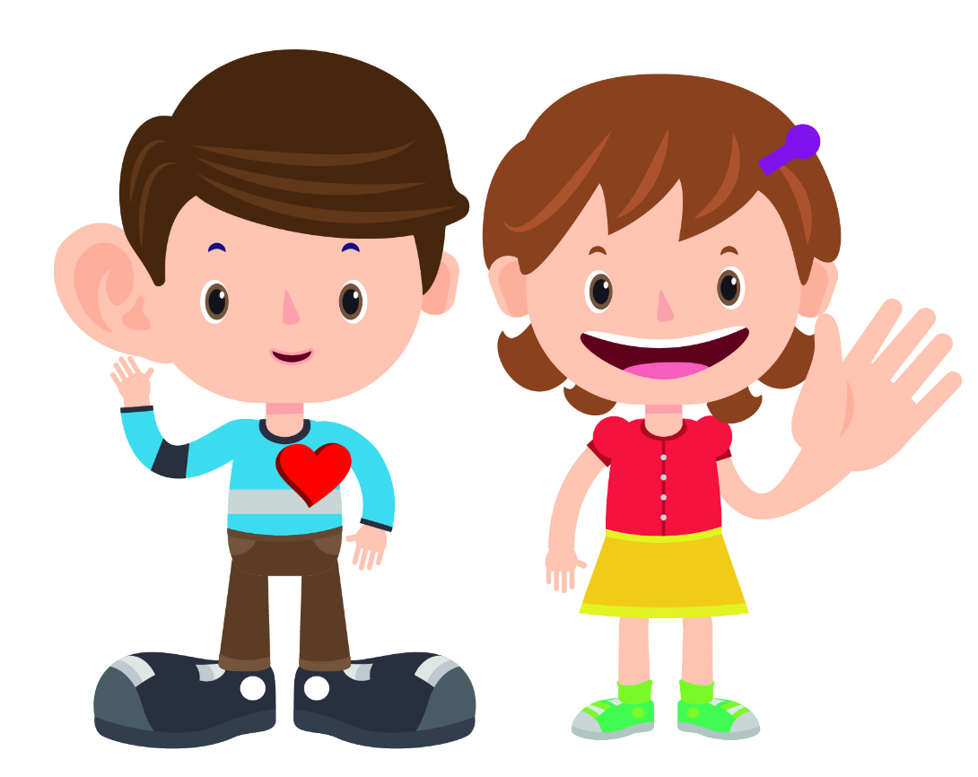

* **help** each other

Friends are kind and helpful. They help you solve problems and give you advice when you need it. Friends can disagree without hurting each other.

* **trust** each other

Friends keep their promises and keep your secrets. They are honest and dependable.