**Titles**

* A title gives the audience an instant idea of what the poster is about;
* It is short and right to the point.
* It is usually put at the top or over a large image.
* It is usually in larger font size or in bold print.

**Poster “My Friend ROCKS”**

**Font size and**

**bold print**

* The use of larger font size and bold print helps highlight and emphasise the theme, create a dramatic effect and get readers’ attention.

**(Teacher’s notes on analysis of text and language features)**

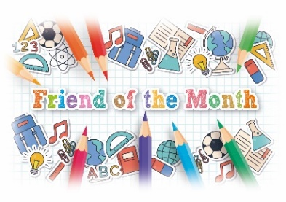

Language features of a poster

* Use simple words that are right to the point.
* Use short sentences/questions.
* Use imperatives.

**Bullet points**

* Help present the messages and information clearly.

**Headings**

* Help readers get the main ideas easily.

**Pictures**

* Help readers visualise and enhance understanding of the key messages.

**Colours**

* The use of different colours helps show the emphases and get readers’ attention.

Characteristics that make a poster **interesting and attractive**

* Use of font size
* Use of bold print
* Use of colour
* Use of pictures

Characteristics that make a poster **easier to read**

* Use of titles
* Use of headings
* Use of bullet points

My Friend ROCKS!



Background

Do you have a super friend?

Do you want to do something special to thank him/her?

Nominate your best friend to be “Friend of the Month” for December!

 

How to join

★ Design an A4 poster about your friend.

★ Tell us why your friend deserves to be crowned “Friend of the Month”.

★ Send the poster to bigbrothersandsisters@happyschool.edu.hk on or before 18

December 20xx.

Prizes

The two students who receive the largest number of votes in the election will win

★ a trophy; and

★ two tickets for a movie of their choice.

Make your poster **interesting** and **attractive**!