Planning a family day-trip to the Hong Kong Wetland Park
Leaflet “Hong Kong Wetland Park”
(Teachers’ Notes)
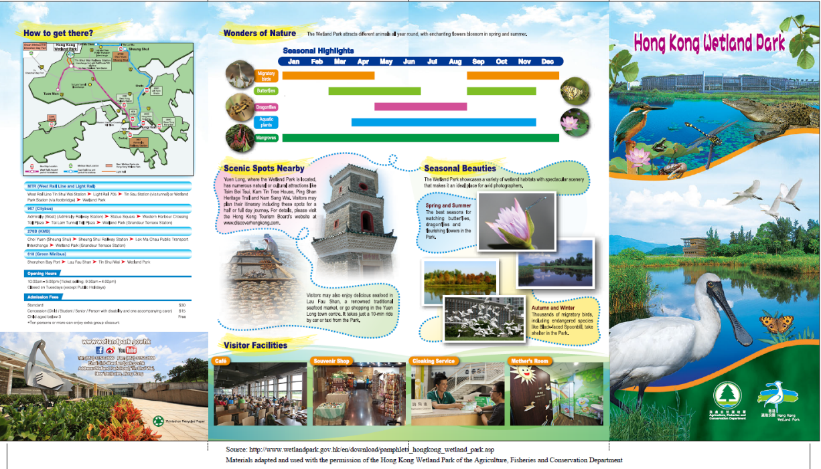
Where is the park?
*Key words/features: Address, the map of Hong Kong

Highlight other useful information: website address, telephone and fax numbers, email address
What can visitors see and do in the park?
*Key words/features: the heading “Visitor Facilities”, photos and names of places “Café”, “Souvenir Shop”
How much is the admission ticket?
*Key words/features: the heading “Admission Fees”, different types of tickets, prices, the dollar signs “$”, discounts
When can visitors visit the park?
*Key words/features: the heading “Opening Hours”, time and days
The “Scenic Spots Nearby” Section
- Focus on the word “Nearby” and draw students’ attention to the base word “near”
- Ask students if they think they can see the scenic spots in the Hong Kong Wetland Park (contextual clues: “It takes just a 10-min ride by car or taxi from the Park.”)
What can visitors see and do in the park?
*Key words/features: the heading “Seasonal Beauties”, “showcases”, “photographers”, “watching butterflies”, “thousands of migratory birds”, the photos
What can visitors see and do in the park?
*Key words/features: the heading “Wonders of Nature”, “different animals”, “flowers”, “Seasonal Highlights”, months, “birds”, “Butterflies”, “plants”, the bar chart, the photos
How can visitors go to the park?
*Key words/features: the heading “How to get there?”, the different routes/means of transport
*Ask students to circle/highlight the key words/features on the leaflet to heighten their awareness of them.
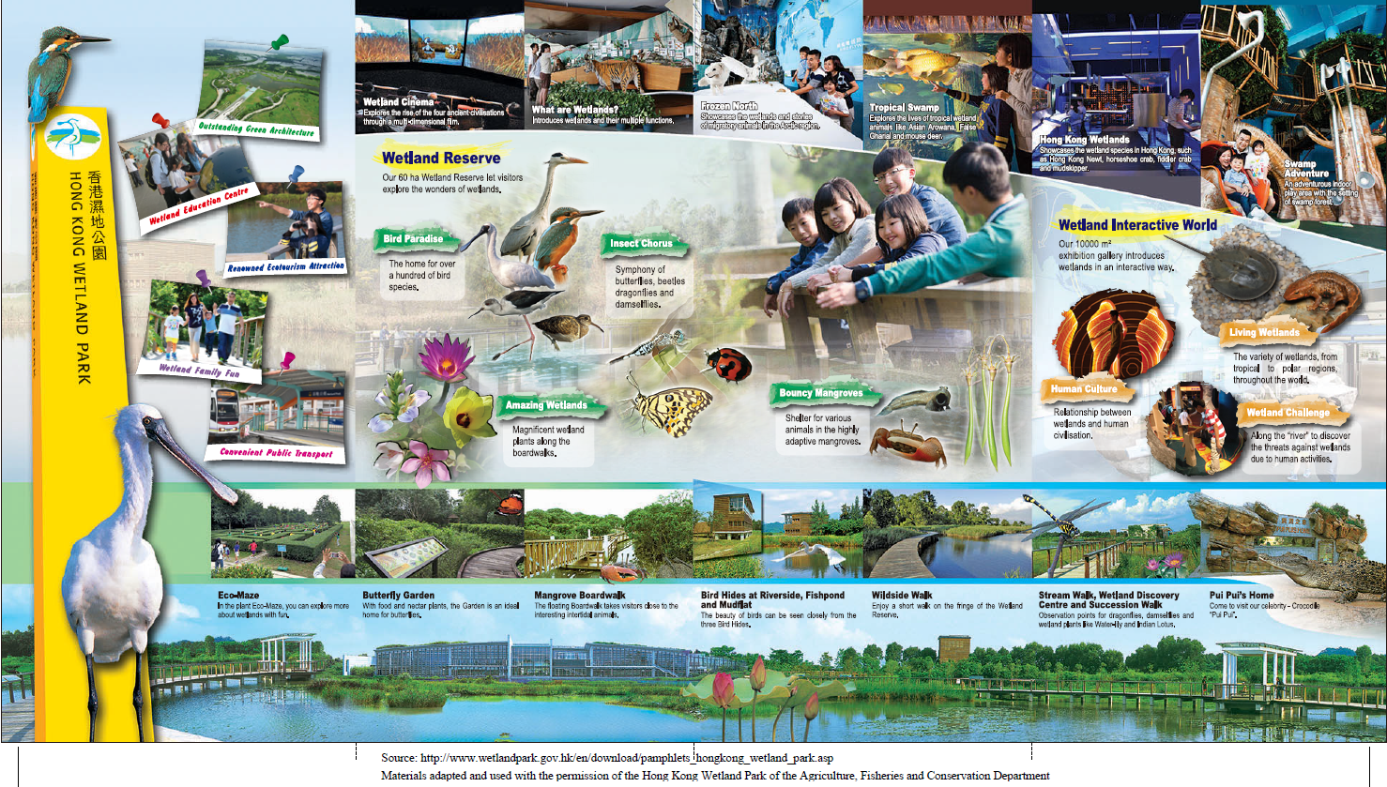
Photos and captions/descriptions
What can we see/do in the park?
*Key words/features: the heading “Wetland Interactive World”, “exhibition gallery”, “interactive”, the photos
What can we see/do in the park?
*Key words/features: the heading “Wetland Reserve”, “let visitors explore”, “wonders of wetlands”, the photos
* Ask students to circle/highlight the key words/features on the leaflet to heighten their awareness of them.

