ETV on Short Film Appreciation (I): My Grandmother
Learning Activity Sheets (Teacher’s notes)

This set of materials, together with the materials on Short Film Appreciation (II): Snap Chat, is designed to support secondary English Language students and teachers in the learning and teaching of film appreciation and film review writing. The materials can be used as a learning task in class to introduce the different elements of a film and the text structure and language features of a film review, or as supplementary materials to extend students’ learning beyond the classroom and promote self-learning.

The set contains the following:
- Student’s copy
- Teacher’s notes (with suggested answers)
- A short film titled My Grandmother

Teachers are advised to use this set of materials on My Grandmother to introduce to students the basics of short film appreciation and use the set on Snap Chat as consolidation or extension. The suggested answers are for reference only and any reasonable answers should be accepted.

Understanding a Film Review: My Grandmother

A film review is a report or a piece of work in which a critic assesses a film, gives comments on it and advises whether or not it is worth recommending. The following are some elements that a film review may include:

General information: | - director  - lead actors and actresses  - genre  - year of release  - length
Plot: | - setting  - storyline  - narrative technique  - pace
Acting: | - how the actors/actresses perform
Film techniques: | - editing  - use of colour  - music and sound effects  - special effects (e.g. CGI – computer generated imagery)
Directing: | - how the director makes use of the different elements in a film to enhance its overall quality

Learning Activity 1: Understanding Film Genres
Match the different film genres below with their corresponding definitions.

 | Action | C |  |  | This type of films includes elements such as breaking the law and solving a crime.
 | Adventure | F |  |  | This type of films is imaginative, often featuring advanced technology and unreal situations.
 | Comedy | G |  |  | This type of films features a lot of fighting, incredible stunts and sometimes dangerous acts.
 | Drama | J |  |  | This type of films includes in-depth investigations of real-life issues or people based on facts.
 | Horror | E |  |  | This type of films aims to scare the audience with monsters or ghosts trying to hurt the main characters.
 | Musical | L |  |  | This type of films features stories of people going on a quest in an exotic setting and overcoming difficulties.
 | Science-fiction (sci-fi) | B |  |  | This type of films is always funny and light-hearted with a happy ending.
 | Crime/Detective story | A |  |  | This type of films is made with a series of drawings, computer graphics or pictures.
 | Tragedy | K |  |  | This type of films features a heart-warming story of people finding the love of their life.
 | Romance | I |  |  | This type of films features stories in a real-life situation, especially a difficult one, with realistic characters.
 | Documentary | D |  |  | This type of films features stories of suffering and sorrow with an unhappy ending.
 | Animation | H |  |  | This type of films includes a lot of songs and dance performances.

Learning Activity 2: Understanding and Summarising the Plot
Before you watch the short film My Grandmother, study some basic facts of the film.
Film Title: | My Grandmother
Year of Release: | 2018
Length: | 7 mins 48 secs
Director: | Annie Yau
Main Cast / Characters: | Yee Yee Yeung as Grandmother  Laia Kee Lopez Ng as young Charlotte  Janice Wan as teenage Charlotte

Watch the short film. Number the pictures in the order of appearance and answer the questions that follow. Some have been done for you as examples.

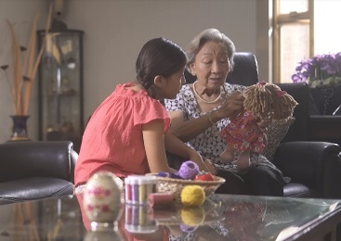 | 3 |  | 4
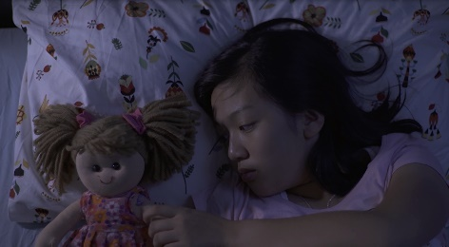 | 2 | 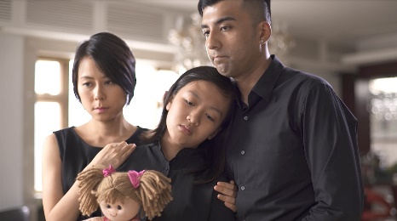 | 1
 | 5 | 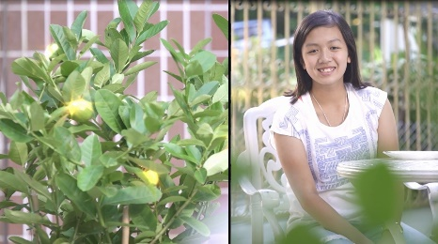 | 6

1. | Where is the film set?
 | e.g. Charlotte’s house
2. | Who are the main characters?
 | e.g. Charlotte and her grandmother
3. | What happens in the opening scene?
 | The funeral of Charlotte’s grandmother is held at Charlotte’s house.
4. | Does the film unfold in a linear, chronological order?
 | No. The film starts with the funeral of Charlotte’s grandmother. Flashbacks
 | are used to recount moments Charlotte and her grandmother spent
 | together.

The plot structure of a film usually contains four key stages:
Study the four key stages of the plot structure. Then identify the four key stages in the short film and complete the plot organiser below.

Stage 1 | The Beginning | characters and setting
Stage 2 | The Conflict | events that lead to the main problem that will happen in the story
Stage 3 | The Climax | the main problem, the most intense moment of the story
Stage 4 | The Resolution | how the conflict is resolved

Stage 1 The Beginning
Where does the story begin? What characters are introduced? How are they introduced?
The story begins with a home funeral of a grandmother. The parents are busy
with guests while the main character, Charlotte, appears only after all the
guests have left. With a doll in her hand, Charlotte looks very sad.
Stage 2 The Conflict
What are the events that lead to the main problem of the story?
In a sleepless night, memories of sweet moments with her grandmother
strike Charlotte when she sees the doll that her grandmother fixed. When
Charlotte is having a slice of cake in the garden, the cake reminds her of the
time her grandmother taught her to bake a cake. When she sees the plant
they grew together, memories strike again.
Stage 3 The Climax
What is the main problem of the story? What is the most intense moment of the story?
The pain of losing her grandmother is overwhelming and Charlotte cannot
make sense of what her grandmother once said to her - “life is full of magic
and miracles”. Seeing her dying grandmother, Charlotte is so overwhelmed
with rage and frustration that she slams the pots down in the garden.
Stage 4 The Resolution
How does the conflict end? What happens to the main character at the end?
Glowing lemons emerge from the plant Charlotte seeded with her
grandmother. Seeing the lemons magically glow, Charlotte smiles and
feels hopeful and reassured.

Learning Activity 3: Describing a Scene
- When describing a(n) scene/action/event in a film review, critics often use the present tenses to make it more engaging and dramatic. Study the following pictures and descriptions and circle the verbs.

Charlotte tosses and turns in bed. Memories of her grandmother flash through her mind.
Charlotte’s parents urge Grandmother to eat but she refuses.
Charlotte and Grandmother sow seeds in a pot together.

Describe the scenes below by filling in the blanks with appropriate words.
 |  | Charlotte | feels |  | sad and |  |  | rests
 |  | her head on her father’s shoulder.
 |  | Charlotte |  | smiles |  |  | at the glowing
 |  | lemons.

- A film review contains a lot of descriptive language. Participles can be used to present actions or describe the relationship between two actions in a concise and economical way.

Participle phrases can be used as adverbs expressing (1) time, (2) reason, and (3) manner. Study the following examples.
Active / Present Participle (time) |  | Passive / Past Participle (reason)
When Charlotte looks at the doll, she thinks of her grandmother. |  | As the doll is mended by Charlotte’s grandmother, it reminds Charlotte of her grandmother.
Looking at the doll, Charlotte thinks of her grandmother. |  | Mended by Charlotte’s grandmother, the doll reminds Charlotte of her grandmother.
Active / Present Participle (manner) |  | Passive / Past Participle (reason)
Charlotte and her grandmother sit side by side and sow seeds in a pot together. |  | As the plant is seeded together by Charlotte and her grandmother, the plant means a lot to Charlotte.
Sitting side by side, Charlotte and her grandmother sow seeds in a pot together. |  | Seeded together by Charlotte and her grandmother, the plant means a lot to Charlotte.
Active / Present Participle (Manner) |  | Passive / Past Participle (Time)
Grandmother lies in bed and refuses to eat. |  | When Grandmother is urged to eat more, she refuses.
Lying in bed, Grandmother refuses to eat. |  | Urged to eat more, Grandmother refuses.

Note:
In using participles as adverbs, the following points should not be overlooked:
- The subject of the two clauses must be the same.
- The present participle is usually used to replace a verb in the active voice while the past participle to replace a verb in the passive voice.

Rewrite the follow sentences with the use of a participle.
1. | Charlotte feels sad and rests her head on her father’s shoulder.
 | Feeling sad, Charlotte rests her head on her father’s shoulder.
2. | When Charlotte is eating a cake by herself, she recalls the happy moment with her grandmother.
 | Eating a cake by herself, Charlotte recalls the happy moment with her
 | grandmother.
- Describe the characters’ facial expressions and body language/action in the following scenes. Use the present tenses and participles, if applicable.

Charlotte nestles in her grandmother’s arms. Holding the mended doll,
they both look at it contentedly with a warm smile on their faces.

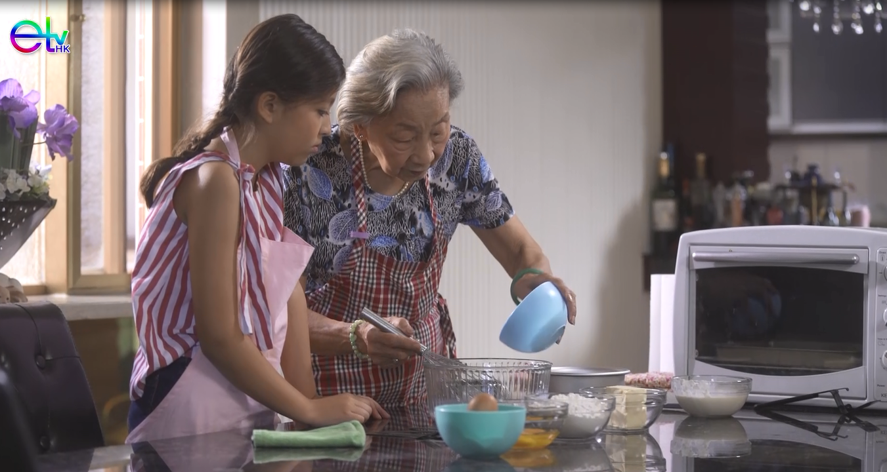
Charlotte’s grandmother teaches Charlotte how to bake a cake with
patience and love.

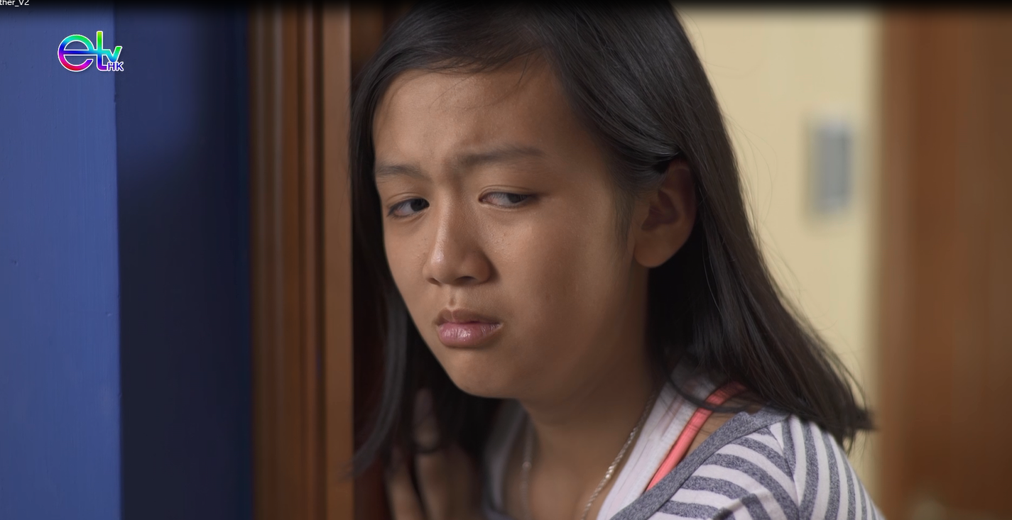
Seeing her ailing grandmother, Charlotte finds it difficult to hold back her
tears.

Overwhelmed with rage and frustration, Charlotte slams the pots down
in the garden.

Learning Activity 4: Analysing Film Elements
Colour and Music
Colour and music play an important role in a film as they can be used to arouse the audience’s emotions, build up the moods and create contradictions. The following mind map shows vocabulary related to colour and music. Fill in the bubbles with appropriate adjectives.

Warm
Bright
Tempo
Music
Colour
Slow
Fast
Moderate
Dramatic
Romantic
Comical
Scary
Mood
Memorable
Catchy
Repetitive
Melody
Filmic Techniques
Dark
Watch the following excerpts from the film again and fill in the table below. One example has been given to you.

Duration | What and how  music / colour is used | Functions
0:57 – 1:40 | slow / sentimental / sad music | to show the sadness of Charlotte, who has lost her dear grandmother
1:40 – 2:30 | slow / heartwarming / nostalgic music | to show how much Charlotte misses her grandmother when recalling the fond memories of their sweet moments
6:20 – 6:28 | a shift from black and white to colour | to suggest the miracles and wonder of life and restoration of hope (as represented by the glowing lemons)
6:20 – 6:47 | uplifting / light-hearted music | to show that life is full of magic and hope

Learning Activity 5: Identifying Themes and Messages
The theme of a film refers to the message(s) the director wants to convey to the audience. The following are some common “theme words”, which are usually abstract nouns.

Friendship | Bravery | Loyalty | Love
Family | Greed | Betrayal | Hope
Technology | Death | Transformation | Sacrifice

Identify the theme(s) of the short film My Grandmother by writing down the appropriate “theme words” in the box below.
Love / Death / Hope / Family

We can develop a “theme word” into a theme statement by presenting the central idea/message of a film in one sentence. Write two theme statements for My Grandmother based on the example below.

Learning Activity 6: Evaluating a Film
A good film review is more than a plot summary. It should contain analysis and evaluation of the different aspects of and evidence from the film to support your judgement. Below are some guiding questions and useful expressions to help you evaluate a film.

Elements of a film review | Guiding questions | Useful expressions
Plot  - setting  - storyline  - narrative techniques | - When and where does the story take place?  - What happens in the four key stages?  - Is the narrative voice effective? | - The film successfully captures the audience’s attention by creating suspense in the opening scene…  - I am on the edge of my seat when the story reaches a climax...  - The narrative structure is… (non-linear / logical / fragmented / chronological…), which skillfully conveys…  - The narrative voice is … (confusing / effective in enhancing the experience…)
Acting | - Do the actors have good acting skills?  - Are the actors / actresses convincing? | - The performance of XXX in the film is excellent / remarkable…  - … is very / not so convincing.  - The acting is true to life / powerful / natural.  - She steals the show in her debut.  - He brings the character to life.  - She is wooden / overacting all the time.
Film techniques:  - editing  - use of colour  - music and sound effects  - special effects (e.g. CGI – computer generated imagery) | - How is the editing?  - How does the use of colour create the mood of the scene?  - Do the music or sound effects match the mood of the scene?  - How is the use of special effects? | - The editing is smooth / jerky.  - The fade-out effectively brings us to XXX’s memories…  - The skillful use of dark colour to create…  - The background music contributes to the atmosphere of… / provides an extra feeling of tension…  - The music is gloomy / slow / catchy / suspenseful / light-hearted…  - The special effects are breathtaking / stunning / state-of-the-art // enhance the viewing experience / ruin the film / leave something to be desired…
Directing:  - how the director makes use of different elements to enhance the overall quality of a film | - How is the film directed?  - Is there any message you can get from the film?  - What is your overall impression of the film? | - The film is well-directed / expertly directed.  - The director tries to convey an impression of ... / draws the viewer’s attention to … but…  - Overall speaking, the film is moving / clichéd / full of tension / coherent / confusing / well worth seeing / thought-provoking / hard to follow / a complete waste of time and money.

Learning Activity 7: Understanding a Film Review
The following is a film review on the short film My Grandmother. Identify the text features by filling in the blanks with appropriate words provided in the box below.

lead | characters | colour
length | evaluation | genre
recommendation | setting | title
Conclusion
9. Recommendation with reason(s)
Comments
- 7. Evaluation of the
different aspects of the film, e.g. use of 8. colour, music and sound effects, editing, acting
Plot summary
- 5. Setting, main
6. characters and the development of the story without giving away the ending
Introduction
- General information of the film, e.g. the 4. lead actors and what the film is generally about
Basic facts about the film such as the
1. title, year of release, director, 2. length, 3. genre and rating [the answers are interchangeable in this part]
My Grandmother (2018)
Director: Annie Yau
7 mins 48 secs / Drama

My Grandmother is a story about a teenage girl’s struggle with the grief of losing her beloved grandmother and the bond of love between them. It stars Laia Kee Lopez Ng as young Charlotte, Janice Wan as teenage Charlotte and Yee Yee Yeung as Grandmother.

The story begins with the funeral of Charlotte’s grandmother and unfolds through flashbacks of sweet moments between Charlotte and her grandmother. The loss of her grandmother is overwhelming to Charlotte and she is on the verge of collapse. Is she able to overcome her sadness and regain her faith in life in the end?

The narrative structure of the film is engaging. As the film progresses, sweet memories of the past intertwine with the bitterness of the present. The skillful use of music helps shape the mood of the melancholic present and the warm and happy past. The special effects in the final scene are stunning with a shift from black and white to colour, giving a magical touch and a thought-provoking ending to the story - humans are not immortal but love is. I felt inspired and touched after watching this film.

The film is full of emotional moments. The scenes of Charlotte’s memories with her grandmother successfully portray a strong bond between Charlotte and her grandmother, and their care and love for each other. The most intense moment is how Charlotte reacts when she sees that her grandmother refuses to eat. Watching her grandmother on her deathbed, she feels helpless and frustrated. The great acting of the cast brought tears to my eyes. Janice Wan, the teenage Charlotte, definitely steals the show in her debut and successfully brings the character to life. The performance of Yee Yee Yeung is equally impressive and the image of the endearing grandmother always lingers in my mind.

Despite its slightly jerky editing, the film is on the whole well-directed. The up-and-coming young director, Annie Yau, has successfully portrayed the genuine love between the granddaughter and her grandmother, and conveyed the message that love does not end with death. My Grandmother is a film you cannot afford to miss.

