

Student Version



**Ensuring Self-sufficient Food Supply**

**Introduction:**

You will understand the importance of safeguarding the food security of our country, and how this can be achieved through emerging technologies and deliberate policies.

**Learning Objectives:**

**Content**

To explore and develop understanding of the following:

* the importance of safeguarding the food security of our country;
* the technologies adopted and policies implemented to safeguard food security in our country; and
* our responsibility for safeguarding the food security of our country and how students can raise their schoolmates’ awareness of food security at school.

**Language**

To develop English language knowledge and skills, e.g.

* the use of a variety of sentence patterns to give reasons, provide examples and give suggestions.

**Main Tasks:**

* Viewing the video **“Solving Our Food Crisis”** to understand how China has addressed the problem of food shortages
* Participating in a group discussion about the issue of food security in China
* Making an individual presentation in response to a question relating to the issue of food security

[](https://chinacurrent.com/education/22931/solving-our-food-crisis-22931)[](https://www.nsed.gov.hk/national_security/index.php?l=en&a=national_security_main_focus)**Part 1 – Warm-up Activities**

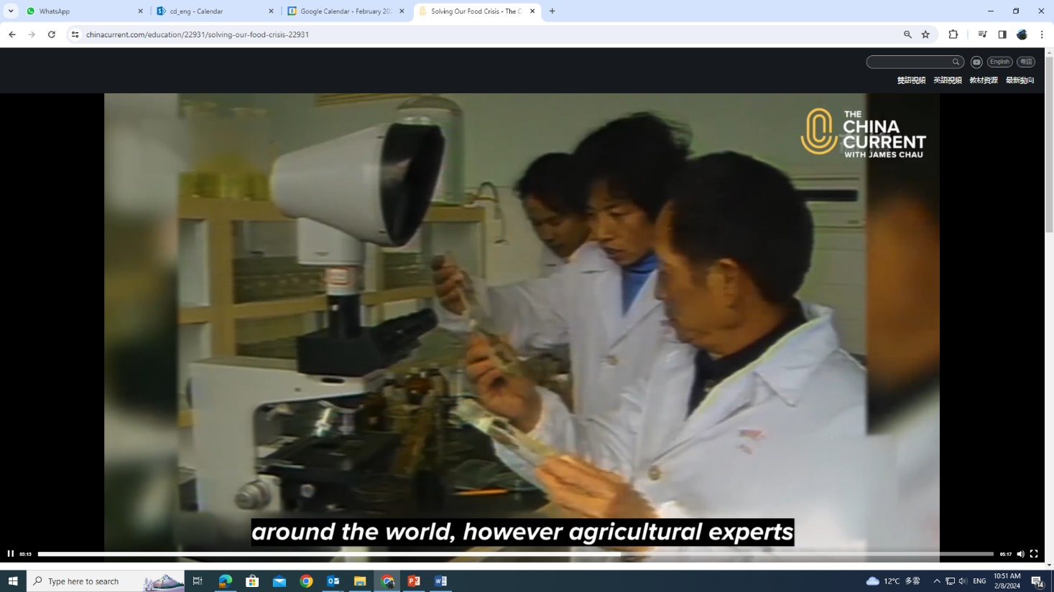

***Solving Our Food Crisis***

|  |  |  |
| --- | --- | --- |
|  |  |  |
|  |  |  |
|  |  |  |
|  |  |  |
|  |  |  |
|  |  |  |

1. Before exploring the topic, write down in the box below what springs to your mind when it comes to food security.

You may refer to the webpage on “Major Fields of National Security” ([*https://www.nsed.gov.hk/national_security/index.php?l=en&a=national_security_main_focus*](https://www.nsed.gov.hk/national_security/index.php?l=en&a=national_security_main_focus)) for some ideas.

1. Watch the following video from *The China Current* and answer the questions that follow.

[*https://chinacurrent.com/education/22931/solving-our-food-crisis-22931*](https://chinacurrent.com/education/22931/solving-our-food-crisis-22931)

1. Identify four threats to global food security from the video.

|  |  |  |
| --- | --- | --- |
|  |  |  |
|  |  |  |
|  |  |  |
|  |  |  |
|  |  |  |

1. How do new technologies and innovations help solve food crisis?

|  |  |  |
| --- | --- | --- |
|  |  |  |
|  |  |  |
|  |  |  |
|  |  |  |
|  |  |  |

1. Name three kinds of food that China has been developing to address the problem of food shortages.

|  |  |  |
| --- | --- | --- |
|  |  |  |
|  |  |  |
|  |  |  |
|  |  |  |
|  |  |  |

**Part 2 – Group Interaction**

Situation: This article appeared on the bulletin board of your school’s Citizenship and Social Development Department. Read the article and **conduct a 10 to 15-minute discussion in groups of 3-4**. You may make use of information from the video in Part 1 and the article below and jot notes in the space provided.

**Safeguarding food security is one of our top priorities**

When it comes to national security, political, territorial and military security may first cross our minds. Yet, for the Central People’s Government, food security is also crucial to national security as it is the backbone of our country’s economic development and social stability.

With a population of more than 1.4 billion people, food security is one of China’s major concerns regarding people’s livelihood and national affair. It involves ensuring a sustainable, self-sufficient food supply and stable access to food for the whole nation, and is therefore not taken lightly. There are plenty of reasons for us to be alarmed, especially if the amount of food we grow fails to keep pace with that we consume and we start to rely on foreign imports as a result.

To prevent this from happening, China has rolled out relevant policies, one of which is to set a “farmland red line” during the 14th Five-Year Plan period (2021-2025) to ensure that its total arable land does not fall below 120 million hectares. It will also continue to build and upgrade “well-facilitated farmland” with facilities such as irrigation systems to counter adverse weather conditions.

In addition to protecting and improving the farmland, China also makes every effort to boost crop yields and domestic agricultural production. Universities and biotech companies have accelerated the development of genetically modified soybean crops and corn crops. The number of state-sponsored seed breeding and production bases has also been increasing, aiming to provide enough seeds for domestic crop production.

Feeding one-fifth of the world’s population with less than 10 per cent of the world’s arable land cannot be achieved with a wave of magic wand. While scientists and farmers have dedicated their lives to increasing food supply for us, what role can we play in safeguarding our country’s food security? This question deserves our deep thought.

**Discussion Topic:**

Your class is doing a project on national security. Your group has been asked to discuss the issue of food security in our country. You may want to talk about:

* the importance of food security to China
* what China has done to safeguard food security
* what we can do to safeguard our country’s food security
* what the school can do to raise students’ awareness of food security
* anything else you think is important



**Notes**

**Part 3 – Individual Response**

In this part, each of the group members will take turn to **give a short speech of about one minute** on one of the following questions.

1. What makes it difficult for people to reduce food waste?
2. What can you do to help reduce food waste?
3. Why is reliance on imported food a potential threat to our country’s food security?
4. Professor Yuan Longping, the “Father of Hybrid Rice”, once said, “Increased grain production is a joy, but how painful it is to see the food produced being wasted.” What are your views on what he said?