

**Ensuring Self-sufficient Food Supply**

Teacher Version

|  |  |  |  |
| --- | --- | --- | --- |
| **Major Field of National Security** | **Module** | **Unit** | **Topic** |
| Food Security | Technology | Changes Brought about by Technology | Ensuring Self-sufficient Food Supply |

**Suggested Levels:** S4-6

**Summary of the Learning Topic:**

The learning topic aims to guide students to understand the importance of safeguarding the food security of our country, and how this can be achieved through emerging technologies and deliberate policies.

**Learning Objectives:**

**Content**

To explore and develop understanding of the following:

* the importance of safeguarding the food security of our country;
* the technologies adopted and policies implemented to safeguard food security in our country; and
* our responsibility for safeguarding the food security of our country and how students can raise their schoolmates’ awareness of food security at school.

**Language**

To develop English language knowledge and skills, e.g.

* the use of a variety of sentence patterns to give reasons, provide examples and give suggestions.

**Learning Tasks:**

* **Part 1 – Warm-up Activities:** Students understand how China has addressed the problem of food shortages through a video.
* **Part 2 – Group Interaction:** Students participate in a group discussion about the issue of food security in China.
* **Part 3 – Individual Presentation:** Students respond to a question relating to the issue of food security.

[](https://chinacurrent.com/education/22931/solving-our-food-crisis-22931)[](https://www.nsed.gov.hk/national_security/index.php?l=en&a=national_security_main_focus)[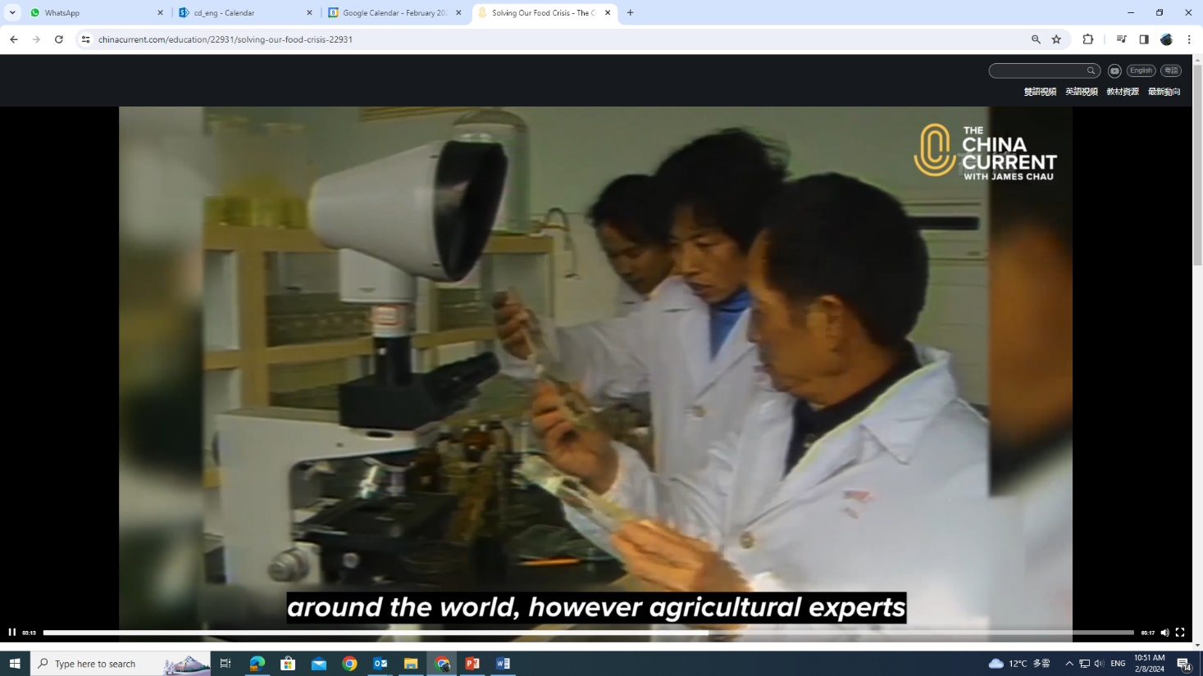](https://chinacurrent.com/education/22931/solving-our-food-crisis-22931)**Part 1 – Warm-up Activities**

***Solving Our Food Crisis***

1. Watch the following video from *The China Current* and answer the questions that follow.

[*https://chinacurrent.com/education/22931/solving-our-food-crisis-22931*](https://chinacurrent.com/education/22931/solving-our-food-crisis-22931)

|  |  |  |
| --- | --- | --- |
|  | Suggested answers: |  |
|  | * Food security is about ensuring a sustainable, self-sufficient food supply and stable |  |
|  | access to food for the whole nation. |  |
|  | * Food security is about people’s basic needs, livelihood and welfare. |  |
|  | * Food security is the backbone of economic development and social stability. |  |
|  |  |  |

1. Before exploring the topic, write down in the box below what springs to your mind when it comes to food security.

You may refer to the webpage on “Major Fields of National Security” ([*https://www.nsed.gov.hk/national_security/index.php?l=en&a=national_security_main_focus*](https://www.nsed.gov.hk/national_security/index.php?l=en&a=national_security_main_focus)) for some ideas.

1. Identify four threats to global food security from the video.

|  |  |  |
| --- | --- | --- |
|  | (Any four):   * population explosions // war // natural disasters // extreme weather |  |
|  | * disease // economic turmoil |  |
|  |  |  |
|  |  |  |
|  |  |  |

1. How do new technologies and innovations help solve food crisis?

|  |  |  |
| --- | --- | --- |
|  | Suggested answers: |  |
|  | New technologies and innovations help solve food crisis by further promoting access to |  |
|  | food and providing new and sustainable ways of food production and consumption. |  |
|  |  |  |
|  |  |  |

1. Name three kinds of food that China has been developing to address the problem of food shortages.

|  |  |  |
| --- | --- | --- |
|  | * alternative meat/plant-based meat |  |
|  | * seawater rice (a new hybrid species of rice) |  |
|  | * insect-based chips and spaghetti |  |
|  |  |  |
|  |  |  |

**Part 2 – Group Interaction**

Situation: This article appeared on the bulletin board of your school’s Citizenship and Social Development Department. Read the article and **conduct a 10 to 15-minute discussion in groups of 3-4**. You may make use of information from the video in Part 1 and the article below and jot notes in the space provided.

**Safeguarding food security is one of our top priorities**

When it comes to national security, political, territorial and military security may first cross our minds. Yet, for the Central People’s Government, food security is also crucial to national security as it is the backbone of our country’s economic development and social stability.

With a population of more than 1.4 billion people, food security is one of China’s major concerns regarding people’s livelihood and national affair. It involves ensuring a sustainable, self-sufficient food supply and stable access to food for the whole nation, and is therefore not taken lightly. There are plenty of reasons for us to be alarmed, especially if the amount of food we grow fails to keep pace with that we consume and we start to rely on foreign imports as a result.

To prevent this from happening, China has rolled out relevant policies, one of which is to set a “farmland red line” during the 14th Five-Year Plan period (2021-2025) to ensure that its total arable land does not fall below 120 million hectares. It will also continue to build and upgrade “well-facilitated farmland” with facilities such as irrigation systems to counter adverse weather conditions.

In addition to protecting and improving the farmland, China also makes every effort to boost crop yields and domestic agricultural production. Universities and biotech companies have accelerated the development of genetically modified soybean crops and corn crops. The number of state-sponsored seed breeding and production bases has also been increasing, aiming to provide enough seeds for domestic crop production.

Feeding one-fifth of the world’s population with less than 10 per cent of the world’s arable land cannot be achieved with a wave of magic wand. While scientists and farmers have dedicated their lives to increasing food supply for us, what role can we play in safeguarding our country’s food security? This question deserves our deep thought.



**Discussion Topic:**

Your class is doing a project on national security. Your group has been asked to discuss the issue of food security in our country. You may want to talk about:

* the importance of food security to China

Possible ideas:

* It is the backbone of economic development and social stability.
* There is a large population to feed, and food shortages or hunger is a threat to people’s basic livelihood and national security. Food security must be safeguarded for the welfare and wellbeing of the people.
* what China has done to safeguard food security

Possible ideas:

* It has developed new sources of sustainable and alternative food (e.g. plant-based meat, seawater rice, insect-based chips and spaghetti).
* It has made efforts to protect its farmland and improve its productivity (e.g. setting a “farmland red line”, upgrading “well-facilitated” farmland).
* It has made efforts to boost crop yields and domestic agricultural production (e.g. accelerating the development of domestically grown, genetically modified soybean crops and corn crops, increasing state-sponsored seed breeding and production bases).
* what we can do to safeguard our country’s food security

Possible ideas:

* changing our diet and food choices (e.g. embracing plant-/insect-based /genetically modified food which cause less harm to the environment in the food production and consumption process)
* protecting areas designated for farming
* minimising food waste in our daily life
* developing an interest in food science and technology to meet our country’s need for talents to support the research and development of safe, healthy and accessible food for all
* what the school can do to raise students’ awareness of food security

Possible ideas:

* holding a board exhibition on our country’s achievements in safeguarding food security
* selling vegetarian and plant-based food at the school tuck shop
* inviting experts in food science and technology to give talks/seminars
* organising tours and visits to innovative food production companies and seed breeding and production bases in Hong Kong and/or the Mainland to understand the latest developments in food technology conducive to food security
* creating a social media reel and short videos on responsible food consumption to be broadcast on the school website and Campus TV
* anything else you think is important



Teacher’s notes:

Suggested sentence patterns for different communicative purposes:

|  |  |
| --- | --- |
| Communicative purposes | Suggested sentence patterns |
| 1. Give reasons | * Food security is important to China because it is the backbone of economic development and social stability. * The reason why food security is vital to China is that China has a large population to feed. * Given (the fact) that China has a large population to feed, food security is vital to the country. |
| 1. Provide examples | * China has developed new and sustainable ways of the production and consumption of food. For example/For instance, alternative meat starts to appear on menus, and insect-based chips and spaghetti are already on the market. * China has rolled out relevant policies to protect farmland and improve its productivity. A case in point is setting a “farmland red line”. |
| 1. Give suggestions | * I suggest (that) we start to embrace plant- or insect-based diets because the production process emits less carbon dioxide and causes less harm to the environment. * To raise schoolmates’ awareness of food security, we can/may/should organise a board exhibition displaying some facts and figures that inform them of the importance of food security to our country. There could/might also be a quiz corner where questions are set to test their understanding of the issue. * What about inviting a guest speaker who is an expert in crop production to give a talk on the challenges of boosting crop yields and how to overcome them at the assembly? |

**Part 3 – Individual Response**

In this part, each of the group members will take turn to **give a short speech of about one minute** on one of the following questions.

1. What makes it difficult for people to reduce food waste?

Possible ideas:

* Most people do not realise that they are wasting food.
* Food is sometimes considered a symbol of abundance and prosperity, especially during festivals and celebrations. To ensure family members, relatives and friends have enough food to eat, people may buy, cook or order more than enough food.
* People may find storing leftovers inconvenient and lack ideas on ways to use up leftovers.
* Consumers are confused by the expiry date on food labels and end up discarding food which can still be eaten.

1. What can you do to help reduce food waste?

Possible ideas:

* Plan meals carefully; buy and cook only what is needed
* Learn how to store/use up leftovers properly
* Study food labels carefully to understand the expiry date of food
* Share extra food with others

1. Why is reliance on imported food a potential threat to our country’s food security?

Possible ideas:

* The stability of imported food can never be guaranteed. If we over-rely on foreign imports of food, especially for staple food like rice and wheat, there may be food shortages any time.

1. Professor Yuan Longping, the “Father of Hybrid Rice”, once said, “Increased grain production is a joy, but how painful it is to see the food produced being wasted.” What are your views on what he said?

Possible ideas:

* Increased grain production is to be celebrated because the concerted efforts of scientists and farmers have paid off and our country no longer needs to worry about food shortages or hunger, which may hinder economic development and social stability.
* It is saddening to see people waste food because the food produced is the result of scientists and farmers’ sweat and toil. Their strenuous efforts for years seem to be futile if we do not treasure their contributions and let the food go to waste easily.