

**Enhancing the Safety of Nuclear Energy**

Student Version

**Introduction:**

You will understand the latest development of nuclear energy in China, the importance of safeguarding the nuclear security of our country and measures taken to achieve it.

**Learning Objectives:**

**Content**

To explore and develop understanding of the following:

* the importance of safeguarding the nuclear security of our country;
* the technologies adopted and measures implemented to safeguard nuclear security in our country; and
* our responsibility for safeguarding the nuclear security of our country and how students can raise their schoolmates’ awareness of nuclear security at school.

**Language**

To develop English language knowledge and skills, e.g.

* the use of relative clauses to provide additional information/descriptions
* the use of creative elements of English (e.g. alliteration) to attract the audience’s attention

**Main Tasks:**

* Viewing the video **“The Next Nuclear Plants”** to understand the latest development and safe use of nuclear energy for electricity generation in China
* Participating in a group discussion about the issue of nuclear security in China
* Making an individual presentation in response to a question relating to the issue of nuclear security

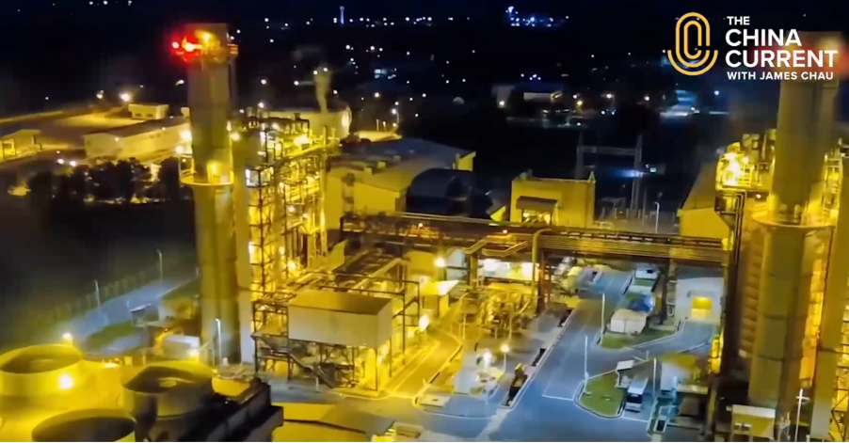[](https://www.nsed.gov.hk/national_security/index.php?l=en&a=national_security_main_focus)**Part 1 – Warm-up Activities**

1. Watch the following video from *The China Current* and answer the questions that follow.

https://chinacurrent.com/story/24003/the-next-nuclear-plants

***The Next Nuclear Plants***

|  |  |  |
| --- | --- | --- |
|  |  |  |
|  |  |  |
|  |  |  |
|  |  |  |
|  |  |  |
|  |  |  |
|  |  |  |

1. Before exploring the topic, put down in the box below what comes to your mind when you think of nuclear security.

You may refer to the webpage on “Major Fields of National Security” ([*https://www.nsed.gov.hk/national_security/index.php?l=en&a=national_security_main_focus*](https://www.nsed.gov.hk/national_security/index.php?l=en&a=national_security_main_focus)) for some ideas.

1. Identify the threat posed by the current use of nuclear fission reactions to generate electricity in nuclear power plants.

|  |  |  |
| --- | --- | --- |
|  |  |  |
|  |  |  |
|  |  |  |

1. What are the advantages of developing the new technology of nuclear fusion power generation?

|  |  |  |
| --- | --- | --- |
|  |  |  |
|  |  |  |
|  |  |  |
|  |  |  |
|  |  |  |
|  |  |  |
|  |  |  |
|  |  |  |

1. How has China been contributing to global nuclear security?

|  |  |  |
| --- | --- | --- |
|  |  |  |
|  |  |  |
|  |  |  |
|  |  |  |
|  |  |  |
|  |  |  |

**Part 2 – Group Interaction**

Situation: The theme at your school for this month is “Green and Safe Energy”. Members of the Environmental Protection Club have been putting different articles on the bulletin board to raise schoolmates’ awareness of an array of clean energy sources. This month, the article is about nuclear power. Read the article and **conduct a discussion of 10-15 minutes in groups of 3-4**. You may make use of information from the video in Part 1 and the article below and jot notes in the space provided.

**Nuclear security, a key responsibility**

With a growing energy demand, our country has been seeking ways to secure a stable supply of green energy to accommodate the needs of the whole nation. Nuclear power is one of the most efficient energy sources, but some people are unsettled by its potential risks.

In view of this, our country has been making great efforts in developing nuclear energy into a safer and more reliable energy source. There are strict guidelines on the design and running of nuclear power plants in China. Take the Daya Bay Nuclear Power Station as an example. It has had an excellent record in plant reliability, performance and safety since it started running three decades ago. To protect the health of the staff working there and the general public nearby, a comprehensive monitoring programme has been developed to ensure no excessive or undue release of radioactivity, and maintain negligible effect of radioactive releases on the environment. Environmental monitoring stations have also been set up within 5 kilometers of the Daya Bay Nuclear Power Station to keep track of the radiation level.

The site selection of the Daya Bay Nuclear Power Station also complies with international guidelines and satisfies stringent safety assessment by the National Nuclear Safety Administration. The site is seismically stable and far away from major cities, hazardous industrial installations and commercial flight paths. In case of human error or equipment failure, auxiliary equipment will step in to maintain safe operation of the station. The Government of the Hong Kong Special Administrative Region has also developed a comprehensive Daya Bay Contingency Plan which explains the emergency measures to be taken in Hong Kong in case of a nuclear emergency. With all these measures, the Daya Bay Nuclear Power Station has been the champion in Capability Factors at the Électricité de France (EDF) Safety Challenge Competition for 11 consecutive years.

Not only has nuclear power been ensuring a stable energy supply and optimising the energy mix, it has also been helping our country reach its green goals. A total of 309.49 million tons of carbon dioxide emissions was reduced in 2022. With the advancement in technology in this field, China is now exporting its domestically developed reactors and associated technologies to countries and regions participating in the Belt and Road Initiative, hoping to bring the benefits of nuclear power worldwide.



**Notes**

**Discussion Topic:**

Your group has been asked to discuss the issue of nuclear security in our country in an English lesson. You may want to talk about:

* the importance of nuclear security to China
* how the design and measures adopted in the Daya Bay Nuclear Power Station contribute to safeguarding nuclear security
* what we can do to safeguard our country’s nuclear security
* what else our school can do to raise students’ awareness of nuclear security during the month of “Green and Safe Energy”
* anything else you think is important

**Part 3 – Individual Response**

In this part, each of the group members will take turn to **give a short speech of about one minute** on one of the following questions.

1. What are the possible misconceptions about generating electricity by nuclear power?
2. Why is reliance on fossil fuels a potential threat to our country? What would be a possible alternative?
3. How can safeguarding nuclear security contribute to energy (including energy security) and ecological security?
4. Our country aims to achieve carbon neutrality by 2060. What can you do to help achieve it?