

**Enhancing the Safety of Nuclear Energy**

Teacher Version

|  |  |  |  |
| --- | --- | --- | --- |
| **Major Field of National Security** | **Module** | **Unit** | **Topic** |
| Nuclear Security | Nature and Environment | Protecting the Environment | Enhancing the Safety of Nuclear Energy |

**Suggested Levels:** S4-6

**Summary of the Learning Topic:**

The learning topic aims to guide students to understand the latest development of nuclear energy in China, the importance of safeguarding the nuclear security of our country and measures taken to achieve it.

**Learning Objectives:**

**Content**

To explore and develop understanding of the following:

* the importance of safeguarding the nuclear security of our country;
* the technologies adopted and measures implemented to safeguard nuclear security in our country; and
* our responsibility for safeguarding the nuclear security of our country and how students can raise their schoolmates’ awareness of nuclear security at school.

**Language**

To develop English language knowledge and skills, e.g.

* the use of relative clauses to provide additional information/descriptions
* the use of creative elements of English (e.g. alliteration) to attract the audience’s attention

**Learning Tasks:**

* **Part 1 – Warm-up Activities:** Students understand through a video the latest development of nuclear energy in China and measures adopted to enhance the safe use of nuclear energy for electricity generation.
* **Part 2 – Group Interaction:** Students participate in a group discussion about the issue of nuclear security in China.
* **Part 3 – Individual Presentation:** Students respond to a question relating to the issue of nuclear security.

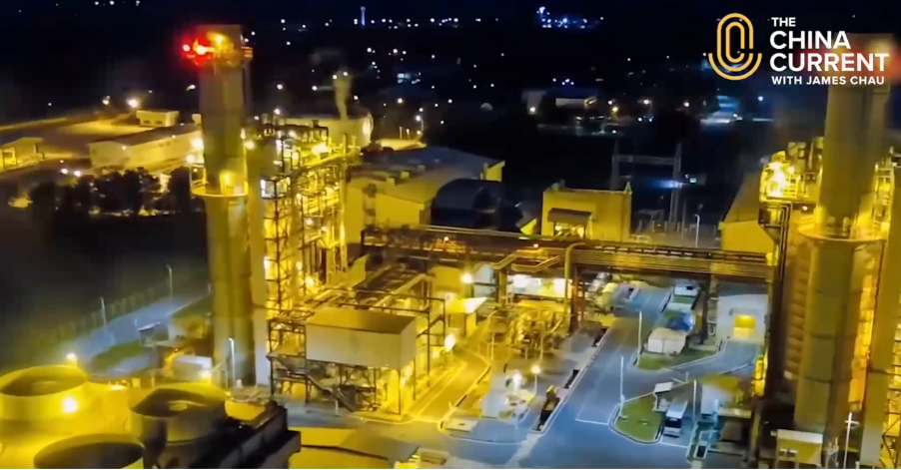[](https://www.nsed.gov.hk/national_security/index.php?l=en&a=national_security_main_focus)**Part 1 – Warm-up Activities**

|  |
| --- |
| * Nuclear security is about ensuring the operational safety of nuclear facilities, safe use of nuclear technology, proper treatment of nuclear materials, and minimising the risks and effects of radiation on the public. * Nuclear security is about the peaceful use of nuclear energy and technology to meet the needs of the nation, and avoiding the initial use of nuclear weapons at any time under any circumstances. * Nuclear security is about the preparedness for nuclear emergency, nuclear accidents and related terrorism. * Nuclear security is about strengthening international collaboration to enhance radiation protection and radioactive waste management, thereby contributing to global nuclear safety. |

1. Watch the following video from *The China Current* and answer the questions that follow.

https://chinacurrent.com/story/24003/the-next-nuclear-plants

***The Next Nuclear Plants***

Suggested answers:

1. Before exploring the topic, put down in the box below what comes to your mind when you think of nuclear security.

You may refer to the webpage on “Major Fields of National Security” ([*https://www.nsed.gov.hk/national_security/index.php?l=en&a=national_security_main_focus*](https://www.nsed.gov.hk/national_security/index.php?l=en&a=national_security_main_focus)) for some ideas.

1. Identify the threat posed by the current use of nuclear fission reactions to generate electricity in nuclear power plants.

|  |  |  |
| --- | --- | --- |
|  | Suggested answer: |  |
|  | This type of nuclear power plants may generate hazardous waste. |  |
|  |  |  |

1. What are the advantages of developing the new technology of nuclear fusion power generation?

|  |  |  |
| --- | --- | --- |
|  | Suggested answers: |  |
|  | * Nuclear fusion causes less radioactive pollution and no carbon emissions, helping |  |
|  | reduce the potential risks to people’s health and the environment. |  |
|  | * As our world becomes more reliant on consistent and powerful sources of energy, |  |
|  | there is a need to explore alternative and clean energy sources to reduce the use and |  |
|  | extraction of oil and gas, and nuclear development will play a pivotal role for years to |  |
|  | come. |  |
|  |  |  |

1. How has China been contributing to global nuclear security?

|  |  |  |
| --- | --- | --- |
|  | Suggested answers: |  |
|  | China, which is already at the forefront in the development of global, controllable |  |
|  | nuclear fusion, may bring new insights to other countries which are exploring the |  |
|  | technology behind nuclear fusion to supply energy and on their way to achieving similar |  |
|  | breakthroughs in this field. |  |
|  |  |  |

**Part 2 – Group Interaction**

Situation: The theme at your school for this month is “Green and Safe Energy”. Members of the Environmental Protection Club have been putting different articles on the bulletin board to raise schoolmates’ awareness of an array of clean energy sources. This month, the article is about nuclear power. Read the article and **conduct a discussion of 10-15 minutes in groups of 3-4**. You may make use of information from the video in Part 1 and the article below and jot notes in the space provided.

**Nuclear security, a key responsibility**

With a growing energy demand, our country has been seeking ways to secure a stable supply of green energy to accommodate the needs of the whole nation. Nuclear power is one of the most efficient energy sources, but some people are unsettled by its potential risks.

In view of this, our country has been making great efforts in developing nuclear energy into a safer and more reliable energy source. There are strict guidelines on the design and running of nuclear power plants in China. Take the Daya Bay Nuclear Power Station as an example. It has had an excellent record in plant reliability, performance and safety since it started running three decades ago. To protect the health of the staff working there and the general public nearby, a comprehensive monitoring programme has been developed to ensure no excessive or undue release of radioactivity, and maintain negligible effect of radioactive releases on the environment. Environmental monitoring stations have also been set up within 5 kilometers of the Daya Bay Nuclear Power Station to keep track of the radiation level.

The site selection of the Daya Bay Nuclear Power Station also complies with international guidelines and satisfies stringent safety assessment by the National Nuclear Safety Administration. The site is seismically stable and far away from major cities, hazardous industrial installations and commercial flight paths. In case of human error or equipment failure, auxiliary equipment will step in to maintain safe operation of the station. The Government of the Hong Kong Special Administrative Region has also developed a comprehensive Daya Bay Contingency Plan which explains the emergency measures to be taken in Hong Kong in case of a nuclear emergency. With all these measures, the Daya Bay Nuclear Power Station has been the champion in Capability Factors at the Électricité de France (EDF) Safety Challenge Competition for 11 consecutive years.

Not only has nuclear power been ensuring a stable energy supply and optimising the energy mix, it has also been helping our country reach its green goals. A total of 309.49 million tons of carbon dioxide emissions was reduced in 2022. With the advancement in technology in this field, China is now exporting its domestically developed reactors and associated technologies to countries and regions participating in the Belt and Road Initiative, hoping to bring the benefits of nuclear power worldwide.



**Discussion Topic:**

Your group has been asked to discuss the issue of nuclear security in our country in an English lesson. You may want to talk about:

* the importance of nuclear security to China

Possible ideas:

* There is an ever-growing demand for electricity. However, the heavy reliance on fossil fuels for energy supply poses a threat to people’s health and the environment because the burning of fossil fuels leads to emissions of greenhouse gases which causes air pollution. Nuclear security must be safeguarded for the welfare and well-being of our nation.
* Nuclear security aims to ensure nuclear technology is used for peaceful purposes, for example, generating unlimited and clean energy for future generations by nuclear power, and avoiding the initial use of nuclear weapons at any time under any circumstances.
* It also ensures safe operation of nuclear facilities, proper disposal of nuclear materials, and minimal effects of radiation on the public and the environment.
* It raises people’s awareness of the preparedness for nuclear emergency, nuclear accidents and related terrorism.
* It contributes to global nuclear security through improving radiation protection and radioactive waste management to prevent the spread of radiation.
* how the design and measures adopted in the Daya Bay Nuclear Power Station contribute to safeguarding nuclear security

Possible ideas:

* Due consideration has been given to the following regarding the design and operation of the nuclear power station. For example:
  + a seismically stable region which is also far away from major cities, hazardous industrial installations and commercial flight paths is selected for the construction of the station;
  + auxiliary equipment is installed in the station to maintain its safe operation even during nuclear accidents;
  + contingency plans are prepared in case of nuclear emergency;
  + a comprehensive monitoring programme has been developed to ensure no excessive or undue release of radioactivity, and maintain negligible effect of radioactive releases on the environment; and
  + the radiation level is under close monitoring through setting up environmental monitoring stations within 5 kilometers of the station.
* what we can do to safeguard our country’s nuclear security

Possible ideas:

* learning more about nuclear energy to clear our misconceptions about it
* complying with the emergency measures in case any contingency plans are activated during a nuclear accident
* developing an interest in learning about different kinds of renewable and green energy sources to meet our country’s need for talents to support the research and development of clean and safe energy sources, including nuclear energy
* minimising electricity waste in our daily life



* what else our school can do to raise students’ awareness of nuclear security during the month of “Green and Safe Energy”

Possible ideas:

* launching a lunchtime radio programme which introduces the latest development of nuclear technology in China
* organising an inter-class quiz competition to enhance students’ understanding of measures regarding nuclear security and clear their misconceptions
* holding a board exhibition on our country’s achievements in safeguarding nuclear security
* inviting experts in nuclear technology to give talks/seminars
* organising tours and visits to nuclear power stations (e.g. the Daya Bay Nuclear Power Station) to understand the latest development of nuclear technology conducive to nuclear security
* anything else you think is important



Teacher’s notes:

Suggested sentence patterns for different communicative purposes:

|  |  |
| --- | --- |
| Communicative purposes | Suggested sentence patterns |
| 1. Provide additional information/descriptions | 1. **Defining relative clause**   To provide essential information about a place or thing.  e.g. We should switch to electric cars which emit fewer greenhouse gases when compared to petrol or diesel cars.   1. **Non-defining relative clause**   To provide additional or supplementary information about a place or thing.  e.g. China, which is already at the forefront in the development of global, controllable nuclear fusion, may bring new insights to other countries looking to explore further in this field. |
| 1. Attract the audience’s attention | **Alliteration**  e.g. As our world becomes more reliant on consistent and powerful sources of energy, nuclear development will play a pivotal role for years to come.  e.g. Nuclear energy, as a clean, controllable and cost- effective energy source, helps secure energy supply with negligible impacts on the environment. |

**Part 3 – Individual Response**

In this part, each of the group members will take turn to **give a short speech of about one minute** on one of the following questions.

1. What are the possible misconceptions about generating electricity by nuclear power?

Possible ideas:

* Most people believe that nuclear power will cause radiation-related health problems such as cancer.
* Nuclear power plants will emit a significant amount of radiation which causes detrimental impacts on the environment and our food sources.
* Most nuclear waste cannot be properly disposed of and will pollute the environment.
* Nuclear energy is not safe as nuclear power plants/nuclear reactors may explode easily.

1. Why is reliance on fossil fuels a potential threat to our country? What would be a possible alternative?

Possible ideas:

* Fossil fuels, which include coal, oil and natural gas, are limited in nature and may run out one day. Burning fossil fuels also causes pollution to the environment and negative impacts on people’s health.
* On the contrary, nuclear power generates electricity in a clean and sustainable way.
* Therefore, safeguarding nuclear security is important in a way it secures our energy supply with minimal impacts on the environment.

1. How can safeguarding nuclear security contribute to energy (including energy security) and ecological security?

Possible ideas:

* Due to the growing energy demand, our country has been seeking ways to increase power supply while reducing reliance on fossil fuels to generate electricity which causes air pollution and climate change.
* Nuclear energy, which is a clean, low-carbon and cost-effective energy, helps secure energy supply with negligible impacts on the environment.
* Therefore, safeguarding nuclear security ensures that electricity is generated in a safe manner to meet the needs of our nation, both leading to resource security (including energy security) and ecological security.

1. Our country aims to achieve carbon neutrality by 2060. What can you do to help achieve it?

Possible ideas:

* We should support the development of clean energy (e.g. nuclear power, wind power).
* We should reduce energy consumption at home so that less pollution will be caused while generating electricity in various means.
* We should switch to electric cars which emit fewer greenhouse gases when compared to petrol or diesel cars.
* We should build a habit of “reducing, reusing and recycling” items so as to reduce the production of new products which emits greenhouse gases.