

**Water Conservation**

Student Version

**Introduction:**

You will understand the importance of safeguarding the resource security of our country, and how this can be achieved through conserving water resources with a national water network and deliberate policies and strategies adopted in China and Hong Kong. .

**Learning Objectives:**

**Content**

To explore and develop understanding of the following:

* the importance of safeguarding the resource security of our country;
* the policies and strategies implemented to safeguard resource security in our country; and
* our responsibility for safeguarding the resource security of our country and how students can raise their schoolmates’ awareness of resource security at school.

**Language**

To develop English language knowledge and skills, e.g.

* the use of passive voice to place emphasis on the process, action and/or outcome;
* the use of *to*-infinitive clauses to express purposes and objectives; and
* the use of a variety of sentence patterns to give reasons and provide examples.

**Main Tasks:**

* Viewing the video **“Conservation Water for Thousands of Years”** to understand how China has addressed the imbalance of water resources distribution
* Participating in a group discussion about the issue of resource security in China
* Making an individual presentation relating to the issue of resource security

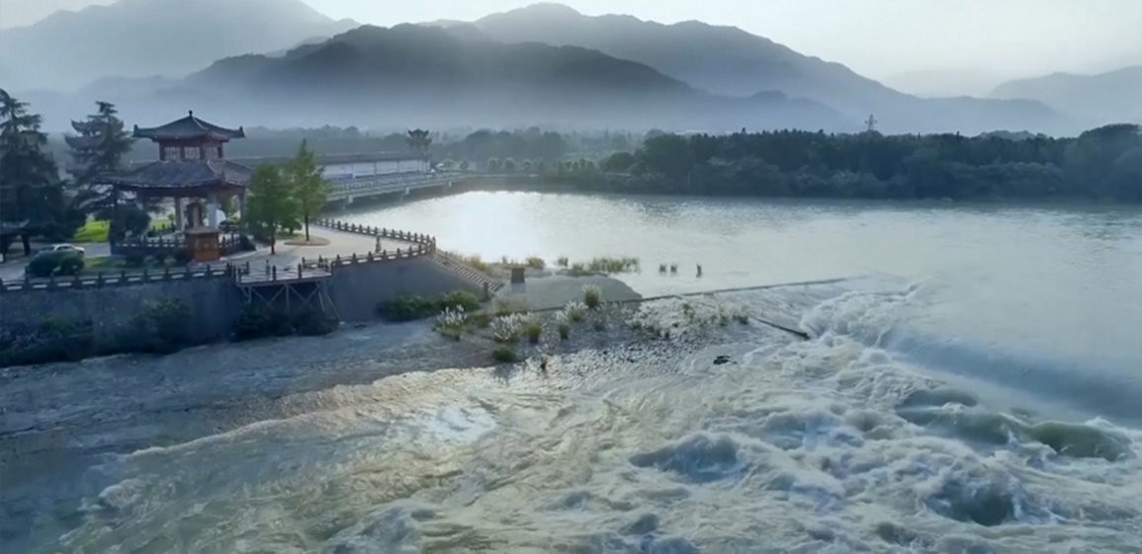[](https://www.nsed.gov.hk/national_security/index.php?l=en&a=national_security_main_focus)**Part 1 – Warm-up Activities**

1. Watch the following video from *The China Current* and answer the questions that follow.

[*https://chinacurrent.com/story/23586/conserving-water-for-thousands-of-years*](https://chinacurrent.com/story/23586/conserving-water-for-thousands-of-years)

***Conserving Water for Thousands of Years***

|  |  |  |
| --- | --- | --- |
|  |  |  |
|  |  |  |
|  |  |  |
|  |  |  |
|  |  |  |
|  |  |  |
|  |  |  |

1. Before exploring the topic, write down in the box below what you know about resource security.

You may refer to the webpage on “Major Fields of National Security” ([*https://www.nsed.gov.hk/national_security/index.php?l=en&a=national_security_main_focus*](https://www.nsed.gov.hk/national_security/index.php?l=en&a=national_security_main_focus)) for some ideas.

1. Based on the information in the video, fill in the blanks in the fact sheet below.

|  |  |
| --- | --- |
| About Dujiangyan | |
| Location | (a) province |
| Year of construction | Around (b) f |
| Significance of Dujiangyan | The Dujiangyan is an irrigation system and the oldest water conservancy in the world. The waterworks does not only serve as a (c) , it also leverages the power of (d) to channel and divide the water to solve different problems during different (e) . Dujiangyan embodies the wisdom and innovation China adopts in water conservation. |

1. Identify two water-related problems the communities surrounding Dujiangyan experienced.



**Problem 1:**



**Problem 2:**

1. How does Dujiangyan safeguard the resource security of China?

|  |  |  |
| --- | --- | --- |
|  |  |  |
|  |  |  |
|  |  |  |
|  |  |  |
|  |  |  |
|  |  |  |

**Part 2 – Group Interaction**

Situation: Your class is preparing a presentation on resource security and your group has decided to focus on resource security. Your group has found some relevant information online about water in the Mainland and Hong Kong. Read the texts below and **conduct a 10 to 15-minute discussion in groups of 3-4**. You may make use of information from the video in Part 1 and the texts below and jot notes in the space provided.

**Resource security safeguarded with innovative water policy in China**

Executives from international organisations have spoken highly of China’s achievements in water resources management as they attended the 18th World Water Congress, saying “China is an example of innovative and proactive water policy.” Some remarkable achievements in the past decade include:

|  |  |  |
| --- | --- | --- |
| China’s reservoir storage capacity has increased by 163.2 billion cubic meters. | The average proportion of GDP losses caused by floods in the country over the past decade has fallen from 0.51% to 0.24% in the previous decade. | 90% of the country’s rural residents now have access to tap water. |

Issues such as water scarcity, uneven water distribution and excessive water consumption do not only threaten people’s lives and property but also hinder the socio-economic development of the country. To address the mismatch between water resource distribution and productivity, rural water supply programmes have been launched to ensure direct access to drinking water for nearly China’s entire population. To optimise water resource allocation, a national water network is set to be constructed to establish a unified national water market and smooth domestic circulation, and to promote coordinated regional development. Digital technologies are also being explored to further improve network system monitoring and enhance resource security.

**Text A**

Information taken from: <https://www.chinadaily.com.cn/a/202403/18/WS65f81f69a31082fc043bd443.html>

<https://www.chinadaily.com.cn/a/202305/27/WS64716ebba310b6054fad55e4.html>

<https://www.chinadaily.com.cn/a/202309/14/WS65027241a310d2dce4bb5af1.html>

**Water issues in Hong Kong**

Given the limited local yield of fresh water in Hong Kong, the Water Supplies Department (WSD) has endeavoured to secure an adequate water supply through various means. For example, Dongjiang water has been imported since 1965 to meet local water demand. In 2022, 58% of the total water consumption was imported. WSD has also devoted significant efforts to promoting water conservation. The “Let’s Save 10L Water” Campaign was launched in 2014 and the “Let’s Save 10L Water 2.0” Campaign has been in place as a continuation since 2019 to engage the general public in reducing water consumption. The latest campaign features a number of initiatives, for example, the use of flow controller for water taps, a 4-minute shower challenge, and an innovative water efficient shower head design competition. At the school level, WSD strives to cultivate a water conservation culture among the younger generation through competitions and activities such as the “Cherish Water Campus” initiative and teaching resources like the “Water: Learn & Conserve” e-learning platform.

Water is limited but the demand continues to grow. Only through concerted effort can we ensure sustainable water supply for everyone. The government has taken proactive measures to safeguard water security, so it’s time for citizens to start conserving water in our daily lives.

**Text B**

Information from the WSD website: <http://www.waterconservation.gov.hk/en/home/index.html>



**Discussion Topic:**

Your group is going to discuss the importance of water conservation in safeguarding resource security in our country. You may want to talk about:

* the importance of resource security, particularly water security, to our country
* what our country and Hong Kong have done to safeguard resource security through ensuring water security
* what the school can do to raise students’ awareness of the need to save water and safeguard our country’s resource security
* what we can do to save water and safeguard our country’s resource security
* anything else you think is important

**Notes**

**Part 3 – Individual Response**

In this part, each of the group members will take turn to **give a short speech of about one minute** on one of the following questions.

1. What can you and your family do to save water at home?
2. Why do you think we need to save water?
3. How does conserving water resources contribute to the resource security of our country?
4. Li Guoying, China’s Minister of Water Resources, remarked at the 2023 UN Water Conference in New York, “We should respect the right of rivers to survive in nature, treat water as living entities, develop river ethics, protect rivers’ healthy life and achieve a harmonious coexistence between human and river.” What are your views on what he said?