

**Water Conservation**

Teacher Version

|  |  |  |  |
| --- | --- | --- | --- |
| **Major Field of National Security** | **Module** | **Unit** | **Topic** |
| Resource Security | Nature and Environment | Protecting the Environment | Water Conservation |

**Suggested Levels: S4-6**

**Summary of the Learning Topic:**

The learning topic aims to guide students to understand the importance of safeguarding the resource security of our country, and how this can be achieved through conserving water resources with a national water network and deliberate policies and strategies adopted in China and Hong Kong.

**Learning Objectives:**

**Content**

To explore and develop understanding of the following:

* the importance of safeguarding the resource security of our country;
* the policies and strategies implemented to safeguard resource security in our country; and
* our responsibility for safeguarding the resource security of our country and how students can raise their schoolmates’ awareness of resource security at school.

**Language**

To develop English language knowledge and skills, e.g.

* the use of passive voice to place emphasis on the process, action and/or outcome;
* the use of *to*-infinitive clauses to express purposes and objectives; and
* the use of a variety of sentence patterns to give reasons and provide examples.

**Learning Tasks:**

* **Part 1 – Warm-up Activities:** Students understand how an ancient China irrigation system has addressed the imbalance of water resources distribution through a video.
* **Part 2 – Group Interaction:** Students participate in a group discussion about the issue of resource security in China.
* **Part 3 – Individual Presentation:** Students respond to a question relating to the issue of resource security.

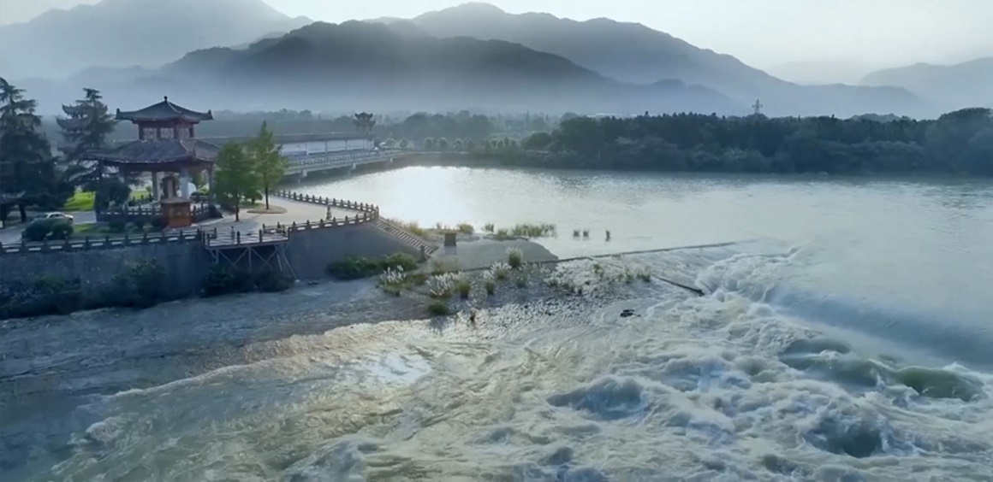[](https://www.nsed.gov.hk/national_security/index.php?l=en&a=national_security_main_focus)**Part 1 – Warm-up Activities**

|  |  |  |
| --- | --- | --- |
|  | * Resource security is about ensuring a sustainable and stable supply of necessary natural |  |
|  | resources. |  |
|  | * Resource security is the foundation of economic and social development. |  |
|  | * Resource security covers aspects such as energy resources, mineral resources, water |  |
|  | resources, land resources and environmental resources. |  |
|  |  |  |

1. Before exploring the topic, write down in the box below what you know about resource security.

You may refer to the webpage on “Major Fields of National Security” ([*https://www.nsed.gov.hk/national_security/index.php?l=en&a=national_security_main_focus*](https://www.nsed.gov.hk/national_security/index.php?l=en&a=national_security_main_focus)) for some ideas.

1. Watch the following video from *The China Current* and answer the questions that follow.

[*https://chinacurrent.com/story/23586/conserving-water-for-thousands-of-years*](https://chinacurrent.com/story/23586/conserving-water-for-thousands-of-years)

Suggested answers:

***Conserving Water for Thousands of Years***

1. Based on the information in the video, fill in the blanks in the fact sheet below.

|  |  |
| --- | --- |
| About Dujiangyan | |
| Location | (a) Sichuan province |
| Year of construction | Around (b) 256 BC |
| Significance of Dujiangyan | The Dujiangyan is an irrigation system and the oldest water conservancy in the world. The waterworks does not only serve as a (c) dam , it also leverages the power of (d) nature to channel and divide the water to solve different problems during different (e) seasons . Dujiangyan embodies the wisdom and innovation China adopts in water conservation. |

1. Identify two water-related problems the communities surrounding Dujiangyan experienced. (in any order)

flooding



**Problem 1:**

sand drainage



**Problem 2:**

1. How does Dujiangyan safeguard the resource security of China?

|  |  |  |
| --- | --- | --- |
|  | The irrigation system safeguards resource security of China by improving water |  |
|  | resources management through controlling the water flow during different seasons to |  |
|  | ensure a more stable, reliable and effective water supply for millions of people who live |  |
|  | in the area. |  |
|  |  |  |

**Part 2 – Group Interaction**

Situation: Your class is preparing a presentation on resource security and your group has decided to focus on resource security. Your group has found some relevant information online about water in the Mainland and Hong Kong. Read the texts below and **conduct a 10 to 15-minute discussion in groups of 3-4**. You may make use of information from the video in Part 1 and the texts below and jot notes in the space provided.

**Water issues in Hong Kong**

Given the limited local yield of fresh water in Hong Kong, the Water Supplies Department (WSD) has endeavoured to secure an adequate water supply through various means. For example, Dongjiang water has been imported since 1965 to meet local water demand. In 2022, 58% of the total water consumption was imported. WSD has also devoted significant efforts to promoting water conservation. The “Let’s Save 10L Water” Campaign was launched in 2014 and the “Let’s Save 10L Water 2.0” Campaign has been in place as a continuation since 2019 to engage the general public in reducing water consumption. The latest campaign features a number of initiatives, for example, the use of flow controller for water taps, a 4-minute shower challenge, and an innovative water efficient shower head design competition. At the school level, WSD strives to cultivate a water conservation culture among the younger generation through competitions and activities such as the “Cherish Water Campus” initiative and teaching resources like the “Water: Learn & Conserve” e-learning platform.

Water is limited but the demand continues to grow. Only through concerted effort can we ensure sustainable water supply for everyone. The government has taken proactive measures to safeguard water security, so it’s time for citizens to start conserving water in our daily lives.

**Text B**

Information from the WSD website: <http://www.waterconservation.gov.hk/en/home/index.html>

**Resource security safeguarded with innovative water policy in China**

Executives from international organisations have spoken highly of China’s achievements in water resources management as they attended the 18th World Water Congress, saying “China is an example of innovative and proactive water policy.” Some remarkable achievements in the past decade include:

|  |  |  |
| --- | --- | --- |
| China’s reservoir storage capacity has increased by 163.2 billion cubic meters. | The average proportion of GDP losses caused by floods in the country over the past decade has fallen from 0.51% to 0.24% in the previous decade. | 90% of the country’s rural residents now have access to tap water. |

Issues such as water scarcity, uneven water distribution and excessive water consumption do not only threaten people’s lives and property but also hinder the socio-economic development of the country. To address the mismatch between water resource distribution and productivity, rural water supply programmes have been launched to ensure direct access to drinking water for nearly China’s entire population. To optimise water resource allocation, a national water network is set to be constructed to establish a unified national water market and smooth domestic circulation, and to promote coordinated regional development. Digital technologies are also being explored to further improve network system monitoring and enhance resource security.

**Text A**

Information taken from: <https://www.chinadaily.com.cn/a/202403/18/WS65f81f69a31082fc043bd443.html>

<https://www.chinadaily.com.cn/a/202305/27/WS64716ebba310b6054fad55e4.html>

<https://www.chinadaily.com.cn/a/202309/14/WS65027241a310d2dce4bb5af1.html>



**Discussion Topic:**

Your group is going to discuss the importance of water conservation in safeguarding resource security in our country. You may want to talk about:

* the importance of resource security, particularly water security, to our country

Possible ideas:

* Resource security is the foundation of economic and social development and social stability.
* Issues like water scarcity, uneven water distribution and over water consumption threaten people’s lives and property and socio-economic development of the country. Resource security must be safeguarded for the livelihood of the people, stability and prosperity of our country.
* what our country and Hong Kong have done to safeguard resource security through ensuring water security

Possible ideas:

Our country and Hong Kong have implemented different policies to ensure a stable and adequate water supply to safeguard resource security.

|  |  |
| --- | --- |
| **Our country** | **Hong Kong** |
| * Our country has funded rural water supply programmes to ensure people’s direct access to drinking water. * Our country has planned to construct a national water network to establish a unified national market, smoothen domestic circulation, and promote coordinated regional development. * Our country continues to explore digital technologies to enhance network system monitoring. | * Hong Kong has imported Dongjiang water to secure an adequate water supply. * Campaigns have been run in Hong Kong to engage the general public in reducing the consumption and waste of water. * Hong Kong has devoted efforts to cultivating a water conservation culture in the younger generation through competitions and activities such as the “Cherish Water Campus” initiative and teaching resources like the “Water: Learn & Conserve” e-learning platform. |

* what the school can do to raise students’ awareness of the need to save water and safeguard our country’s resource security

Possible ideas:

* organising “Water Saving Week”
* devising a water saving plan/water-efficient action plan
* conducting a cross-curricular project to invent a water saving device
* organising visits to the H2OPE Public Education Centre/waterworks installations (e.g. Ma On Shan Water Treatment Works)/the Ex-Sham Shui Po Service Reservoir (Ex-SSPSR)
* joining in the “Water Cherish Campus” initiative
* making effective use of the “Water: Learn & Conserve” e-learning platform



Teacher’s notes:

Suggested language items and sentence patterns for different communicative purposes:

|  |  |
| --- | --- |
| **Language items** | **Communicative purposes & examples** |
| 1. **Passive voice** | **To highlight and emphasise the process, action and/or outcome**   * China’s effort in water conservation was highly praised by executives from international organisations in the 18th World Water Congress. * Resource security must be safeguarded for the livelihood of the people and development of the country. |
| 1. ***to*-infinitive clauses** | **To express purposes and objectives**   * Digital technologies are also being explored to further improve network system monitoring and enhance resource security. * To address the mismatch between water resource distribution and productivity, rural water supply programmes have been launched to ensure direct access to drinking water for nearly the entire population of China. |

|  |  |
| --- | --- |
| **Communicative purposes** | **Suggested sentence patterns** |
| 1. **Provide examples** | * China has implemented innovative and proactive policies to conserve water resources. For example/For instance, rural water supply projects were planned nationally to improve citizens’ direct access to drinking water. * Hong Kong has organised activities and educational resources to cultivate a water saving culture in schools. One example is the “Cherish Water School” Initiative in kindergartens and primary schools and another is the interactive e-learning platform for secondary students. |

* what we can do to save water and safeguard our country’s resource security

Possible ideas:

* changing water consumption habits (e.g. taking a shower instead of a bath, taking shorter showers, turning off the tap while brushing teeth or soaping hands, reusing and recycling water)
* studying “Water Efficiency Labels” to choose water efficient products
* anything else you think is important

**Part 3 – Individual Response**

In this part, each of the group members will take turn to **give a short speech of about one minute** on one of the following questions.

1. What can you and your family do to save water at home?

Possible ideas:

|  |  |
| --- | --- |
| * taking a shower instead of a bath * take shorter showers * installing flow controller on water taps * washing vegetables and fruits in a basin | * running washing machine with a full load * reusing water (e.g. watering plants with water used for washing rice) |

1. Why do you think we need to save water?

Possible ideas:

|  |  |
| --- | --- |
| Water scarcity:   * Water is a limited resource. Overconsumption of water can cause water shortages. Saving water can help reduce water demand and conserve water resources. | Environmental protection:   * Water is essential for wildlife. Saving water can help protect the ecosystems and biodiversity of aquatic and wetland animals. |
| Energy saving:   * Energy is required for treatment, pumping and distribution of water. Saving water can help save energy and reduce our carbon footprint. | Money saving:   * Saving water can save money on water bills. * Saving water can reduce the cost of water treatment and distribution. |

1. How does conserving water resources contribute to the resource security of our country?

Possible ideas:

* Water scarcity is one of the issues the whole world is facing. Conserving water resources helps ensure a more stable, reliable and effective supply of water resources for domestic, agricultural, and industrial uses, which is pivotal to people’s livelihood and the socio-economic development of our country.

1. 2025 marks the 60th anniversary of Dongjiang water supply to Hong Kong. What is the significance of Dongjiang water supply to Hong Kong people?

Possible ideas:

* Dongjiang water supply helps resolve the problem of water scarcity in Hong Kong. The supply reflects our country’s tremendous and ongoing support to Hong Kong and helps ensure the quality and quantity of water resources for sustainable social and economic development.

Teachers’ notes

* Dongjiang water was first diverted through mountains and valleys into the Hong Kong waterways, resolving the prolonged water scarcity that had plagued the city. The country expanded and upgraded the water supply system three times. Today, Dongjiang water accounts for over 70% of Hong Kong's freshwater supply.