Fresh Fruit and Vegetable Stall
Do you like eating fruit and vegetables? You will write about a Fresh Fruit and Vegetable Stall with the help of pictures and listening activity.

Part 1
What are your favourite fruit and vegetables? Draw and write them down in the table below. Follow the example.
e.g. carrots

Part 2
Aunt Mary is going to tell you the fruit and vegetables she can see on a stall. Listen and complete the picture of the stall.
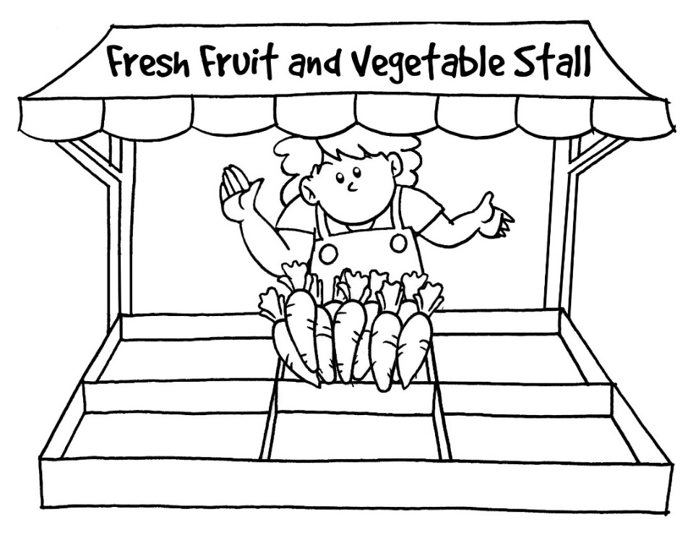

Part 3
Write about the stall and ask your friends to buy some fruit and vegetables. Follow the example.
(e.g.) This is Fresh Fruit and Vegetable Stall. Mrs Chan is a friendly and helpful
owner.

Source of the materials:
The materials were selected and adapted from the resource package “Using Dictation to Develop Pupils’ Listening and Writing Skills (CDI, EDB, 2011)”. (https://cd.edb.gov.hk/eng/dict/index.html)

Suggested answers
Part 1
Accept any reasonable answers

Part 2
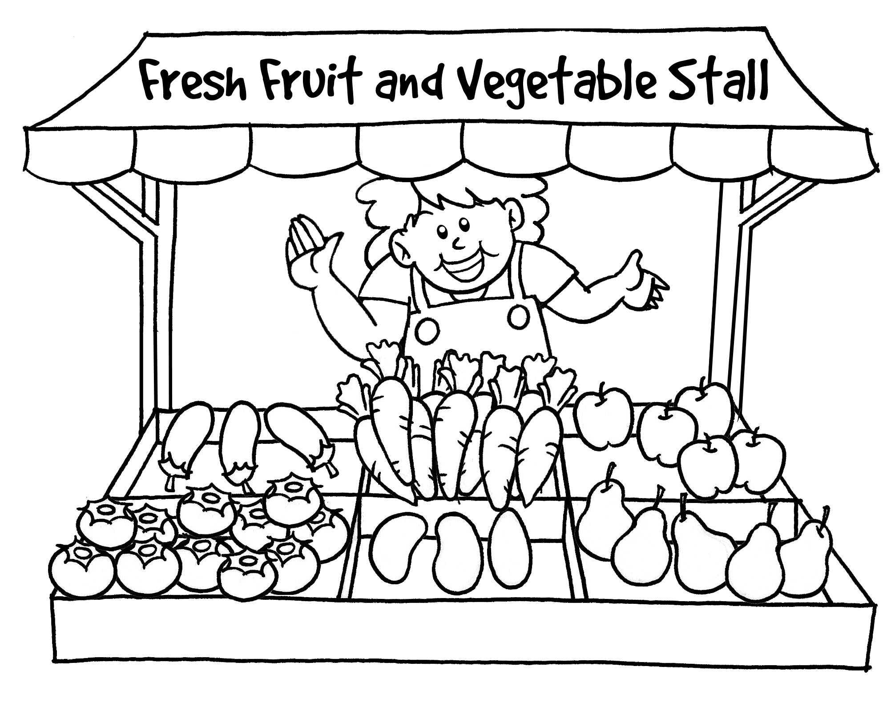

Script

(Audio Clip No. 8)
Fresh Fruit and Vegetable Stall
Aunt Mary is going to tell you the fruit and vegetables she can see on a stall. Listen and complete the picture of the stall.

- Mrs Chan is the owner of Fresh Fruit and Vegetable Stall. She is helpful and friendly. She always smiles.
- There are many carrots in front of Mrs Chan.
- There are some apples on the right of the carrots.
- There are a few eggplants next to the carrots.
- There are some pears in front of the apples.
- There are a few mangoes next to the pears.
- There are many tomatoes on the left of the mangoes.

An 8-second pause for drawing different parts of the picture

Part 3:
Accept any reasonable answers

(e.g.) This is Fresh Fruit and Vegetable Stall. Mrs Chan is a friendly and helpful
owner. There are some apples on the right of the carrots. They are red and big.
There are a few eggplants next to the carrots. They are purple. Do you like eating
mangoes and pears? The pears are sweet and soft. The mangoes are big and juicy
too! Please buy some for your family. There are many tomatoes at the stall. You
can also buy some tomatoes and carrots to cook a soup. They are sweet and
good for your health!

