Join Our Club

Think about the clubs in your school. Which ones would you like to join? Why? In this assessment paper, you will write about the clubs that you would like to join with the help of the listening activities.

Part 1 You are going to hear the names of some clubs in Tom’s school. Decide which group they belong to and write them in the boxes of the tree diagram below.

Clubs in Tom’s school
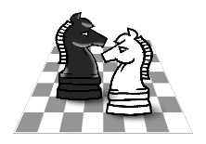

Sports

(e.g.) Swimming Club

Interest groups
(Hobbies)

Academic
(Subject-related)

Art and Music

Part 2 Think about the clubs in your school and write them in the boxes below.

Clubs in my school

Sports

Interest groups
(Hobbies)

Academic
(Subject-related)

Art and Music

Part 3 Four students are talking to David, a student helper, about their interests and hobbies.
Pet Club
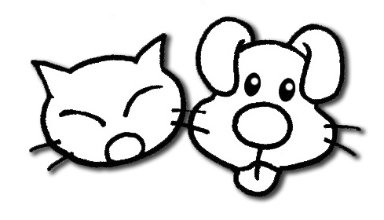
Art Club
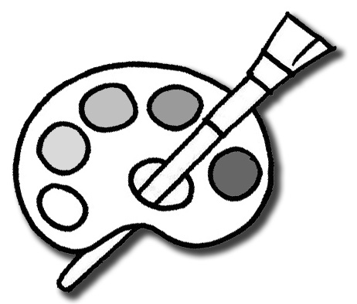
Take notes about what you hear and write down the most suitable clubs for them. The first one has been done for you as an example.

Sports Club

Music Club
English Club
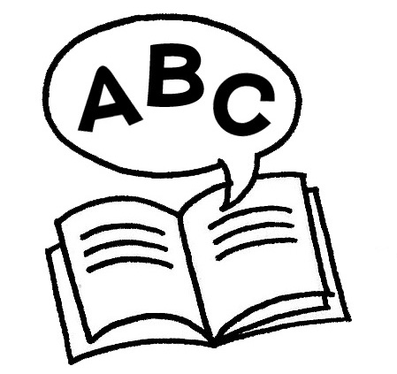
Drama Club

Example

Name: Eric Fong
Interests:
- ____________
- ____________
- ____________
Which is the best club for him / her?
__________________________
Name: Eva Choi
Interests:
- ____________
- ____________
- ____________
Which is the best club for him / her?

Name: Joanne Lee
Interests:
- ____________
- ____________
- ____________
Which is the best club for him / her?
_________________________
Name: Martin Wong
Interests:
- drawing
- Putonghua
- taking care of pets
Which is the best club for him / her?
Pet Club
Part 4 Choose two clubs that you would like to join in school. Write a few sentences to explain why you want to join them. The words and phrases in the box may help you. Follow the example.
I want to join … because I like / enjoy …
I also want to improve / learn / do better …

(e.g.) I want to join the English Club because I enjoy listening to English songs and stories. I also want to improve my English results.
1.

2.

Source of the materials:
The materials were selected and adapted from the resource package “Using Dictation to Develop Pupils’ Listening and Writing Skills” (CDI, EDB, 2011). (https://cd.edb.gov.hk/eng/dict/index.html)

Answer Key:
Part 1

Clubs in Tom’s school

Sports

(e.g.) Swimming Club
Badminton Club

Interest groups
(Hobbies)
Cooking Club
Chess Club

Academic
(Subject-related)
English Club
Maths Club

Art and Music

Art Club
Music Club

Script
(Audio Clip No. 5)
Join Our Club
Part 1: You are going to hear the names of some clubs in Tom’s school. Decide which group they belong to and write them in the boxes of the tree diagram below.

Tom: Hello, I’m Tom. I’d like to tell you about the clubs in my school. We have different kinds of clubs, for example, clubs about sports, interest groups, academic subjects as well as art and music. This year, I joined the Swimming Club, which is a club about sports. I like painting, so I joined the Art Club. I also took part in the English Club to improve my English. Cooking is my favourite hobby. That’s why I joined the Cooking Club. Next year, I want to join four new clubs. They are the Music Club, the Badminton Club, the Maths Club and the Chess Club. How about the clubs in your school?

An 8-second pause for writing the answer

Part 2 (Accept any reasonable answers.)
Part 3

Example

Name: Joanne Lee
Interests:
- English
- Maths
- Art
Which is the best club for him / her?
Art Club
Name: Martin Wong
Interests:
- drawing
- Putonghua
- taking care of pets
Which is the best club for him / her?
Pet Club

Script
Name: Eva Choi
Interests:
- painting
- gardening
- drama
Which is the best club for him / her?
Drama Club
Name: Eric Fong
Interests:
- music
- reading
- sports
Which is the best club for him / her?
Sports Club
P.3
(Audio Clip No. 6)
Join Our Club - Extended Activity 1
Four students are talking to David, a student helper, about their interests and hobbies. Take notes about what you hear and write down the most suitable clubs for them. The first one has been done for you as an example.
Example
David: | Hi, I’m David, your student helper. What’s your name?
Martin: | Hello! My name is Martin Wong.
David: | You look puzzled. Can I help you?
Martin: | Yes, please help me choose a suitable club. I like drawing and I also like Putonghua. But I like pets most of all. I want to take good care of my pet.
David: | I think you should choose …
Conversation 1
David: | Hello! I’m your student helper, David. What can I do for you?
Joanne: | Hi! I’m Joanne. I don’t know which club I should choose.
David: | What are your interests?
Joanne: | Well, I have many interests. I like learning English and doing Maths, but I like Art best. I really want to improve my drawing.
David: | OK, I think you should choose …
Conversation 2
David: | Hi, Eric! How are you?
Eric: | Hi, David! I’m fine. It’s nice to see you here.
David: | I’m a student helper. Can I help you?
Eric: | Oh, yes please! I want to join a good club, but I have too many interests. I like music and reading. I also enjoy playing different sports.
David: | Do you have any new plans this year?
Eric: | Yes, I want to play more sports this year because I want to keep fit.
David: | I see. You should join …
Conversation 3
David: | Hello, I’m a student helper. May I help you?
Eva: | Hi! I’m Eva. I have no idea which club I should choose. I like painting and I enjoy gardening too. I also like drama because I want to act in a play. I joined the Art Club and the Gardening Club last year.
David: | That’s easy. You should join a new club this year …
A 5-second pause for writing the answer

Part 4 (Accept any reasonable answers.)

