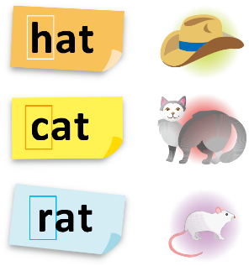
Worksheets on Phonics

Suggested levels: P4-6
(Adapted from the resource kit “Teaching Phonics at Primary Level”, English Language
Education Section, CDI, EDB)

Consonants

K, c, r are consonant letters. They are produced by a stoppage of breath.
Other examples: b (bird), d (dance), f (fun), h (hungry)

Can you think of other examples of consonant letters?

Learning Activity for Consonants

Guess and Create

- Read the following riddle aloud. Do you know the answer to this riddle?

Until I am measured,
I am not known.
Yet how you miss me,
When I have flown!
What am I?

The answer is: ________________________

- Write the beginning letter of the answer here:

- Read the following word steps describing a ball. Do you notice anything special about the words in the word steps?
ball

big ball

Bob’s big ball

Borrow Bob’s big ball

D. Create another word steps. Add a new word beginning with the same consonant sound of the answer to the riddle in Part A. Remember that every word added should make sense to the meaning of the whole expression.

Letter-sound Word Steps –

Consonant Digraphs

A consonant digraph is a single sound which is represented by two consonant letters.
Examples: ch (chair), wh (where), sh (ship), ck (rock)

Can you think of other examples of consonant digraphs?

Learning Activity for Consonant Digraphs

Consonant Digraphs Hunt

- Study the pictures “At the Supermarket”
and “At School” carefully.

2. Find four items in each picture which are spelt with consonant digraphs.
(e.g. At the Supermarket: “a shelf”; At
School: “some chairs”).

3. Write the words in the note sheet provided.

Note Sheet

“At the Supermarket” | “At School”

“At the Supermarket”
____________33

“At School”

Can you think of other items that can be found at school or the supermarket beginning with a consonant digraph?

At the Supermarket At School

Consonant Blends

A consonant blend is the blended sound represented by two or three consonant letters.
Examples: bl (black), dr (draw), cr (cream), st (stand)

Can you think of other examples of consonant blends?

Learning Activity for Consonant Blends

Phonics Bingo

- Invite your family members to play with you.

- Assign one of the family members to read aloud the consonant blends one by one in each round.

- Circle the words which contain the consonant blends read aloud by your family member.

- Shout out “Bingo!” if you have all words circled diagonally, across a row or vertically in a column.

Vowels - Short Vowels

The following are examples of short vowel letters.
a (gas) e (well) i (hit)

Can you think of other examples of short vowels?

Learning Activity for Short Vowels

Phonics Da Vinci: Create an artwork displaying words containing the same short vowel sound

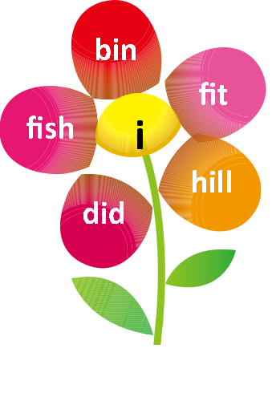

- Decide on the short vowel sound to focus on.
- Choose one of the objects below for creating an artwork for display.
e.g. a butterfly, a peacock, the sun, a windmill, a palm, a caterpillar, a fish
- Write the short vowel sound in the centre/appropriate space in the picture of the object.
- Write the words containing the respective short vowel sound on the other parts of the object.
- Colour/decorate the picture after writing the words.

Phonics Da Vinci

Phonics Da Vinci

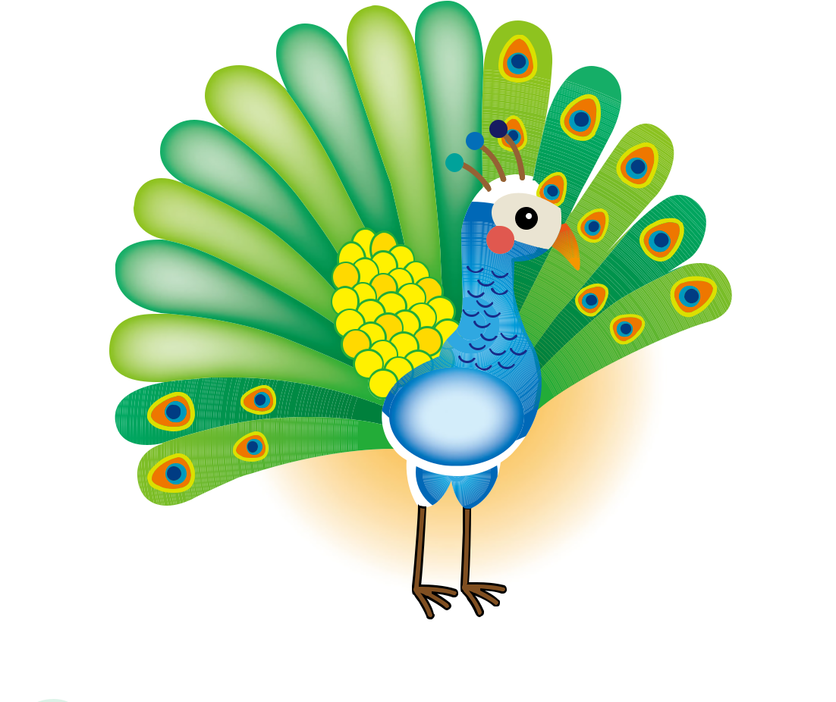

Phonics Da Vinci

Phonics Da Vinci

Phonics Da Vinci

Phonics Da Vinci
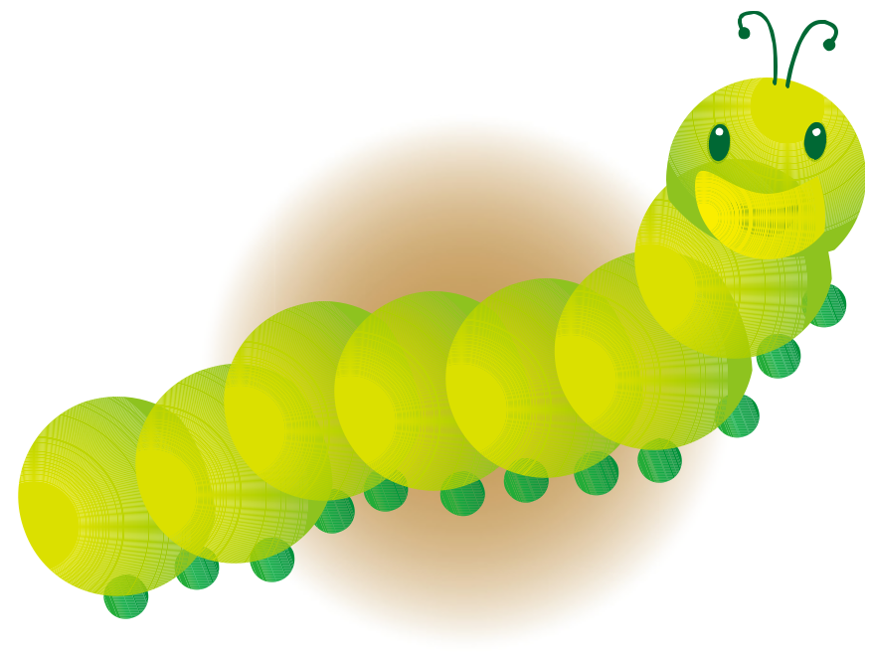

Phonics Da Vinci

Vowels - Long Vowels

A long vowel is a vowel that is pronounced the same as the name of the letter.
Examples: Long a: (ai) – paint, (ay) – pray
Long e: (ea) – mean, (ee) – sheep
Long o: (oa) – boat, (ow) – throw

Can you think of other examples of long vowels?

Learning Activity for Long Vowels

Magic e

A “Magic e” makes the letters “a”, “e”, “i”, “o”, “u” say their own names when the letter “e” is added after a consonant which follows a vowel.
Examples: Long a (age), Long i (wine), Long u (tube)

Learning Activity for Magic e

Careless Pete and Puzzled Grace

A. Pete has written a letter to his wife, Grace, from summer camp. However, he is very careless and has made some spelling mistakes. Grace feels very puzzled when she receives the letter. Help Grace understand the letter by finding out Pete’s spelling mistakes, circling them and writing down the correct words. The first one has been done for you as an example.
Suggested answers for learning activities

Consonants – Guess and Create
- Time
- T
- All the words begin with the consonant sound "b".
- Letter-sound Word Steps - T: "Tim took ten tests today."

Consonant digraphs – Consonant Digraph Hunt

At the Supermarket
Some shelves, a fish, some cheese, potato chips, a tooth brush

At School
Some chairs, a piece of chalk, a Math textbook, a whistle, a chart

Other items that can be found at the supermarket and at school:
Supermarket: shampoo, washing powder, toothpaste, cashier
School: pencil sharpener, chess, class photo

Consonant blends – Phonics Bingo
N.A.

Short vowels – Phonics Da Vinci
Students’ own design.

Long vowels – Phonics Tic-Tac-Toe
(from left to right)
1st row: “meal”; “Mary used the green oven to bake the pumpkin toast with cheese.”; “smoke” & “home”
2nd row: “beef”; “iron” & “nine”; “school, tooth, food, mood” or any acceptable answers
3rd row: “idea & iron, duty & music, table & radio”; “seats, please” or any acceptable answers; “mail”

Magic e – Careless Pete and Puzzled Grace
Part A

My dear wife,
How are you? I hope you’re well.
I’m having a very good time at summer camp. The weather here is fine every day.
I have made a nice kite in the shape of a cute bird. I’ll fly it with you when I come home.
Love,
Pete

Part B
cage, plane, delete, complete, pipe, mile, coke, cone, tube

