Suggested Key Stage: KS1
Assessment Tasks
Notes to Teachers
Design of the Assessment Paper
This set of assessment paper, which consists of four parts, is designed under the theme ‘Maintain Cough Manners’. The thematically-linked tasks aim to assess students’ mastery of the four language skills in a meaningful and interesting context.
Brief Description of the Paper
Reading Part
- The reading part involves reading a text about various ways to prevent pneumonia and respiratory tract infection, and then solving a word puzzle.
Speaking Part
- This part includes a speaking task which requires students to give advice to a classmate on various health conditions, with reference to the information in the text on good cough manners.
Listening Part
- This part includes a listening task in which students are required to watch two video clips, and sequence the steps of wearing and taking off masks properly.
Writing Part
- The writing part assesses students’ communication skills and creativity. It includes making a bookmark with two rules of their own choice to remind their classmates on ways to prevent infection in school. This writing activity involves the use of information from the previous reading, listening or speaking task.
Adaptation of the Paper
This set of assessment paper contains questions of different levels of difficulty. Schools are encouraged to modify or adapt the design and contents of the paper according to their students’ needs and existing assessment practices. The following are suggestions on marks and time allocation:
- Reading 30% (20 minutes)
- Speaking 20% (5 minutes per student)
- Listening 20% (20 minutes)
- Writing 30% (10 minutes)
Do you want to be the hygiene pioneer of your class to help teachers promote the prevention of infection in school? Finish the following tasks and you will become one of them!
Reading Part
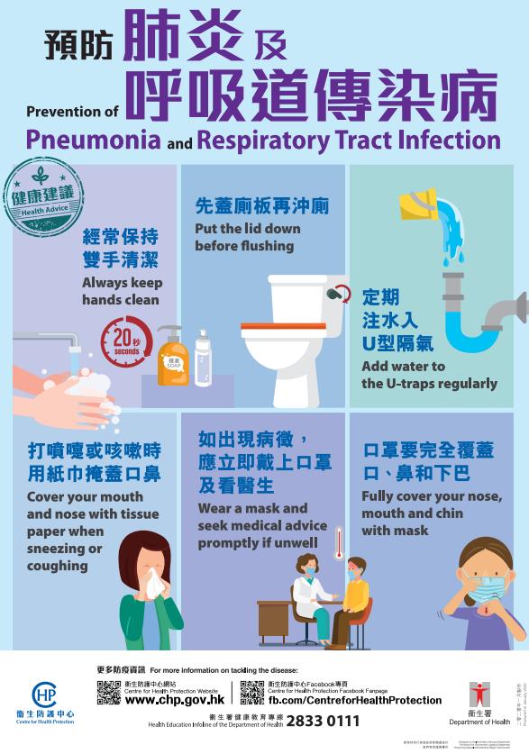
Task A: Read the poster ‘Prevention of Pneumonia and Respiratory Tract Infection’. Then solve the word puzzle below.

Read the following questions. Find the best word(s) from the above text to solve the word puzzle. After solving the puzzle, you will have better ideas on the prevention of infection in school.
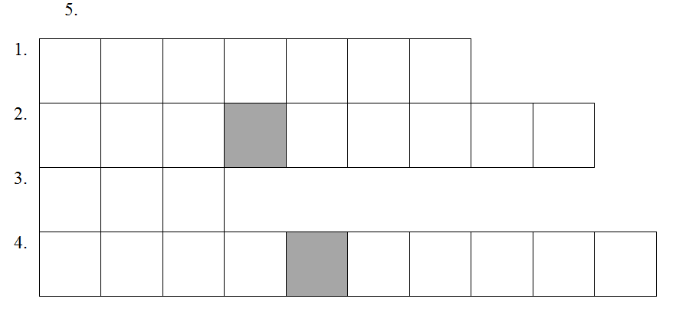
Question 1:
What advice do we seek if we are unwell? ______________ advice.
Question 2:
What do we do to the U-trap in the toilet? ___________ _____________ to the U-trap.
Question 3:
How many ways can we do to stop us from having infection easily? At least _____ ways.
Question 4:
What do we always do with our hands? _____________ our hands ________________.
Question 5:
What do we use to cover our nose, mouth and chin when we are unwell? ____________.

Speaking Part
Task B: To be the hygiene pioneer of your class, you have to give advice to your classmates. Use the information in the poster ‘Maintain Cough Manners’ to tell a classmate the correct way to do in the given health conditions.
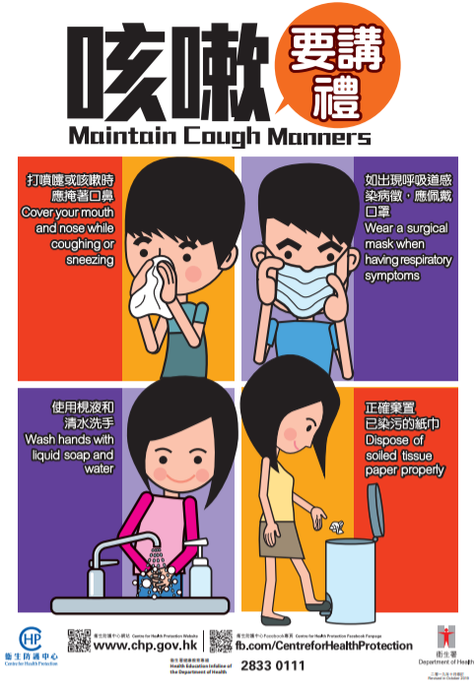
Read the health conditions in the speech bubbles below. Use the information from the above poster to give some advice to your classmate.
1.
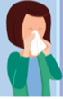
I have a bad cold. I am coughing and sneezing. What do I do now?

…

2.

After coughing and sneezing, what do I do with my hands?
…

3.

My throat is still unwell and I cough a lot. What do I do now?
…

Listening Part
Task C: Proper use of masks is vital to prevent infection. As the hygiene pioneer of your class, you need to tell your classmates how to wear and take off masks properly. Scan the QR codes to watch the two video clips. Then sequence the steps with 1 to 4 below.
(a) How to wear a mask?

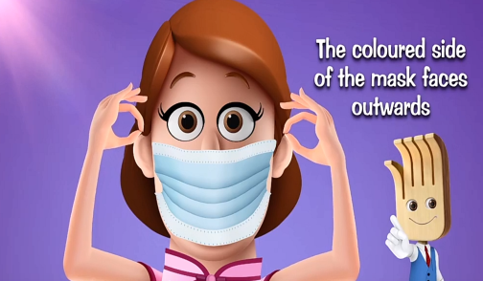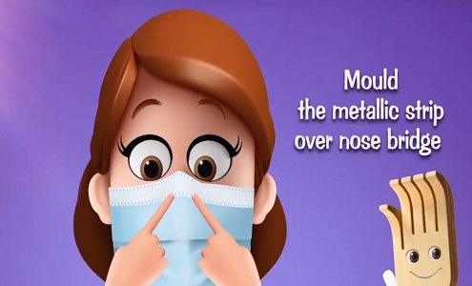
( ) ( )

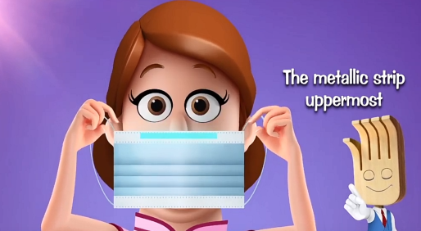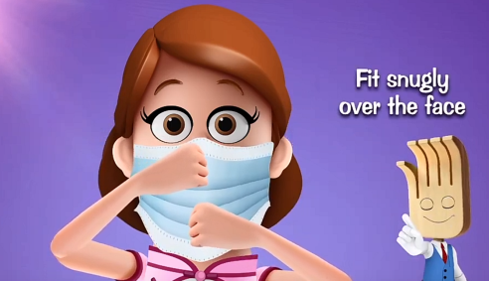
( ) ( )

(b) How to take off a mask?

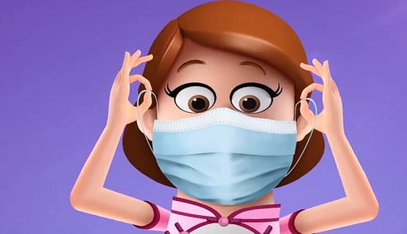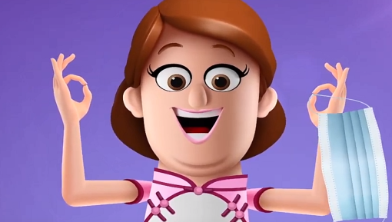
( ) ( )

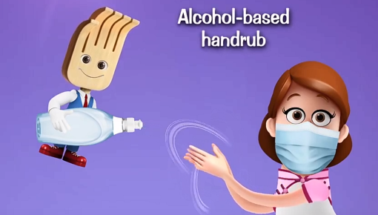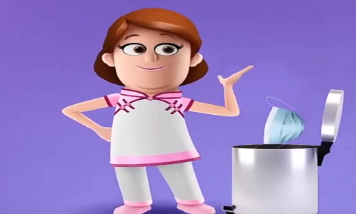
( ) ( )

Writing Part
Task D: Congratulations! You are now the hygiene pioneer of your class! Make a bookmark with at least two rules to tell your classmates how to prevent infection in school.

To:

Fr

Acknowledgements
Information and images / pictures in this set of materials are taken from the following resources from the Centre for Health Protection:
1. Infographic on ‘Prevention of Pneumonia and Respiratory Tract Infection’.
https://www.chp.gov.hk/files/pdf/pneumonia_respiratory_health_advice_abstract.pdf
2. Poster on ‘Maintain Cough Manners’.
https://www.chp.gov.hk/files/her/maintain_cough_manners.pdf
3. Video on ‘How to wear a surgical mask properly?’.
https://www.youtube.com/watch?v=6nmeMq1F50M&feature=youtu.be
4. Video on ‘How to take off a surgical mask properly?’.
https://www.youtube.com/watch?v=D9M57hycc7A&feature=youtu.be

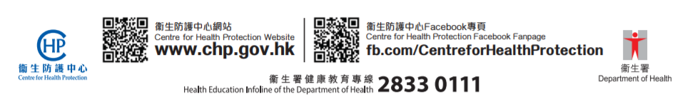

Suggested answers for teachers
Reading Part
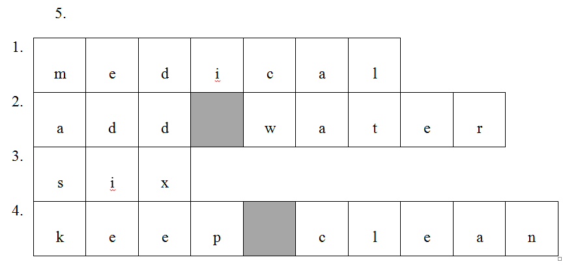

Speaking Part
1. Cover your mouth and nose when you cough or sneeze.
2. Wash hands with liquid soap and water.
3. Wear a mask when you feel unwell.

Listening Part
(a) How to wear a mask?

( 2 ) ( 4 )

( 1 ) ( 3 )

(b) How to take off a mask?

( 2 ) ( 3 )

( 1 ) ( 4 )

Tapescript
(a) How to wear a surgical mask properly
When you put on a mask, the metallic strip should be uppermost.
The coloured side of the mask faces outwards.
Position the elastic bands around both ears.
Mask should fit snugly over the face.
Extend it to cover fully the mouth, nose and chin.
Mould the metallic strip over nose bridge.

(b) How to take off a surgical mask properly
Before taking off the mask, wash your hands first.
Hold both the ear loops and take off the mask gently.
Avoid touching the outside of mask.
Then discard it in a lidded rubbish bin.
Remember to wash your hands immediately.
Masks should not be reused.
Replace the mask immediately if it is damaged or soiled.
Don’t hesitate to change your mask.

Writing Part (an example)
To: Tom

Fr
Wear a mask when feeling unwell!
Always keep hands clean!

