Suggested Key Stage: KS1
Assessment Tasks
Notes to Teachers
Design of the Assessment Paper
This set of assessment paper, which consists of four parts, is designed under the theme ‘Protect others from getting sick’. The thematically-linked tasks aim to assess students’ mastery of the four language skills in a meaningful context.
Brief Description of the Paper
Reading Part
- The reading part involves reading a poster on ways to protect others from getting sick. Students then complete a mind map by filling in the most suitable words taken from the text.
Listening Part
- This part includes a listening task in which students are required to watch a video clip about how to maintain drain pipes properly, and then complete the last part of the mind map.
Speaking Part
- This part includes a speaking task which requires students to read aloud a summary on various ways to protect others from getting sick, and to share their understanding and experience on how to maintain hygiene at home.
Writing Part
- The writing part assesses students’ communication skills. It includes writing a thank-you card to parents or their domestic helper for keeping the house hygienic.
Adaptation of the Paper
This set of assessment paper contains questions of different levels of difficulty. Schools are encouraged to modify or adapt the design and contents of the paper according to their students’ needs and existing assessment practices. The following are suggestions on marks and time allocation:
- Reading 30% (15 minutes)
- Speaking 20% (5 minutes per student)
- Listening 20% (5 minutes)
- Writing 30% (15 minutes)
Maintaining hygiene helps prevent illnesses. Do you know how to protect your family members from getting sick at home?
Reading Part
Task A: Read the poster ‘Protect others from getting sick’. Then complete item A to item C in the mind map by filling in the most suitable words taken from the text.
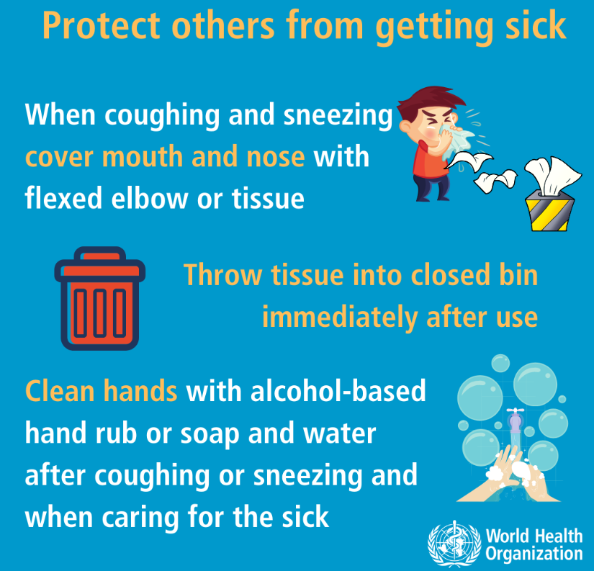

Listening Part
Task B: Watch the video clip ‘Maintain drain pipes properly’. Then complete item D in the mind map by filling in the most suitable words taken from the clip.
https://www.youtube.com/watch?v=H87eKouGF00

Protect others from getting sick
(A) Cough and sneeze
(A) Cover ___________ and ____________ with flexed elbow or a tissue.
(C) Hands
(C) _______________ hands with _______________ hand rub or soap and water after coughing or sneezing.
(B) Used tissues
(B) Throw tissues into a ______________ ___________ immediately after use.
(D) Home hygiene
(D) Fill the U-shaped traps with ____________ and ______________ drains and pipes regularly.

Speaking Part
Task C: You collected a leaflet which summarises various ways to protect others from getting sick. Read aloud the text to your family members to remind them to maintain hygiene at home.
When we cough and sneeze, we need to cover our mouth and nose with a tissue. For used tissues, we have to throw them into closed bins. Always clean our hands with alcohol-based hand rub or soap and water after coughing and sneezing. Keeping our home clean is also important. Regularly fill the U-shaped traps with water and check drains and pipes at home. (64 words)
Task D: Your teacher would like to know more about how you can keep clean at home. Talk with your teacher about your experience.
Writing Part

Task E: Your parents and your domestic helper help keep your home clean and tidy. Write a thank-you card to one of them to show your thanks and love.

Fr

What does this person help at home?
Who gets this card?
Dear _______________,
__________________________________________
__________________________________________
__________________________________________
__________________________________________
Love,
__________________

What do you say to this person?

Fr
Who writes this card?

Acknowledgements
Information and images / pictures in this set of materials are taken from the following resources:
1. World Health Organization, poster on ‘Protect others from getting sick’.
https://www.who.int/images/default-source/health-topics/coronavirus/social-media-squares/blue-3.png
2. Centre for Health Protection, video on ‘Maintain drain pipes properly’.
https://www.youtube.com/watch?v=H87eKouGF00
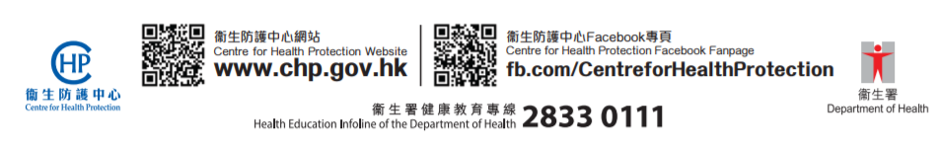

Suggested answers for teachers
Reading Part and Listening Part
Protect others from getting sick
(A) Cough and sneeze
(A) Cover nose and mouth with flexed elbow or a tissue.
(C) Hands
(C) Clean hands with alcohol-based hand rub or soap and water after coughing or sneezing.
(B) Used tissues
(B) Throw tissues into a closed bin immediately after use.
(D) Home hygiene
(D) Fill the U-shaped traps with water and check drains and pipes regularly.

Tapescript
To prevent the spread of diseases, we must keep the enviornment clean. Maintain drain pipes properly and make sure the U-shaped water traps are filled with water. Pour about half a litre of water into all drain outlets once a week and check regularly. If drains and pipes are leaking, or blocked, or drain outlets emit a foul smell, don’t alter drains and pipes on your own. Arrange prompt repair by a qualified person.

Speaking Part
Suggested questions for teachers:
- What do you do when you cough or sneeze?
- Why do we need to have a closed bin for throwing used tissues?
- Who does the housework in your home? What do your parents / does your domestic helper need to do with pipes at home?
- What other things do your parents / does your domestic helper do to keep your home clean and tidy?
- How can you help your parents or your domestic helper at home?

Writing Part (an example)

Fr

Fr

Dear Mum and Dad,
Thank you for the nice bin for my bedroom. It has a lovely colour. I will put the used tissues into this closed bin. Thank you for keeping our home clean and tidy!
I love you both!
Love,
Kitty

