Suggested Key Stage: KS1
The Bear Hunt

Situation
Can you imagine what it is like on a bear hunt? People hunt bears because they want to protect themselves from being hurt by the bears. How would you feel and what would you do if you see a bear? To write your own chant about seeing a bear, you are going to complete the following parts:
- Read a chant about a bear-hunting journey of some children
- Think and write a simple chant to talk about seeing an animal

Part 1: Read the chant ‘The Bear Hunt’ carefully.

The Bear Hunt
Verse
1 | We’re going on a bear hunt.  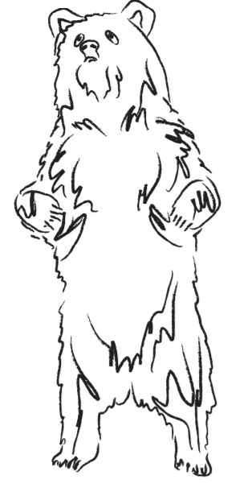  We’re going to catch a big one.  I’m not scared, I’m not scared!  It’s a beautiful day!
2 | We come to a fence,  A very tall fence.  We can’t go over it.  We can’t go through it.  We’ve got to go under it!  Hugggh! Huggghh! Huggghhh!  Crawl! Crawl! Craw! Crawl!
3 | We’re going on a bear hunt.  We’re going to catch a big one.  I’m not scared! Huh!  It’s a beautiful day!
4 | We come to a bridge,  A very long bridge.  We can’t go under it.  We can’t go through it.  We’ve got to go over it!  Stomp! Stomp! Stomp! Stomp! Stomp! Stomp! Stomp! Stomp! Hey!
5 | We come to some mud,  Very sticky mud.  We can’t go over it.  We can’t go DIG! DIG! under it.  We’ve got to go through it!  Squish, Squish, Squish! Squish, Squish, Squish! Weeeeeeeeeeee!
6 | We come to a hill,  A very high hill.  We can’t go under it.  We can’t go DIG! DIG! through it.  We’ve got to go over it!  Huff! Puff! Huff! Puff! Huff! Puff! Huff! Puff!
7 | We get to the top.  Have you seen the bears yet?  NO!  Let’s take a rest! Arhhhhhhhhhhh!
8 | We run down the other side – da da da da da da da da da da  We come to a river,  A very wide river.  We can’t go over it.  We can’t go BLURP BLURP BLURP BLURP BLURP! under it.  We’ve got to go through it!  Splish! Splash! Splish! Splash! Splish! Splash!
9 | We come to a cave,  A dark spooky cave.  Something’s dripping,  Drip! Drop! Plip! Plop!
10 | We’re going on a bear hunt.  We’re going to catch a big one.  I’m not scared!  It’s a beautiful day outside!
11 | ARGGHHHHHHHHHHHH!  Something’s breathing.  Something’s snoring! Zzzz! Phew! Zzzz! Phew! Zzzz! Phew!  Reach out your hand.  Something’s there!  It’s … a … BEAR!  ARGGHHHHHHHHHHHH!
12 | Run from the cave.  Down to the river – Splish! Splash! Splish! Splash!  Run up the hill - da da da da da da da da da da  Get to the top.  Have you seen the bear yet?  IT’S BEHIND US!  ARGGHHHHHHHHHHHH!
13 | Run down the other side - da da da da da da da da da da  Run to the mud - Squish, Squish, Squish! WOW!  Run to the bridge - Stomp! Stomp! Stomp! Stomp! Stomp! Stomp! Stomp!  Run to the fence – Huggggggghhhhhh!  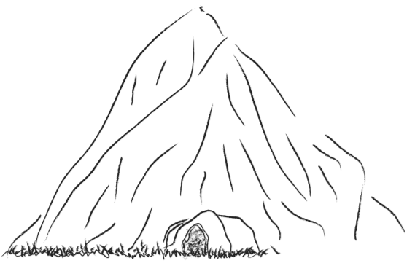  CRAWL! CRAWL! CRAWL! CRAWL!
14 | Run all the way home.  Open the door! Eggggggg!  Run up the stairs - da da da da da da da da da da  OH NO! I FORGOT to CLOSE the door! - - da da da da da da da da da da  SLAMP! ZAP! ZAP! ZAP!  CHA! CHA! CHA! CHA! CHA! CHA!  I am NEVER going on a bear hunt again!  Aaaaaaaaaaaaaaagh!

Part 1: Answer Questions 1 to 10 by choosing the best option.
1. Read verse 1. What are the children going to do? They are going to …
A. | swim. | B. | hunt bears.
C. | fish. | D. | climb.

2. Read verses 1 to 3. How does one of the children feel about the hunt at the beginning? He feels …
A. | worried. | B. | angry.
C. | scared. | D. | confident.

3. Read verse 2. How do the children pass the fence? They …
A. | crawl under it. | B. | run on it.
C. | walk through it. | D. | jump over it.
4. Read verse 6. They say ‘Huff! Puff!’ Why do they make this sound?
A. | They are too excited to climb the hill. | B. | They are too tired to climb the hill.
C. | They are too sleepy to climb the hill. | D. | They are too angry to climb the hill.
5. Read verse 7. Where are they? They are …
A. | at the top of the river. | B. | at the bottom of the hill.
C. | under the bear. | D. | at the top of the hill.
6. Read verse 8. They say ‘Splish! Splash!’ What do the words refer to? They refer to …
A. | the things they get when getting through the river. | B. | the feelings they have when getting through the river.
C. | the people they see when getting through the river. | D. | the sounds they make when getting through the river.
7. Read verse 9. Which word below has a similar meaning as ‘scary’?
A. | spooky | B. | sticky
C. | wide | D. | dark
8. Read verse 11. What is the bear doing? The bear is …
A. | eating. | B. | sleeping.
C. | talking. | D. | playing.

9. Read verse 12 line 6. What does the word ‘IT’ refer to? IT refers to …
A. | the river. | B. | the bear.
C. | the mud. | D. | the bridge.
10. Read verse 14. How does one of the children feel about the hunt in the end? He feels …
A. | glad. | B. | angry.
C. | scared. | D. | confident.

Part 2: The children see different things and go to different places during the journey. Write the names of the things or objects they see, and the places they go in the boxes provided (e.g. a: home).
home
(a)

(e).
(b)
(f).
(d).
(c)

Part 3: The children use a lot of adjectives to describe objects and places. Match the adjectives with the objects and the places by putting letters (a) to (d) into the brackets (e.g. 1: a).
Adjectives | Objects
1. sticky ( ) | a. hill
2. high ( ) | b. cave
3. wide ( ) | c. river
4. dark ( ) | d. mud

Part 4: The children try their best to pass through all the objects and the places during their journey. Some verbs are used to describe how they move. Match the verbs with the objects or the places by drawing the lines.

Under the fence | Over the bridge | Through the mud | Through the river
Squish | Crawl | Stomp | Splash

Part 5: Look at the chant written by one of the children. Learn how adjectives, prepositions and verbs are used in a chant.
We see a mountain,
Adjectives
A very snowy mountain.
We can’t go through it.
Prepositions
We can’t go under it.
We’ve got to go over it!
Verbs
Huff! Puff! Huff! Puff!

Part 6: How would you feel and what would you do if you see an animal? Write a chant using the suitable adjectives, prepositions and verbs.

We see a ___________________. (name of an animal)
A very _________________ (an adjective) ________________ (name of an animal).
We can’t go ________________________it.
We can’t go ________________________ it. (prepositions)
We’ve got to go _____________________it!
__________________________________________________________! (verbs)

answer Key
Part 1
- B
- D
- A
- B
- D
- D
- A
- B
- B
- C
Part 2
- a fence / fence
- a bridge / bridge
- some mud / mud
- a hill / hill
- a river / river
- a cave / cave
Part 3
- d
- a
- c
- b
Part 4
Under the fence | Over the bridge | Through the mud | Through the river
Squish | Crawl | Stomp | Splash

Part 5 and Part 6 (an example)
We see a giraffe,
A very tall giraffe.
We can’t go over it.
We can’t go through it.
We’ve got to go round it!
Crawl! Crawl! Crawl! Crawl!

