Presents for the school anniversary

Below are some suggestions on the presents for the school’s 40th anniversary. Write down what stationery items and materials you need and complete the instructions for making the presents.

Making a shopping bag
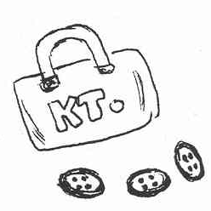
Things you need:

1.
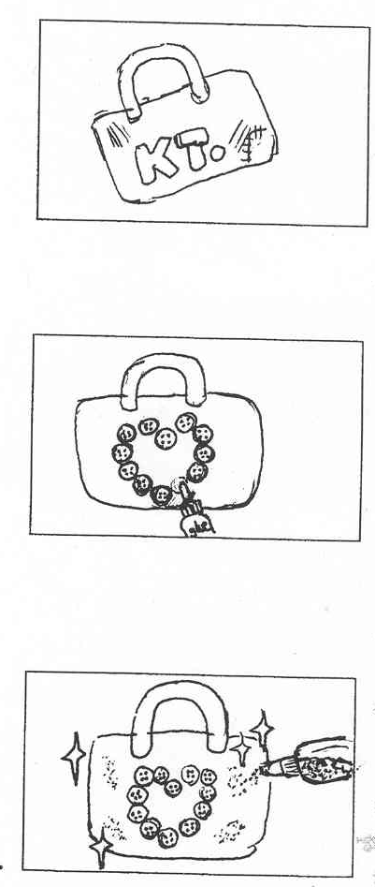
Things to do:

First, get an old shopping bag.

onto the bag
2.
in a shape.
glue

the shopping bag with
3.
.

Making a badge

Things you need:
a safety pin
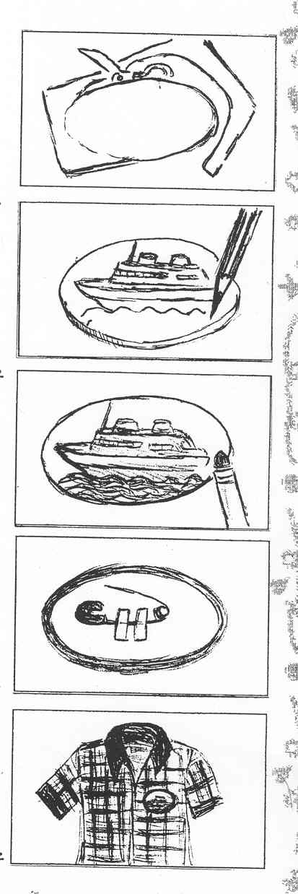
1.
2.
3.
4.
5.
Things to do:

First, in
an shape.

Next, on the
cardboard.

with
.

on the back of the badge.

to your shirt.

Making a paper fan

Things you need:

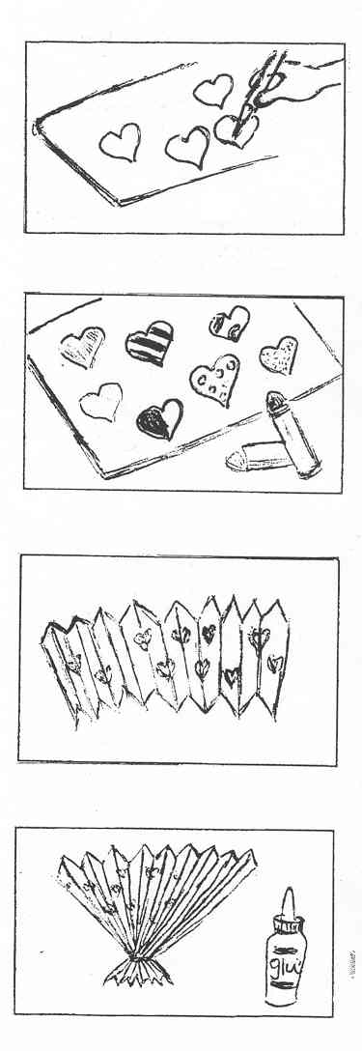
1.
Things to do:
on the
cardboard.
2.

with
.
3.

into
a zigzag shape.
4.
the end of the cardboard
together.

(Answer Keys)

Making a shopping bag
Things you need:
a shopping bag
buttons
glue
glitter
1.
Things to do:

First, get an old shopping bag.

2.
Next, glue the buttons onto the bag
in a heart shape.

3.
Lastly, decorate the shopping bag with
some glitter.

Making a badge

Things you need:
a pair of scissors
a piece of cardboard
a safety pin
sticky tape
crayons

Things to do:
1.
2.
3.
4.
5.

First, cut the cardboard in
an oval shape.

Next, draw a picture on the
cardboard.

Then, colour the picture with
crayons .

After that, tape a safety pin
on the back of the badge.

Lastly, pin the badge to your shirt.

Making a paper fan

Things you need:
a piece of cardboard
crayons
glue

Things to do:
1.
2.
3.
4.

First, draw some hearts on the
cardboard.

Next, colour the hearts with
crayons.

Then, fold the cardboard into
a zigzag shape.
Lastly, glue the end of the cardboard
together.

