Reading Task: Arachne

Suggested Level: S1-2

Task Description
Read the following story entitled “Arachne” and answer the related questions.
Arachne  In ancient Greece there lived a beautiful woman who was highly gifted in weaving. She was called Arachne and was no ordinary weaver. The act of her weaving was sheer magic and a sight to behold. Everyone was amazed at the tapestries she produced.  Arachne had a very high opinion of herself. When she looked at her tapestries, she was very proud of them and boasted that she had a greater talent than the Goddess Athena. Athena was the Goddess of Wisdom, and also the Goddess of Weaving. Athens was her city and it was named after her. Upon hearing her proud words, the people said, “No, no, no… You mustn’t say that because you know you are not the only person to make tapestries. The Goddess Athena will not be happy if you continue boasting about how good you are.” “I don’t care!” said Arachne.  Athena was upset and decided to visit the young woman. A few days later, Arachne had an exhibition of all her latest tapestries. Dressed as a little lady in a long grey cape, Athena came to see Arachne’s work. She walked along looking at all the different tapestries and she finally came to Arachne and warned her of the consequences of provoking the gods. Athena said, “Your work is very good but I happened to think that the tapestry made by Athena is as good as yours.” “No way!” cried Arachne. “I am the best!” When Athena heard of Arachne’s bold claims, she was furious and revealed her true form. There was a big flash and a loud bang and a puff of smoke. When the smoke cleared, the little old lady had disappeared. Standing in her place resplendent in a beautiful blue cape was none other than the Goddess Athena.  “You think your shuttle is better than my shuttle. We should have a competition to see whose shuttle is the best shuttle in the whole of Greece,” shouted Athena.  The next day, the two women set to work, and all the people stirred in the middle watching the shuttles. The people were amazed when they watched Arachne busy over here and Athena busy over there.  Athena made a tapestry that showed Mount Olympus. Olympus was the home of the Greek gods. In this particular picture, they could see Zeus himself, the king of all the gods. It seemed to the people that they were in the presence of the god. When the people looked at the tapestry made by Arachne, they saw a forest and in the forest there was a lion and it was so real as if the lion was about to leap out from the picture. The people recoiled in fear and even Athena had to admit that Arachne’s work was brilliant and flawless. Athena turned and said, “Yes, Arachne… That’s what you keep saying and I must say that your shuttle is better than mine.” “Yes!” said Arachne, “I am the best.”  “So you said that again, but because you are so proud and like to boast, you will be punished. From this day onward, when people see you weaving, they will recoil in horror,” said Athena.  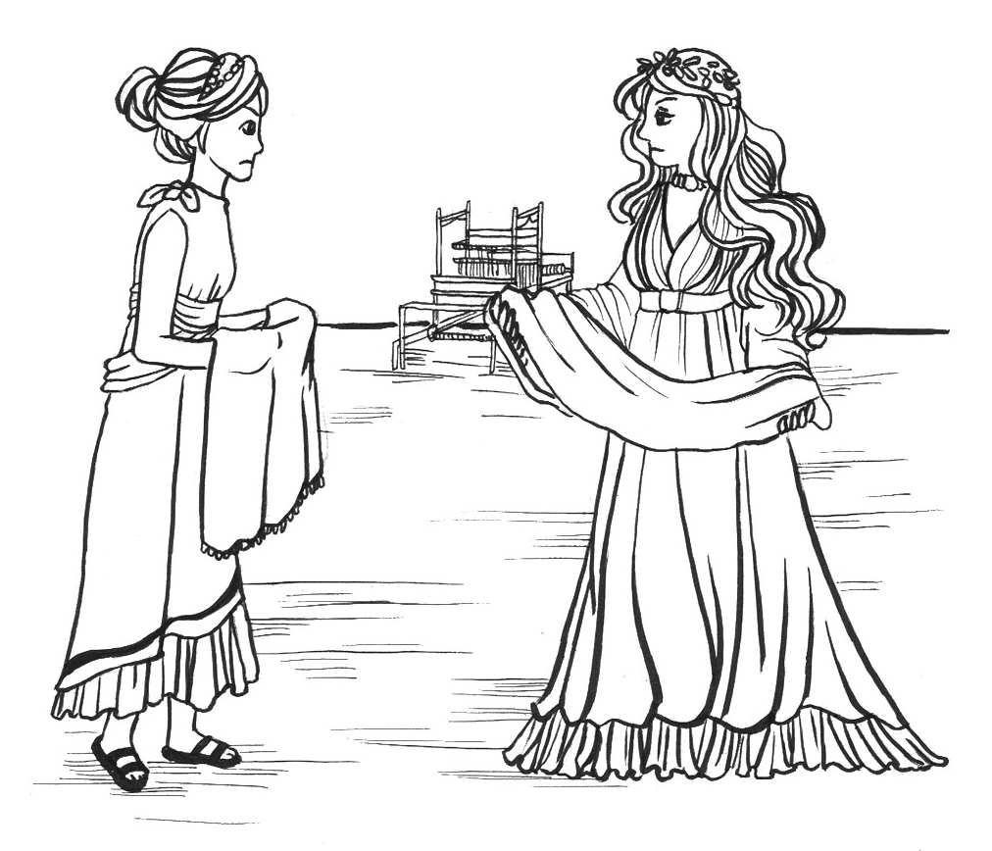  Suddenly there was another flash of light, a big bang and a cloud of smoke. When the smoke cleared, the people saw that Arachne had disappeared and in her place on the ground was a spider. Out of anger, Athena had transformed Arachne into a disgusting spider (“arachni” in Greek). To this day, spiders continue to weave their webs, not a tapestry. Whenever people see their webs, they recoil in horror. That is why to this day, spiders are known as members of the Arachnid family. | 5  10  15  20  25  30  35  40

Refer to the text and answer the following questions.

- What made Arachne feel proud of herself?
________________________________________________________________________________
________________________________________________________________________________

- Why did Athena dress as a little old lady when she went to see the work of Arachne?
________________________________________________________________________________
________________________________________________________________________________

- In line 12, who was “the young woman”?
________________________________________________________________________________

- In line 18, “furious” means very __________.
- happy
- sad
- angry
- lucky

- Based on the story, decide if the following statements are True (T), False (F) or Not Given (NG) by putting a tick “” in the appropriate boxes.
 | T | F | NG
a) Both Athena and Arachne were good at weaving.
b) Arachne was the Goddess of Weaving.
c) People in ancient Greece did not like Arachne.
d) Athena punished Arachne because of her talent for weaving.
e) Zeus, the king of all gods, felt pity for Arachne.

- As in other stories, there are dialogues in this story. Why are dialogues commonly used in story writing?
________________________________________________________________________________________________________________________________________________________________
________________________________________________________________________________

- Describe the personality of Arachne. Find evidence in the text to support your answer.
________________________________________________________________________________
________________________________________________________________________________
________________________________________________________________________________

- Do you think that Arachne should be punished by Athena? Why/Why not?
________________________________________________________________________________
________________________________________________________________________________
________________________________________________________________________________

- What is the moral lesson you have learnt from this story?
________________________________________________________________________________
________________________________________________________________________________
________________________________________________________________________________

Writing Task: Arachne
Task Description
Rewrite the ending of “Arachne”.

Situation
You are Chris, a secondary one student. As a post-reading task, your English teacher has asked you to write another ending for the story “Arachne”. You may use the following guiding questions to brainstorm the ideas and/or your own ideas for your story.

- In the story, Arachne was punished by Athena and turned into a spider. What could be another punishment for Arachne?
- Would Athena change her mind about punishing Arachne? If so, what would happen next?
- Would there be any other characters in the story?
- What would be a better way for teaching Arachne?
- What do you want the readers to learn from the new ending?

Write 120 – 150 words.

Arachne (another ending)
__________________________________________________________________________________
__________________________________________________________________________________
__________________________________________________________________________________
__________________________________________________________________________________
__________________________________________________________________________________
__________________________________________________________________________________
__________________________________________________________________________________
__________________________________________________________________________________
__________________________________________________________________________________
__________________________________________________________________________________
__________________________________________________________________________________
__________________________________________________________________________________
__________________________________________________________________________________
__________________________________________________________________________________
__________________________________________________________________________________
__________________________________________________________________________________
______________________________________________________________________________________________________________________________________________________________________________________________________________________________________________________
__________________________________________________________________________________
__________________________________________________________________________________
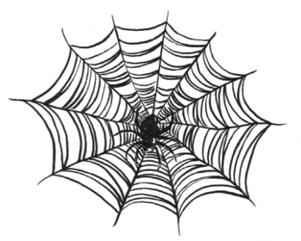
__________________________________________________________________________________
_________________________________________________________________________________________________________________________________________________________________________________________________________________________________________
Reading Task: Arachne

Answer Key

- Arachne was proud of herself because she was highly gifted in weaving/no ordinary weaver and everyone was amazed at the tapestries she produced. (accept other appropriate answers)
- Athena wanted to see if Arachne would really boast about her talent for weaving and say she had a greater talent than Athena. (accept other appropriate answers)
- Arachne
- C
- a) T
b) F
c) NG
d) False
e) NG
- The use of dialogues in story writing can help describe the personality of the characters vividly. (accept other appropriate answers)
- Arachne was arrogant and boastful. She repeatedly said she was the best. She also boasted that she had a greater talent than the Goddess Athena and she did not care whether Athena would be upset by this or not. (accept other acceptable answers)
- Yes/No, accept any appropriate reasons
- We should be humble even if we are very talented, rich, beautiful, etc. (accept other appropriate answers)

