Reading Task: Moso Bamboo

Suggested Level: S2 – 3

Task Description
Read the following story entitled “Moso Bamboo” and answer the related questions.
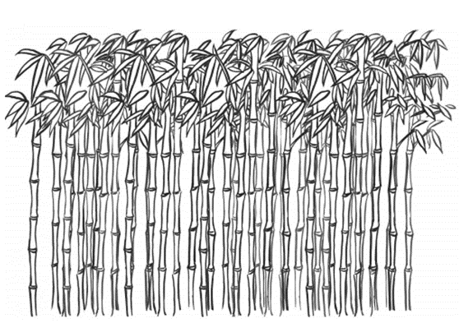  Moso Bamboo  Are you a fan of martial arts movies? The Chinese martial arts movies with those amazing aerial fights when the characters are going through great bamboo forests, leaping and bouncing off the trees, are very, very exciting indeed. This story doesn’t actually talk about martial arts. But let’s talk about the bamboo forest because where they film it, it’s not just any bamboo. It’s a very special type of bamboo called moso bamboo.  What is unusual about moso bamboo? Let’s say you’ve got yourself a seed. You plant the seed and water it. You come back a week later, NOTHING. You come back a month later, still nothing. You are thinking, “Hmm… maybe I should move it somewhere else. But actually where did I plant it?”  Then you come back a year later. And there is still NOTHING. By now you think it is a total waste of time. You’ve spent money on something and nothing happened. You keep walking on the same path every day, for two years, three years, four years, FIVE years.  But then one day, you walk past, and BOOM! there is the moso bamboo and it’s up to your knees! It wasn’t there yesterday, but now, sixty centimetres tall, up to your knees, in just one day.  Tuesday you come back. BOOM! And it’s up here, up to your chest! It has grown FOUR FEET in two days!  Wednesday, JINK! It’s as tall as a man. 1.8 metres tall, sixty centimetres every single day. And it grows, it keeps on growing like that EVERY SINGLE DAY for six to seven weeks, until it’s up to thirty to forty metres tall. How incredible!  So what has it been doing? For those five years seemingly there was no activity at all and you thought you would just give it up and let it die. For five years the moso bamboo has been planting its roots, extending its roots. They go very, very deep, and very, very wide. They have to be wide in order to support its standing so straight and so tall. If you got martial arts fighters do that kind of kick and fight, it doesn’t want to fall over so it has to be wide in order to give it that stability. It has to go deep in order to have the kind of energy to be able to tap on the amazing amount of energy to drive it up so fast for six or seven weeks.  So, what has it got to do with you? By the time you are in Secondary Six, you have been in secondary education for five years. Are you going to shoot up? I don’t mean physically. I don’t want to see another generation of basketball stars. I’m talking about what’s going on in your heart, what’s going on in your mind. What roots are you putting down? How deep and how wide? It is going to help you to make that kind of growth and show what you are really capable of. The story of moso bamboo is the idea about putting down roots, deep and wide. Think about that. What does that mean? What do you have to do to make that kind of growth? Or are you just going to be the same person five years from now, no difference from when you walked into your school from Primary One into Secondary One? True story. Moso bamboo. Right here on your doorstep in China. | 5  10  15  20  25  30  35  40  45  50

Refer to the text and answer the following questions.

- In paragraph 1, the writer wants to tell readers that _______________________. Choose the best answer.
A. bamboo forests are a popular location for practising Chinese martial arts
B. bamboo forests are a popular location for filming martial arts movies
C. moso bamboo is tough and durable by nature
D. moso bamboo is tall and useful by nature

- In line 16, what does “it” refer to?
_________________________________________________________________

- What does “incredible” mean in line 29?
A. difficult
B. pleasant
C. possible
D. unbelievable

- What does “They” in line 33 refer to?
_________________________________________________________________

- Indicate the growing process of moso bamboo by completing the line graph below.

Growth of Moso Bamboo

50

40
Height (m)

30

20

10
1 2 3 4 5 6

Year

- i) With reference to the interjections “BOOM” in lines 21 and 24 and “JINK” in line 26 respectively, decide if they are used appropriately in the following statements. Choose the best two answers.
- “BOOM! Here we go!” Tom shows his newly designed figurine with pride.
- “BOOM!” whispered Mary as she read her favourite love story.
- Bonnie mumbled, “JINK! I need to work harder next time!” as she received her school report.
- “It’s been a long time! JINK! You’re a big boy now, James!” said Uncle Wayne.

ii) What is the effect created by these two interjections?
_________________________________________________________________
- Why is the first five years important to moso bamboo’s overall growing journey?
_________________________________________________________________
_________________________________________________________________
_________________________________________________________________

- Which of the following is another suitable title for the story? Choose the best answer.
- The Secret of Moso Bamboo
- The Growing Journey of Moso Bamboo
- The Foundation of Martial Arts
- The Foundation of Success

Writing Task: Moso Bamboo
Task Description
Write a reflective journal on one’s own learning experience.

Situation
You are Chris, a secondary three student. Your class teacher, Miss Smith, has invited all the students in your class to write a reflective journal on their own learning experience. The reflective journal will be shared among the classmates as inspirational stories in the values education week. You may use the following guiding questions to brainstorm the ideas and/or your own ideas for your reflective journal.

- Did you come across something similar to the growing stages of moso bamboo in your past learning experience (e.g. studying a particular school subject, learning a sport/musical instrument, developing an interest, learning a language)? Describe your experience.
- How did you overcome your difficulties/challenges in the learning process? How did you feel?
- What was the key event that acted as the springboard to your further development?
- What have you learnt from your learning experience?
- How does your learning experience affect your future learning?

Write 150 – 200 words.

Reflective Journal
__________________________________________________________________________________
__________________________________________________________________________________
__________________________________________________________________________________
__________________________________________________________________________________
__________________________________________________________________________________
__________________________________________________________________________________
__________________________________________________________________________________
__________________________________________________________________________________
__________________________________________________________________________________
__________________________________________________________________________________
__________________________________________________________________________________
__________________________________________________________________________________
__________________________________________________________________________________
__________________________________________________________________________________
__________________________________________________________________________________
__________________________________________________________________________________
__________________________________________________________________________________
__________________________________________________________________________________
__________________________________________________________________________________
__________________________________________________________________________________
__________________________________________________________________________________
__________________________________________________________________________________
__________________________________________________________________________________
__________________________________________________________________________________

Reading Task: Moso Bamboo

Answer Key

- C
- The seed
- D
- The roots

Growth of Moso Bamboo
50

40

30

20

10

Height (m)

1 2 3 4 5 6
Year

6. i) a, d
ii) To show the feeling of surprise
7. Moso bamboo has been growing and extending its roots deeply and widely in the soil in the first five years to obtain energy for its rapid growth for six and seven weeks and to support its standing straight and tall.
8. D

