Task 1: A Survey on Diets and Eating Habits

Part A: Finding information on healthy diets and good eating habits
- One week before the lesson, ask students to keep records of what they have for their meals in the coming week and when they have them.
- During the lesson, ask students to extract relevant information from the article Eating for a Healthy Life (p.19 – p.21) and complete Notes on “Eating for a Healthy Life” (p.22).
- Ask students to listen to the interview Good Eating Habits and complete Notes on “Good Eating Habits” (p.23). (Retrieve the interview from the CD-ROM included in this resource package.)

- Talk about healthy eating with students. Ask them to make use of their meal records to reflect on their own diets and eating habits and discuss with them how they could improve their diets.
Tapescript A Radio Interview: Good Eating Habits
Interviewer: Good morning, Miss Lai. I’d like to ask you a few questions about eating habits and health. Today, many young people have very bad eating habits. They often have unhealthy meals and eat a lot of junk food. Mm... Skip... Skipping meals is also very common among youngsters. As a nutritionist, what advice would you give to help them develop good eating habits?
Miss Lai: You’re right. Many young people have bad eating habits. Er... It’s largely because they aren’t aware of the importance of healthy eating. To stay healthy, it’s important that they eat healthily. First, they should have three regular meals a day. Many young people often skip breakfast or lunch but this is not good for health. Skipping meals can lead to out-of-control hunger. As a result, they may tend to eat too much at the next meal.
Interviewer: So they should have three regular meals every day.
Miss Lai: Yes, that’s right.
Interviewer: What about the kinds of foods young people should have? It’s common that they often have junk food for lunch.
53

Miss Lai: You’ve brought up another important point that many young people have neglected, that is, they should have a well-balanced diet.
Interviewer: A well-balanced diet?
Miss Lai: Yes, a healthy and well-balanced diet. A healthy and well-balanced diet should include a variety of nutritious foods. Young people should eat plenty of whole grains, fruit and vegetables, but little fat, salt and sugar. They should avoid junk food such as potato crisps, sweets, ice cream and cookies. Instead of soft drinks, they should drink a lot of water. They should drink at least eight glasses of water every day.
Interviewer: So teenagers should eat more whole grains, fruit and vegetables but less fat, salt and sugar.
Miss Lai: Yes, exactly.
Interviewer: Many young people tend to eat only their favourite food. Do you think it’s a problem?
Miss Lai: Yes, if they eat only what they like, that means they eat little of other kinds of foods. This may lead to an unbalanced diet. They should eat different kinds of foods. In fact, our body needs more than 40 different nutrients.
Interviewer: More than 40 different nutrients!
Miss Lai: Yes. For good health, we need more than 40 different nutrients but no single food supplies them all. We should eat different kinds of foods.
Interviewer: So we shouldn’t eat too much of any single food. What else do you want to remind our youngsters of as far as healthy eating is concerned?
Miss Lai: Right. Mm... They should avoid food with a lot of artificial flavours, colours or chemicals, as they are bad for health. And lastly, they should do exercise regularly if they want to be fit and healthy.
Interviewer: Thank you very much for giving so much advice to our youngsters. I’m sure they have learnt a lot about healthy eating.
Miss Lai: You’re welcome.

54
Keys to Notes on “Eating for a Healthy Life”
- The Five Food Groups
Food Groups | Examples | Why do we need them?
Grain Group | bread, rice, cereals, noodles, pasta, potatoes and sweet potatoes | They contain carbohydrates which give us energy for physical activities and our body's day-to-day functions.
Fruit and Vegetable Group | fresh/frozen/dried/ canned fruits and vegetables | They contain fibres which are essential for a healthy digestive system. They also contain vitamins and minerals which are needed for our organs to perform their functions.
Meat and Protein Group | meat, nuts, beans, peas and soya-bean products | They contain proteins which enable our body to grow new cells and repair old ones. They also help us build strong muscles.
Milk Group | milk, cheese, yogurt and dairy products | They contain calcium which helps us keep our teeth and bones healthy.
Fat and Sugar Group | Oil, butter, cream, sugar, cakes, biscuits, chips, sweets, soft drinks | We eat them mainly because they taste good.

- A balanced diet means eating a variety of foods and eating the right amount.
55

Key to Notes on “Good Eating Habits”
  - Eat three regular meals a day.
  - Have a well-balanced diet.
  - Eat plenty of whole grains, fruit and vegetables but little fat, salt and sugar.
  - Avoid junk food such as crisps and sweets.
  - Drink at least eight glasses of water every day.
  - Do not eat too much of any single food.
  - Avoid food with a lot of artificial flavours, colours or chemicals.

Part B: Writing a questionnaire
- Go over the Chairman’s message (p.24) with students. Get them to search for more information on the suggested websites (p.24) and ask them to make notes.
- Discuss with students the guidelines for designing a questionnaire (p.25). Help them form the questions and design the questionnaire. Go over the structures of different question forms with students.
For Yes/No Questions, you may ask students:
What do you say to your schoolmate if you want to know...
1. whether he/she has meals regularly?
You say: Do you have your meals regularly?
2. whether he/she often skips meals?
You say: Do you often skip meals?
For Wh-Questions, you may ask students:
What do you say to your schoolmate if you want to know...
1. how many meals he/she has a day?
You say: How many meals do you have a day?
2. what he/she usually has for breakfast?
You say: What do you usually have for breakfast?

56

- Go over the sample questionnaire on “Doing Exercise to Keep Fit” (p.26) with students. Get students to work in groups of four. Each group has to construct one questionnaire. Give students time to draft their questionnaires in the space provided (p.27). Remind them to check and improve their drafts by making use of the feedback sheet – Writing a questionnaire (p.28). This gives students an opportunity to improve their own work through self-assessment.
- Explain and illustrate with examples the different items in the sample questionnaire (p.26) before students start writing.
For instance, to illustrate the importance of choice of words under language and style, you may ask students to compare the following questions:
Do you skip meals?
Do you sometimes skip meals?
Do you often skip meals?
How often do you skip meals?
Explain to students how the use of different words might change the meaning of a question and subsequently affect the response.
- When students have finished drafting their questionnaires, they try out their questionnaires with their classmates from other groups to see if the questionnaires need any revision. The feedback sheet (p.28) can also be used for peer assessment and to help students spot the areas for improvement.
- Ask each group to hand in one questionnaire. You can make use of the feedback sheet (p.28) to mark the questionnaires and give students feedback. Design follow-up activities for intervention or consolidation, such as discussions on weaknesses observed and common errors.
- Select the best questionnaire for the school survey.
57

Part C: Conducting a survey and presenting the findings
Conducting the survey
- Decide on the scale of the survey and the total number of interviewees.
- Assign each group a certain number of interviewees (e.g. 10 or 20 fellow schoolmates), depending mainly on the number of participating groups and the scale of the survey.
- Guide students to read the Chairman’s note on conducting a survey (p.29). Ask students to conduct the interviews during lunch break or after school.
Presenting the findings
- Guide students to read the Chairman’s note on presenting findings (p.30). Ask them to work in groups of four and coach them to write a summary of their findings. Ask each group to give an oral presentation based on the summary.
- Ask students to collect data from the presentations of other groups and put the “overall data” together in a table. Go over the summary table on “Doing Exercise to Keep Fit” (p.31) with students as an example. Ask them to work out a summary table of the survey and put it in the space provided (p.33).
- Ask each group to construct a chart with the “overall data” they have collected. Guide them to study the sample chart on “Doing Exercise to Keep Fit” (p.31). Ask them to construct a chart of the survey and put it in the space provided (p.34).
- Discuss with students the sample report on “Doing Exercise to Keep Fit” (p.32). Then ask each group to write a report of the survey using the overall data they have collected on Diets and Eating Habits in the space provided (p.35).
- Remind students that the samples are provided for reference only. They may use any other appropriate ways to present their findings. Originality will be appreciated.
- Ask students to work in groups to select the best chart and the best report for posting up in school. Agree with the students what the success criteria should be (e.g. completeness, correctness and clarity of the information and data).
58
Task 2: Posters for Promoting Healthy Eating

Part A: Designing a poster
- Go over the guidelines for designing posters (p.36) and the sample poster (p.37) with students. Focus on the purpose, the content, the language used (e.g. modals for giving advice, imperatives for writing instructions or slogans) and the layout.
- Invite the students to share the posters they have collected or what they have observed from posters they have come across.
- Ask students to brainstorm ideas, titles and slogans for their posters. Encourage them to study posters from various sources to help them generate ideas. The following websites are useful for reference.
http://www.foodandhealth.com/
http://www.cuphd.org/foodprograms.htm
- Get students to work in groups of four to design their own poster. Remind them to choose a proper title or slogan and select relevant information to be included in the poster. Ask students to put the draft in the space provided (p.38).

Part B: Producing and displaying posters
- Ask students to check and improve their drafts by making use of the feedback sheet – Designing and producing a poster (p.39). Explain the different items on the feedback sheet and illustrate with examples if necessary before they do self-assessment or give feedback to their peers. Guide them to compare their drafts to look for further improvements. Give them feedback if necessary. Ask each group to produce one poster.
- When the posters are ready, ask students to show and introduce their posters to the whole class. Ask students to discuss in groups and choose the best posters, based on the items on the feedback sheet (p.39).
- Display the well-designed posters in school to promote healthy eating.
59
Task 3: A Healthy Recipe

Part A: Learning through games
- Help students identify the features of a recipe. Let them play Game 1 – How to make Sushi Rice (Matching) (p.40) and Game 2 – How to make California Rolls (Reordering) (p.41). Teach students imperatives and connectives in the instructions of the games.

- Arrange for students to play Game 3 – Ways of cutting and cooking (p.42) and Game 4 – Know more about food groups (p.43) to learn/revise the vocabulary needed for writing a recipe. The games can be adapted to suit students’ needs.
Key to Game 1: How to make Sushi Rice (Matching)

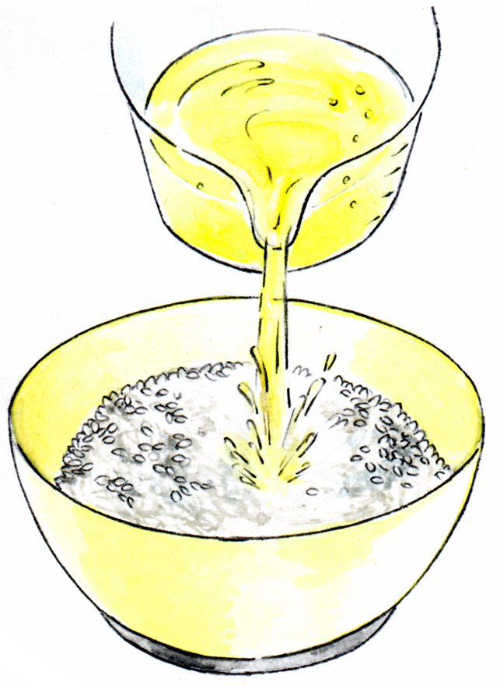
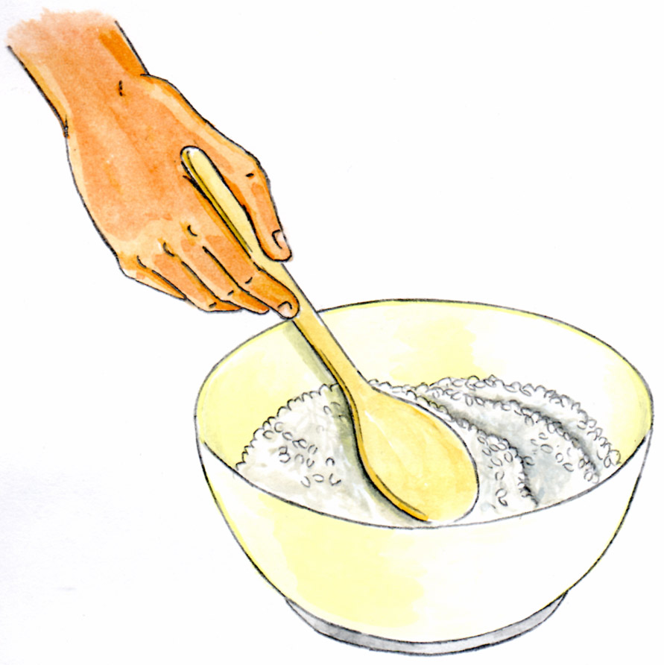
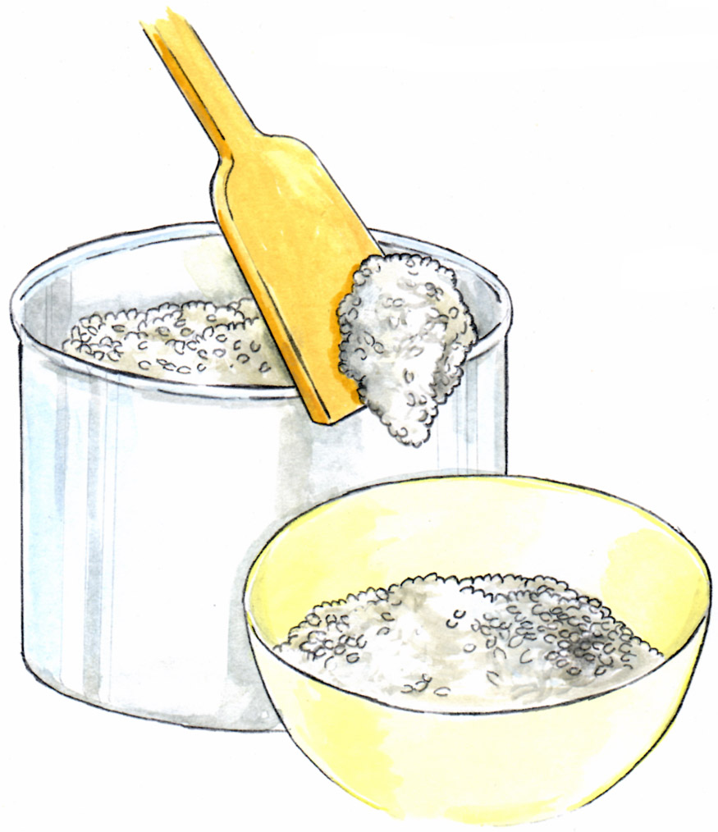
3
4
1

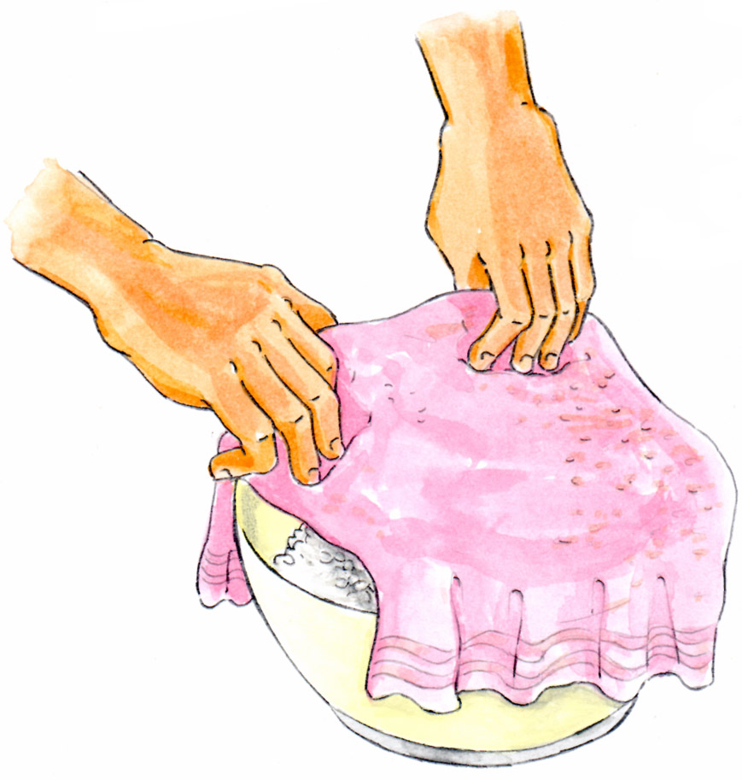
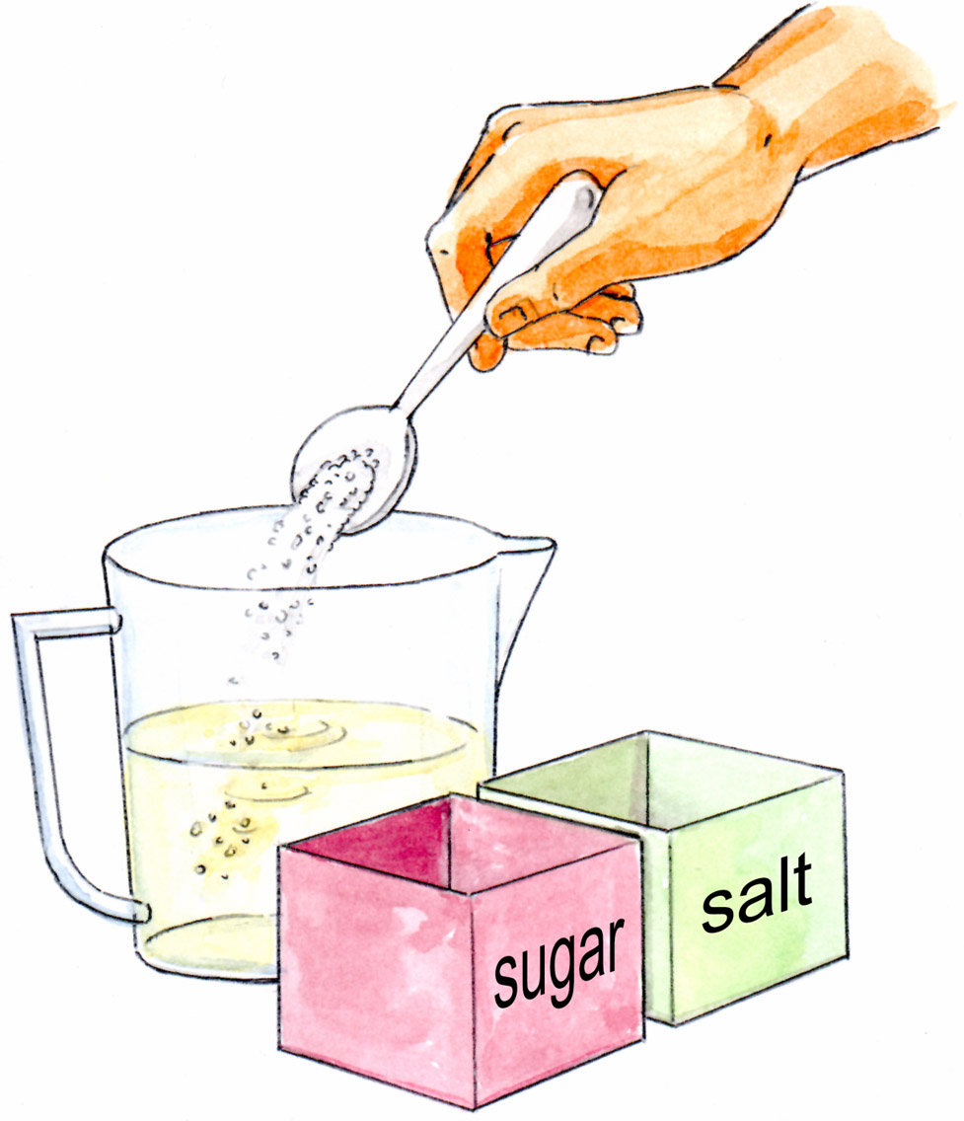
5
2
60
Key to Game 2: How to make California Rolls (Reordering)
 | Finally, cut the rolls into pieces and sprinkle sesame seeds on top.
 | Then, spread a thin layer of sushi rice (about 1/4 inch thick) on the seaweed and leave about an inch at the ends.
 | Serve with wasabi and soy sauce.
 | Begin at the bottom end. Roll the seaweed over until you reach the end of the seaweed.
 | Next, put an avocado slice, some imitation crab meat and a cucumber strip on top of the rice near the bottom edge of the nori seaweed.
 | First, place a sheet of nori seaweed on a bamboo mat.
 | Make more rolls with the remaining ingredients.

Part B: Writing a healthy recipe
- Explain the guidelines for writing a healthy recipe (p.44). Ask students to work in pairs or in groups of four to work out the draft of the recipe and put it in the space provided (p.45).
- Ask students to check and improve their drafts by making use of the feedback sheet – Writing a healthy recipe (p.46).
- Guide students to do self-assessment and give feedback to their peers by making use of the feedback sheet (p.46). Help them revise their recipes.
- Select and compile the well-devised recipes into a recipe booklet and place it in the school library or the English Corner for the reference of other students and teachers.
61

