Situation

The Hong Kong Youth Travel Association (HKYTA) is holding an “Asian Travelling Award Competition” for lower secondary students in Hong Kong. Winners will be awarded a free five-day tour to a country in Asia that they propose for their visit. Interested applicants have to work in groups of four. Each group will (1) submit a mini guide to the country in Asia; (2) submit a brief proposal giving the reasons for visiting the country and describing where they would go as well as what they would do during the trip; and (3) deliver an oral presentation. You and three classmates would like to join the competition.

Task 1: A Mini Guide to a Country in Asia


Part A : Preparing the content of a mini guide
Your group is going to produce a mini guide to a country in Asia to enter the “Asian Travelling Award Competition”. Before you start working, read the leaflet from the HKYTA carefully to understand the requirements.

Leaflet from the HKYTA

Asian Travelling Award Competition

Requirements for writing a mini guide
to a country in Asia

Cover
- Give an appropriate title
- Design an attractive cover
Content
- Not less than 250 words
- With relevant pictures
- Must be type-written
- Must include
- general information (e.g. weather, languages, currency, time difference, useful telephone numbers)
- culture (e.g. festivals, food and drink)
- tourist attractions
Size & Format
- Use plain A4 size paper
- Give appropriate headings
- Number all the pages

81

A mini guide to a country contains a lot of information, which should be well-organized for readers’ easy understanding and reference. You have asked one of your schoolmates, Gary, for help because you know that he entered a similar competition last year. In reply, he has sent you an e-mail message to tell you about his experience and give you some advice. Read Gary’s e-mail message and the attached mini guide to Greece.


Hi, ___________

Glad to hear that you and your friends would like to join the Asian Travelling Award Competition. You’ve got the right person. Our group entered the European Travelling Award Competition last year. Guess what, we won the award and went to Greece. We had a wonderful holiday and learnt so much about the history of Greece and the ways of living there. Here is my advice for preparing a mini guide to a country:

- Use the search engines on the Internet to look for information on the countries in Asia. Here are some useful search engines:

AltaVista http://www.altavista.com/
Ancarta http://www.ancarta.com/
Ask Jeeves http://www.ask.com/
Google http://www.google.com/
Lycos http://www.lycos.com/
MSN http://search.msn.com/
Yahoo http://www.yahoo.com/

- Here are some useful websites on travelling that we used last year. You will find a lot of useful information.

World Travel Guide | http://www.worldtravelguide.net/  - Click ‘Guides’ on the menu. Choose ‘World Trade Guide’ or ‘World City Guide’, then select a destination. Click ‘Mini Guide’, then tick the items (e.g. General Information, Map) on the lists. Click ‘Create Mini Guide’.
Lonely Planet | http://www.lonelyplanet.com/  - Click ‘Worldguide’ on the menu, then choose a destination.

82

Yahoo Travel | http://travel.yahoo.com/  - Click ‘Travel Guides’ on the menu, then choose a destination.
Rough Guide | http://travel.roughguides.com/roughguides.html  - Choose a destination.
Let’s Go Online | http://www.letsgo.com
 | - Choose a destination.
3. Discuss in your group to decide on a country that you like to work on.

4. Collect brochures and pamphlets about the country from travel agencies and travel magazines. You can also visit its embassy in HK.

I have attached the mini guide to Greece we submitted to the HKYTA last year. Hope that it can give you some ideas to prepare yours. Discuss with your group to see if you want to include other useful information.

Cheers.

Gary

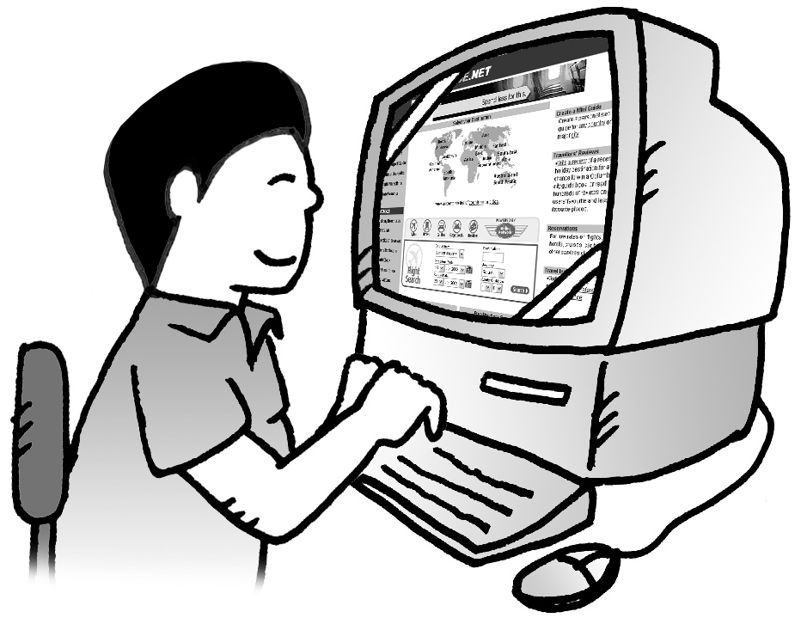
83



1
Gary's mini guide

General Information

Capital City: Athens
Weather: Wet and warm in spring, dry and hot in summer, dry and cool in autumn, and wet and mild in winter
Religion: Mainly Greek Orthodox
Language: Greek
Currency: Euro (EUR)
Time Zone: GMT+2 (GMT+3 from last Sunday in March to Last Sunday in October)
Useful Tel.Nos.: Police – 110
Ambulance/Fire – 112

Culture

Festivals: Gynaikratia in Northern Greece (8 Jan)
Carnival Season (Feb – Mar)
Athens Festival (mid June – late Sept)

Food: Cucumber Yoghurt Dip

1
84


3
3

Meat Kebab (skewered, grilled meat) in pita bread

Spinach and Cheese Pie
Greek Yoghurt (made from goat’s milk)
Greek Salad (consisting of cucumber, tomatoes, onions, feta cheese and olives)

Drink: Greek coffee (usually served chilled)
Ouzo (alcoholic drink which is often drunk with water)

Tourist Attractions

Athens: Acropolis (an ancient temple)
Ancient Theatre of Dionysos (an ancient theatre)
Plaka (an old village)
Agora (a marketplace for shopping)
Olympic Stadium (built in 1896)
National Archaeological Museum

Islands: Mykonos (superb beaches for swimming)
Santorini (black-sand beaches and mighty
cliffs)

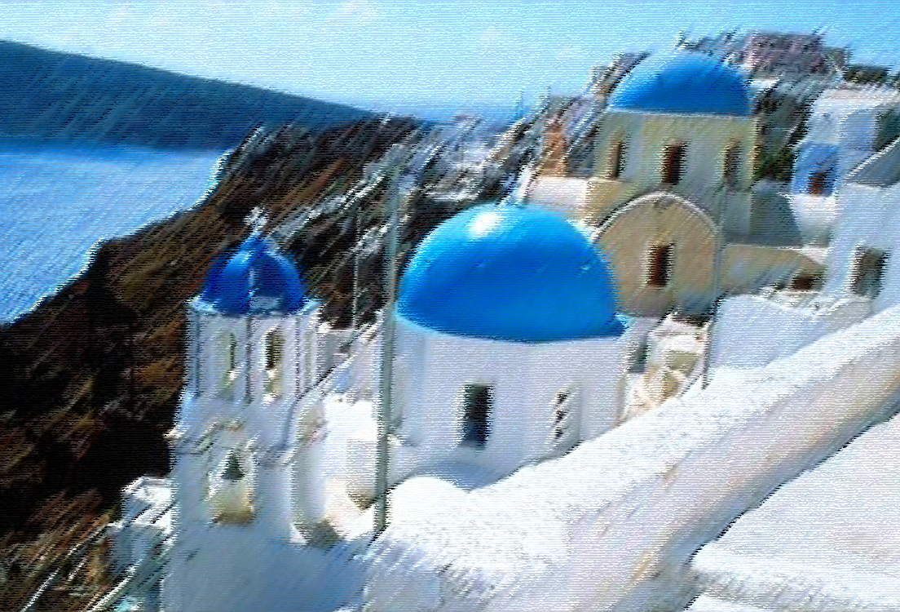

2
85

Follow Gary’s advice in his e-mail message (p.82 – p.83) to prepare your mini guide. You may use the following table to organize the information about the country you have chosen.
Information Sheet

General Information | Country Name
General Information | Capital City
General Information | Weather
General Information | Religion
General Information | Language
General Information | Currency
General Information | Time Zone
General Information | Useful Telephone Numbers
Culture | Festivals
Culture | Food
Culture | Drink
Tourist Attractions

86

Part B : Producing a mini guide

Now, use the information about the Asian country you have chosen to produce a mini guide. Refer to Gary’s mini guide (p.84 – p.85) and discuss in your group how you can make your mini guide informative, attractive and interesting. Be creative in the overall design and the arrangement of information.

Part C : Designing the cover of a mini guide


Your group is going to design the cover of a mini guide. You have to decide on an appropriate title and design an attractive cover for the mini guide. Prepare your draft below.
8
R79
87

Part D : Evaluating and revising the mini guide

You want to see how well you have done and whether you need to improve the guide before sending it to enter the competition. Evaluate your own work and ask your classmates to give you some comments or suggestions. You may use the following feedback sheet to help you.

Feedback Sheet

Task 1: A Mini Guide to a Country in Asia

Aspects | Yes / No | Comments or Suggestions

Is the title appropriate?

Is the design creative?

Is the information relevant?

Is there adequate coverage?

Is the information well-organized?

Is the content interesting?

Are the pictures relevant?

Are the headings appropriate?

Is the word limit followed?

Others

* This feedback sheet can be used for self-, peer and/or teacher assessment. The person who provides the feedback may put his/her name down if necessary.
*Feedback given by

__________________
(Name)
9
88
T Task 2 : A Brief Proposal
Task 2: A Brief Proposal

Your group is going to do a piece of writing about the destination of your trip to enter the “Asian Travelling Award Competition”. Based on the information collected about the Asian country you have chosen, in about 200 words, give reasons for your choice and describe where you would go as well as what you would do during the trip.

Your schoolmate, Gary, has sent you an e-mail message to give some advice on writing the proposal. Read his e-mail message and the attached proposal and outline to get more ideas.
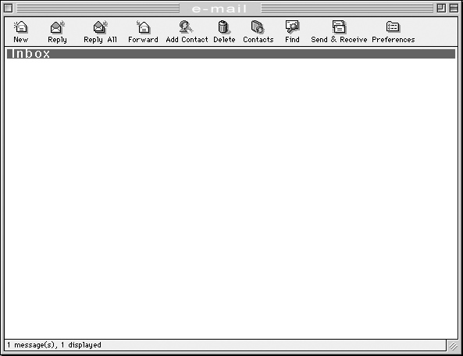

Hi, ___________

Writing the proposal is not very difficult if your group can make use of the information collected and the mini guide. Begin by stating the name of the Asian country and give reasons for your choice. Then select the places that you’d like to visit in the country, and think about what you want to do there. You should prepare an outline before you start writing. I’ve attached the outline and the proposal that we prepared for last year’s competition.

Good Luck.

Gary

Outline of Gary’s proposal

Why we would like to visit

(name of the country)

Introduction
Give details about your group members and your school.
The Body
Paragraph 1
Describe why you would like to go there and where you would like to visit.
Paragraph 2
Describe what you would like to do.
Conclusion
State what you expect to gain or learn from the trip.
89
T Task 2 : A Brief Proposal
Gary’s proposal

Why we would like to visit Greece

We are a group of four Secondary 3 students at Ming Wah Secondary School. We are 14 – 15 years old. Our common interests are travelling, reading and swimming. Our school is in Tsing Yi and there are more than 1,000 students.

We propose to visit Greece because it is a historical country with nice sandy beaches and many ancient sites. We would like to go to Athens, the capital city, and the islands in the Aegean Sea.

In Athens, we hope to visit the Acropolis to get a glimpse of the ancient statues and monuments that we have studied in History lessons at school. After that, we will go to Agora, a marketplace which is situated at the foot of the Acropolis. We will go shopping and dine at some of the restaurants to taste authentic Greek cuisine, like Meat Kebab and Greek Salad. Apart from visiting the capital city, we will go to one of the famous islands, Santorini, for a swim and to experience Greek life in the Aegean.

By visiting Greece, we can know more about Greek history and architecture, how modern Greeks live nowadays as compared to their ancestors, and island life in the Aegean Sea.

90

Now, in about 200 words, write your brief proposal for entering the Asian Travelling Award Competition. Evaluate your draft and get some feedback from your friends to see if you can improve it. You can use the feedback sheet (p.92 – p.93) to do self-assessment and peer assessment. Revise your draft to produce a better piece of work.
T Task 2 : A Brief Proposal

A brief proposal

91
T Task 2 : A Brief Proposal

Feedback Sheet
Task 2: A Brief Proposal

Group : ____________________________
Tick the appropriate box and add comments.

 | ☺  Well Done | 😐  Satisfactory | ☹  Needs Improvement

Task Requirement

- Word limit is followed |  |  | 

Content

- Coverage |  |  | 
- Clarity of ideas |  |  | 
- Relevance of ideas |  |  | 

Organization

- Introduction
- Provides details about the group  - Body  - Ideas are coherently grouped together |    |    |   
- Ideas are in a logical order |  |  | 
- Ideas are linked |  |  | 
- Conclusion
- Ideas are logically developed from the body |  |  | 

92

T Task 2 : A Brief Proposal

 | ☺  Well Done | 😐  Satisfactory | ☹  Needs Improvement

Language & Style  - Meaning is clearly expressed |  |  | 
- Choice of words is appropriate |  |  | 

Grammar
- The proposal is accurate in
- tense |  |  | 
- word order  - subject verb agreement  - connectives  - spelling |        |        |       

Other Comments

*Feedback given by
*This feedback sheet can be used for self-, peer and/or teacher assessment. The person who provides the feedback may put his/her name down if necessary.

________________
(Name)

93
T Task 3 : An Oral Presentation
Task 3: An Oral Presentation


Your group will give an eight-minute oral presentation about a country in Asia to the Selection Board of the HKYTA. According to the requirements of the Board, the presentation should cover the information and content in the mini guide and in the brief proposal. All the group members should take part in the presentation. You are encouraged to use information technology and visual aids during the presentation. For example, you may use maps, photos, graphics and slides.
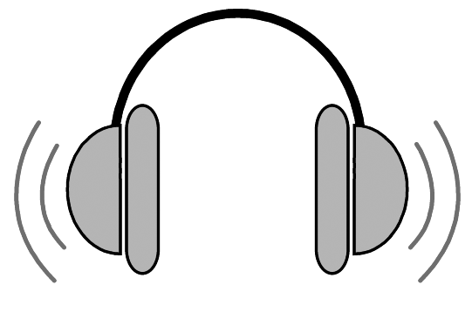
Part A : Attending a briefing session

The HKYTA has arranged a briefing session for applicants of the “Asian Travelling Award Competition” to prepare them for their oral presentations. All the applicants are invited to the HKYTA. Listen carefully and jot down the important points. Complete the list below and refer to it when you prepare your oral presentation.
Oral presentation skills
- Don’t cover every ___________; be selective, precise and focused.
- Use visual aids such as _____________________ and __________________ to help you, so that your audience can _____________________________.
- To add more interest, __________, films and _______________ can be used.
- At the beginning, you should give an _____________ so that your audience can have a better understanding of the structure of your presentation.
- Assign each member more or less the _________ proportion of the job for a balanced division of work.
- Be confident and maintain ______________ with your audience. Look calm and _________ at your audience.
- Pace yourself well; don’t speak too __________ or too _______________.
- You should ___________ some of the words or ideas for emphasis.
- Don’t speak in a _____________. Vary your intonation to give interest to your audience.
- To keep good control of the time, you should ___________ timing yourself before the presentation.
- When you finish, you should ___________ the audience politely.
94
T Task 3 : An Oral Presentation
Part B : Writing an outline and making preparation for producing a script

You have asked your schoolmate, Gary, to help you prepare your presentation. Read his
e-mail message and the attachments.

Hi, _______

So happy to hear that your group has been making good progress in preparing for the competition. Last year I worked with Lily, Simon and Carman. We worked out a brief outline first before writing our script. We made use of the info from our mini guide and proposal and other collected info to prepare our presentation. You can take a look at the attached files to get more ideas before writing your script.

Gary

Presentation outline given by Gary

Outline of a presentation

- Introduction

  - Introduce ourselves
(Ming Wah Secondary School : Gary, Lily, Simon and Carman)
  - Introduce the topic
(Greece)
  - Introduce the main points
(General information, culture, tourist attractions)

- Body

- The first main point with supporting details
General Information about Greece:

    - capital city: Athens
    - weather: warm & wet in spring, dry & hot in summer, dry & cool in autumn, wet & mild in winter
)
- The second main point with supporting details
- The third main point with supporting details

- Conclusion

- Summarize what your group will gain from the visit to the country you have chosen.

95

- situated in southern Europe
- capital city: Athens
- weather: warm & wet in spring, dry & hot in summer, dry & cool in autumn, wet & mild in winter
- religion: Greek Orthodox
- language: Greek
- currency: Euro

- The second main point with supporting details
Culture:
- Festivals: Carnival Season: (Feb-Mar)
Athens Festival: (Jun-Sept)
- Food: Meat Kebab, spinach and cheese pie, Greek Salad
- Drink: Greek coffee, ouzo

- The third main point with supporting details
Tourist Attractions:
  - Acropolis: ancient temple w/ statues & monuments
  - Ancient Theatre of Dionysos: prog of Athens Festival
  - Agora: marketplace for shopping
  - Islands in Aegean Sea: Santorini & Mykonos famous for sandy beaches

- Conclusion

- Summarize what our group will gain from the visit to the country we have chosen
  - know more about the country
  - present vs past

T Task 3 : An Oral Presentation

96
T Task 3 : An Oral Presentation
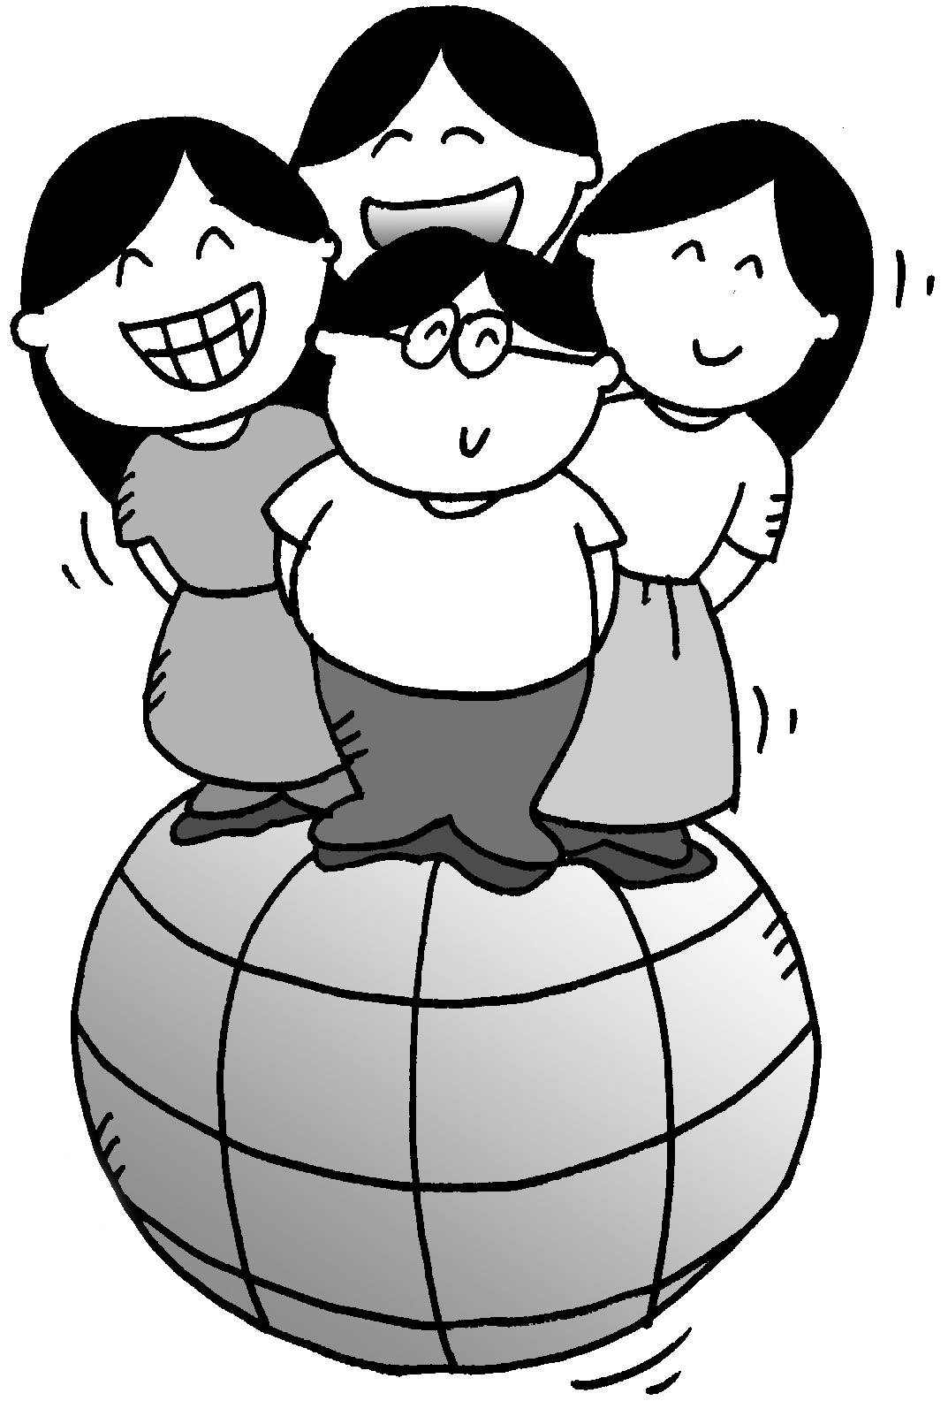
Script of the presentation given by Gary

Gary: Good morning, everyone. We’re from Ming Wah Secondary School. Today, we’re going to talk about an ancient country, Greece, which we would like to visit. There are three main points in our presentation. First, we’ll give you some general information about Greece. Then, its culture. Finally, some of the tourist attractions there.

Lily: First of all, we’d like to introduce some general information about Greece. Greece is situated in southern Europe and its capital city is Athens. It’s wet and warm in spring, dry and hot in summer, dry and cool in autumn, and wet and mild in winter. The major religion in Greece is Greek Orthodox. The people there speak Greek. The currency they use nowadays is the Euro, as Greece is a member of the European Union, but they used to have the Drachma before 2002. Now I hope you have some basic ideas about the country.

Simon: Secondly, what attracts us most is the Greek culture. The Greeks have many celebrations throughout the year. The Carnival Season is celebrated in February and March with feasting and traditional dancing. From June to September, it’s the Athens Festival. There are drama and music performances in ancient theatres. The Greek cuisine also plays a very important part in the Greek culture. Meat kebab, spinach and cheese pie, and Greek salad are very popular dishes. The Greeks like to drink chilled Greek coffee and ouzo, which is a type of wine often drunk with water. Watch out, it’s quite strong.

Carman: Apart from its culture, Greece has a lot of tourist attractions. In Athens, there are many ancient sites. The Acropolis is one of them. It’s an ancient temple with statues and monuments. The Ancient Theatre of Dionysos is situated at the foot of the Acropolis. Some of the programmes of the Athens Festival are performed there. For shopping, Agora, which is a marketplace, is very famous for selling souvenirs. In addition to the ancient sites and the marketplace, the Greek islands in the Aegean Sea are also worth visiting. Santorini and Mykonos are famous for their nice sandy beaches.

Gary: In conclusion, Greece is a country which is worth visiting. If we can visit Greece, we’ll know more about this ancient country, the interesting places there, its culture and how modern Greeks live nowadays as compared to their ancestors.
Thank you.

97

T Task 3 : An Oral Presentation
Work in your group to draft the outline of your presentation below.

Outline of a presentation

Introduction

Body

Conclusion

98

Read the script from Gary (p.97) again and jot down the useful phrases or sentences in the spaces provided on the notepad below to help you write your script. The first one has been done for you.
T Task 3 : An Oral Presentation

Notepad: Script of the presentation given by Gary

Introduction

How to introduce ourselves:

“We’re from Ming Wah Secondary School.”

How to introduce the topic:

How to introduce the main points:

Body

How to introduce the first main point:

How to introduce the second main point:

How to introduce the third main point:

Conclusion

How to give an explicit conclusion:

99

Your English teacher has also given you some excerpts from another presentation script for your reference. Read the excerpts and jot down the useful phrases or sentences in the spaces provided on the notepad (p.101) to help you write your own script.
T Task 3 : An Oral Presentation

Excerpts from another presentation script

Good afternoon, ladies and gentlemen. We’re S.4 students from North Point School. We’d like to introduce Egypt to you. Firstly, we’ll cover some general information about Egypt. Secondly, its ancient culture. Lastly, its historic relics.

To begin with, we’ll give you some information about Egypt. Egypt is situated in northern Africa and Cairo is the capital city. It’s hot and dry in summer and cool and wet in winter. Most of the people are Muslims …

Next, the Egyptian culture. Most of the celebrations follow the Islamic calendar. Ramadan is celebrated during the ninth month of the calendar …

In addition to its culture, Egypt has many historic relics. In Cairo, the most popular ones are the Giza Pyramids which were completed around 2600 BC …

To summarize, we can learn more about this ancient civilization, the Islamic culture …

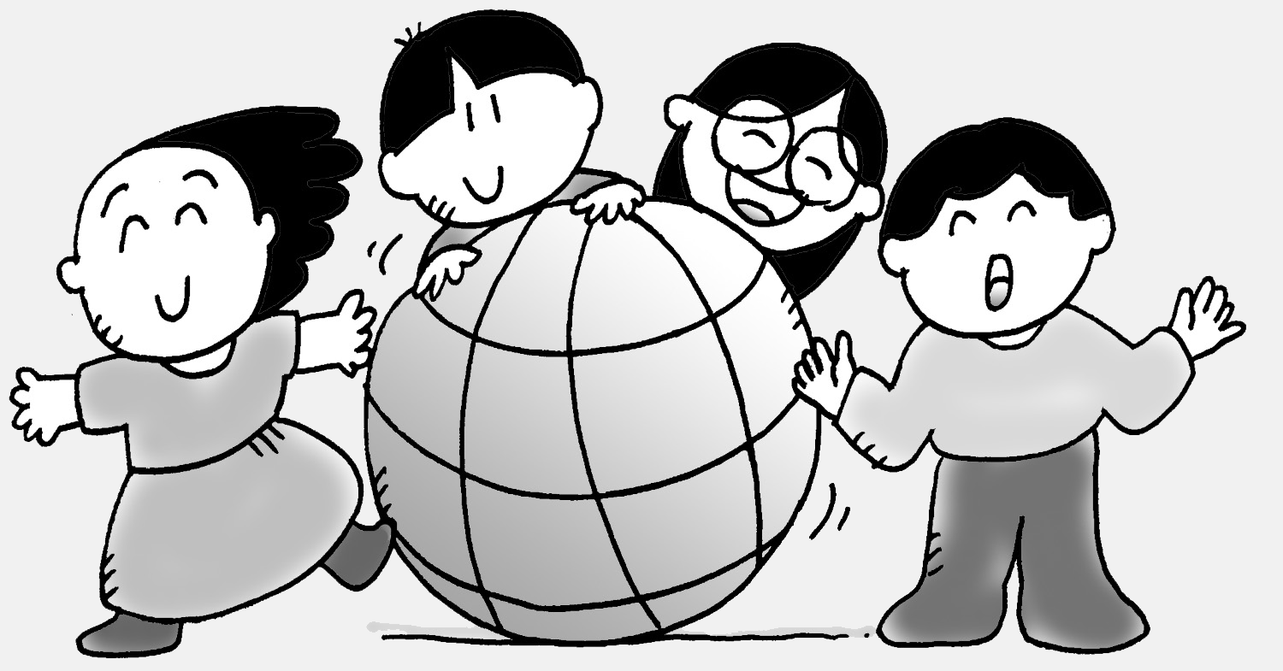

100

Notepad: Another presentation script
T Task 3 : An Oral Presentation

Introduction

How to introduce ourselves:

How to introduce the topic:

How to introduce the main points:

Body

How to introduce the first main point:

How to introduce the second main point:

How to introduce the third main point:

Conclusion

How to give an explicit conclusion:

101

Part C : Writing a script for an oral presentation
T Task 3 : An Oral Presentation


Now, each member of the group has to draft the script for his or her part of the presentation. Refer to your mini guide in Task 1, your brief proposal in Task 2, the notes on presentation skills in Part A and the useful phrases and sentences in Part B of this Task. Write your draft, read it again and revise it if necessary.

A presentation script


102
T Task 3 : An Oral Presentation

Part D : Preparing cue cards

To help you deliver your presentation, you can prepare some cue cards.
Gary has sent you the outline and the script of his group’s presentation.

Gary’s cue cards


- Introduction (by Gary)

(opening) “Good morning, we’re from Ming Wah Secondary School. Today, we’re going to talk about … There are three main points in our presentation.”

  - General info on Greece
  - Culture
  - Tourist Attractions

-1-

2. Body (by Lily)

  - General Info on Greece

(transition) “First of all, we’d like to introduce some general information about Greece.”

    - situated in southern Europe
    - capital city: Athens
    - weather: warm & wet in spring, dry & hot in summer, dry &
cool in autumn, wet & mild in winter
    - religion: Greek Orthodox
    - language: Greek
    - currency: Euro

-2-

103

T Task 3 : An Oral Presentation

- Culture (by Simon)

(transition) “Secondly, what attracts us most is the Greek culture.”

    - Festivals: Carnival Season: (Feb-Mar)
Athens Festival: (Jun-Sept)
    - Food: Meat Kebab, spinach and cheese pie, Greek Salad
    - Drink: Greek coffee, ouzo

-3-

- Tourist Attractions (by Carman)

(transition) “Apart from its culture, Greece has a lot of tourist attractions.”

  - Acropolis: ancient temple w/ statues & monuments
  - Ancient Theatre of Dionysos: prog of Athens Festival
  - Agora: marketplace for shopping
  - Islands in Aegean Sea: Santorini & Mykonos famous for sandy
beaches

-4-

104
T Task 3 : An Oral Presentation

- Conclusion (by Gary)

(transition) “In conclusion, …”

- know more about the country
- present vs past

-5-

Using your group's presentation outline (p.98) and script (p.102), each of you should develop the cue card(s) for your part in the presentation.

Cue card

105

T Task 3 : An Oral Presentation
Part E : Delivering an oral presentation in class

Your group has entered the “Asian Travelling Award Competition”. You and your group members are going to give an oral presentation for about eight minutes. Your group members should take turns to present their parts. You can use cue cards and visual aids to help you present clearly. Maps, photos, graphics, slides, etc. can be used to make your presentation more interesting.

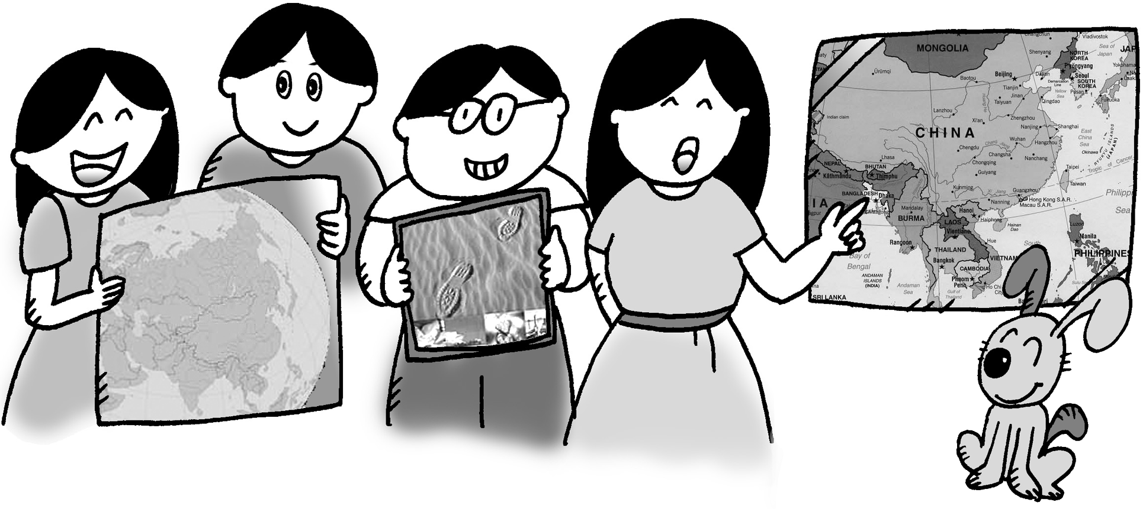

Your group has decided to deliver the presentation to your class first as a rehearsal before presenting it to the Selection Board of the HKYTA. Remember to practise speaking aloud and using the cue cards and visual aids before you give your presentation in class.

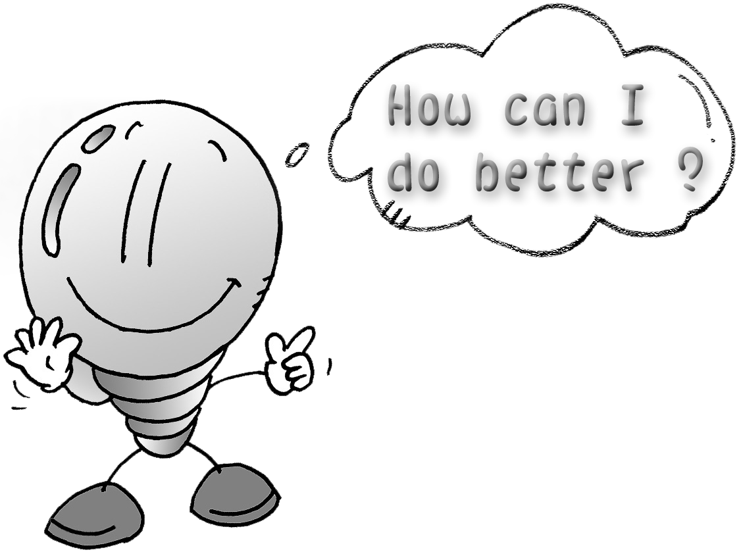
Reflect on your performance during your practice and try to do better in the class presentation. To get some feedback from your classmates so that you can perform better in the presentation to the Selection Board, ask your classmates to fill in a feedback sheet (p.107 – p.108) as they listen to your presentation.

106
T Task 3 : An Oral Presentation
Feedback Sheet
Task 3: Oral Presentation

Group: __________________________________

Tick the appropriate box and add comments.

 |  | ☺  Well Done |  | 😐  Satisfactory |  | ☹  Needs Improvement

Task Requirement

- Observes time limit |  |  |  |  |  | 
- Smooth transitions between presenters |  |  |  |  |  | 

Content

- Coverage |  |  |  |  |  | 
- Clarity of ideas |  |  |  |  |  | 
- Relevance of ideas |  |  |  |  |  | 

Organization

- Introduction |  |  |  |  |  | 
- Body  (e.g. main points with examples or explanation, logical development of ideas) |  |  |  |  |  |  |  | 
- Conclusion |  |  |  |  |  | 

Communication Strategies
 | Presenter |  | ☺  Well Done |  | 😐  Satisfactory |  | ☹  Needs Improvement
- Shows confidence | 1 |  |  |  |  |  | 
 | 2 |  |  |  |  |  | 
 | 3 |  |  |  |  |  | 
 | 4 |  |  |  |  |  | 
- Effective use of non-verbal features | 1 |  |  |  |  |  | 
(e.g. eye contact, gestures, postures, pauses) | 2 |  |  |  |  |  | 
 | 3 |  |  |  |  |  | 
 | 4 |  |  |  |  |  | 

107

T Task 3 : An Oral Presentation

 | Presenter | ☺  Well Done | 😐  Satisfactory | ☹  Needs Improvement
Pronunciation, Fluency, Voice & Pace | 1 |  |  | 
 | 2 |  |  | 
 | 3 |  |  | 
 | 4 |  |  | 
Language and Style | 1 |  |  | 
(e.g. choice of words and expressions, | 2 |  |  | 
degree of formality) | 3 |  |  | 
 | 4 |  |  | 
Grammar | 1 |  |  | 
 | 2 |  |  | 
 | 3 |  |  | 
 | 4 |  |  | 
Visual Aids | 1 |  |  | 
 | 2 |  |  | 
 | 3 |  |  | 
 | 4 |  |  | 

Other Comments

*Feedback given by

__________________
( Name )

* This feedback sheet can be used for self-, peer and/or teacher assessment. The person who provides the feedback may put his/her name down if necessary.

108

