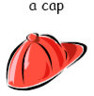
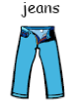
My Favourite Clothes – Worksheet A

Read the questions and write your answers in the boxes under You.

 | You | Your partner
1. What are your favourite clothes?

2. Who gave you these clothes? |  | 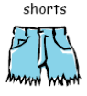
3. Did you get any clothes for your birthday? |  | 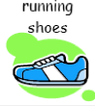
4. Did you get any clothes for Christmas?

5. What do you do with your old clothes? | 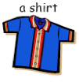
6. What new clothes would you like?


Now ask your partner the questions and write his/her answers under Your partner.

