The First Marathon

1. Match the country with the nationality.
Greece  Sparta  Persia | Persians  Greeks  Spartans

2. Athens and Marathon are both cities in _________.

3. In 490 BC there was a big war between the _________ and the _________.
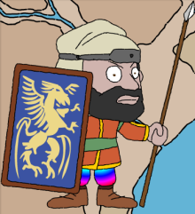
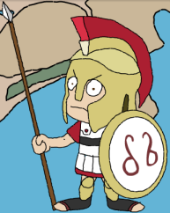
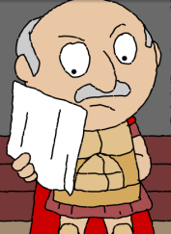
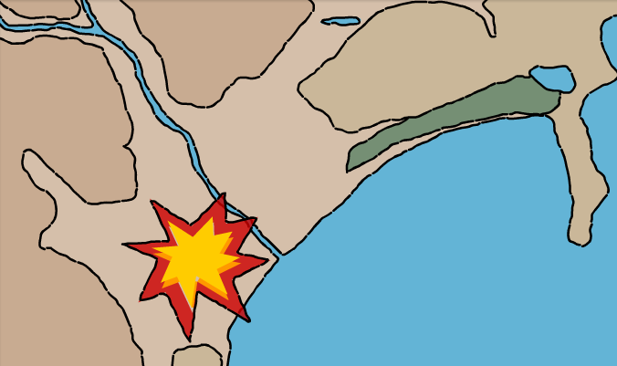
Persia
Marathon
Sparta
Greece

4. Although the _________ army had more soldiers, the _________ army won the war.

5. In 490 BC there was a big (a) ______ between the Persians and the Greeks. Persia wanted to capture (b) ____________. The Persians arrived at Marathon in Greece. They had more (c) ________________ than the Greeks. The Greeks sent a messenger to Sparta to get help. The messenger ran for (d) ______ days over the mountains of Marathon to Sparta. The Spartans couldn’t help and the messenger ran back to (e) ________________. The Greeks and Persians fought, and the Greeks won. The messenger ran to (f) ____________ to tell everybody that the Greeks had won. He ran more than (g) ____ kilometres to Athens, and then he (h) ________. This was the first marathon.

