The Greedy Hippo - Answers
Part 1 Put the sentences in the correct order by numbering the strips.
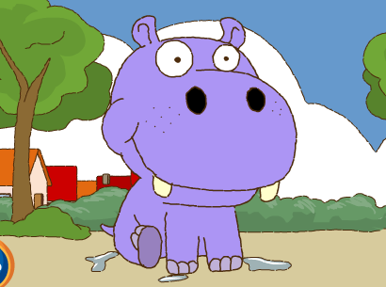
a. _1. _ There was a greedy hippo.
b. _6._ The animals were very angry and played a trick on him.
c. __5._ Out he popped and he ran to the table and ate their food.
d. _ 9._ Something wasn’t right. He felt sick. Oh no! He had a tummy ache!
e. _3.__ He began to shout “Help! Pull me out!”
f. _10. _ Hippo learnt his lesson and left the town. Goodbye!
g. _8._ Hippo swallowed the special pie and jumped back into the lake.
h. _4.__ The animals all pulled and pulled.
i. __2.__ One morning he jumped into the lake and was stuck.
j. __7.__ They made a fish and soap pie!

Part 2
What happened to Hippo next? Rewrite the following text using correct spelling, punctuation and capital letters.

whenhearrivedinthenexttownhippodecidednottobegreedyimgoingtobeakind
andgeneroushippofromnowonhesaidhesharedhisfoodwiththeotheranimalsandmadelotsofnewfriends

When he arrived in the next town, Hippo decided not to be greedy. “I’m going to be a kind and generous hippo from now on”, he said. He shared his food with the other animals and made lots of new friends.

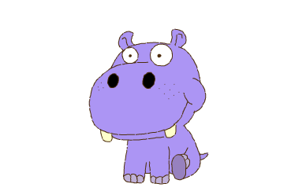
Part 3
Can you make up a different ending to the story?

