The Greedy Hippo
Part 1 Put the sentences in the correct order by numbering the strips.
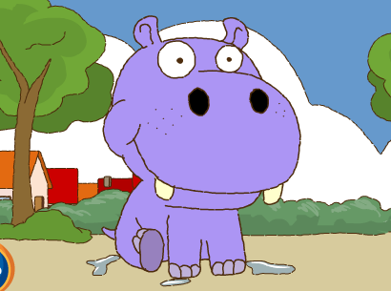
a. _1. _ There was a greedy hippo.
b. _____ The animals were very angry and played a trick on him.
c. _____ Out he popped and he ran to the table and ate their food.
d. _____ Something wasn’t right. He felt sick. Oh no! He had a tummy ache!
e. _____ He began to shout “Help! Pull me out!”
f. _____ Hippo learnt his lesson and left the town. Goodbye!
g. _____ Hippo swallowed the special pie and jumped back into the lake.
h. _____ The animals all pulled and pulled.
i. _____ One morning he jumped into the lake and was stuck.
j. _____ They made a fish and soap pie!

Part 2
What happened to Hippo next? Rewrite the following text using correct spelling, punctuation and capital letters.

whenhearrivedinthenexttownhippodecidednottobegreedyimgoingtobeakind
andgeneroushippofromnowonhesaidhesharedhisfoodwiththeotheranimalsandmadelotsofnewfriends

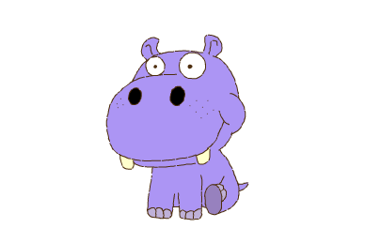
Part 3
Can you make up a different ending to the story?

