My Favourite Day - Answers
Listen to or read the information texts and complete the table below.

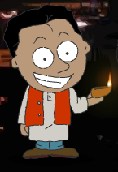 | When? | Clothes? | Decorations? | Gifts? | Activities? | Fireworks?
Diwali | November and October | special clothes | √ - candles and clay lamps (diyas) in windows / roofs | √ - barfi (coconut sweets) | √ - play card games | √
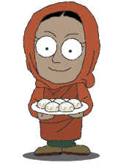  Eid al-Fitr | end of Ramadan | best clothes | √ - lights and decorations on homes | √ - money | √ - street fairs: music, dancing, kids’ games | √
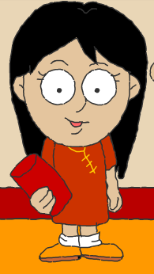  Chinese New Year | beginning of spring | red clothes | √ (accept all correct answers - though not mentioned in story) | √ - oranges, tangerines, lucky money | √ - carry lanterns, Lion Dance | √ (though not mentioned in story)

Now write about your favourite festival.
My favourite festival is _______________________________ .

During the festival, we . . .

