My Favourite Day
Listen to or read the information texts and complete the table below.

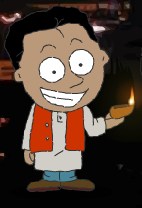 | When? | Clothes? | Decorations? | Gifts? | Activities? | Fireworks?
Diwali | November and October
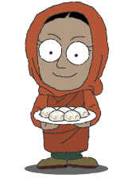  Eid al-Fitr | end of Ramadan
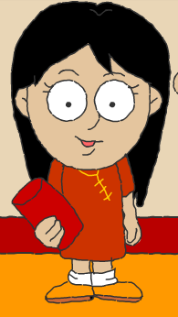  Chinese New Year | beginning of spring

Now write about your favourite festival.
My favourite festival is _______________________________ .

During the festival, we . . .

