www.britishcouncil.org/learnenglishkids

No Dogs, Please!

These activities are about the story – No Dogs, Please! You can read and listen to the story on the
LearnEngish Kids website:
http://learnenglishkids.britishcouncil.org/short-stories/no-dogs

1) Have you read the story? Who said what?

M=Mum, K=Katie, J=Jaia, D=Jessie the dog | Write M, K, J or D
a) “Can we go to the park?”
b) “Come on! Let’s see how high we can go on the swings!”
c) “You can’t come in here!”
d) “Did you have a nice time?”
e) “Yes, it was brilliant! I went the highest!”
f) “No, I went the highest!”
g) “Wooooof!”
h) “I went the highest!”

2) Read the sentences and write the numbers next to the pictures of Jessie:

a) He went on the swing.

b) He bounced on the springy.

c) He went up and down on the see-saw. d) He whizzed round on the roundabout. e) He climbed up the ladder.
f) He went down the slide.

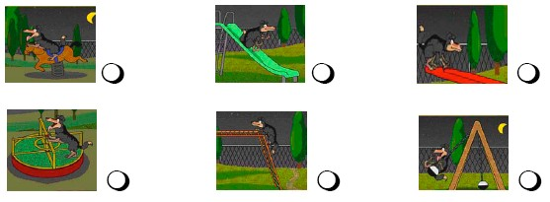

© The British Council, 2009

The United Kingdom’s international organisation for educational opportunities and cultural relations. A registered charity : 209131 (England and Wales) SC037733 (Scotland).

