The Twins’ Week – Answers

Read these sentences about the Twins’ Week and correct the wrong information.
shower
- On Mondays, the twins take a bath with the hippos.

fish
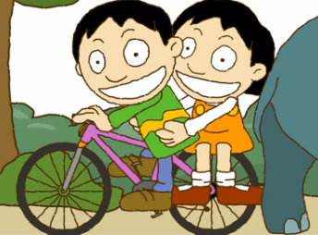
- They watch TV with the shark.

breakfast
- On Tuesdays, they eat lunch with the pandas and frogs.

dogs
- They eat dinner with the chimps, cats and fish.

teeth
- On Wednesdays, the twins clean their shoes with the crocodiles.

rhino
- They ride their bikes with the chimps.
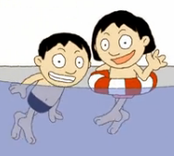
football
- On Thursdays, they play tennis with parrots.

homework
- On Fridays, the twins do their shopping with the octopus.

shopping
- On Saturdays, they go swimming with the kangaroos.

walk
- On Sundays, the twins take a shower in the zoo.

Now write some sentences about what you do during the week.
a. On Mondays, I ______________________________________________ .

b. On Tuesdays, I ______________________________________________ .

c. ___________________________________________________________ .

d. ___________________________________________________________ .

e. ___________________________________________________________ .

f. ___________________________________________________________ .

g. ___________________________________________________________ .

