The Treasure Map - Answers 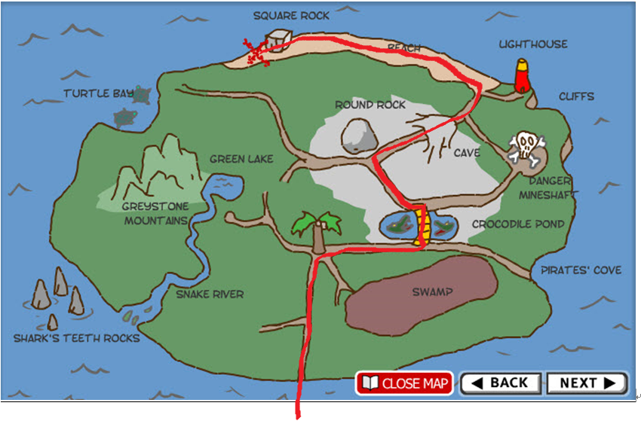
North
the treasure
start

