The Treasure Map 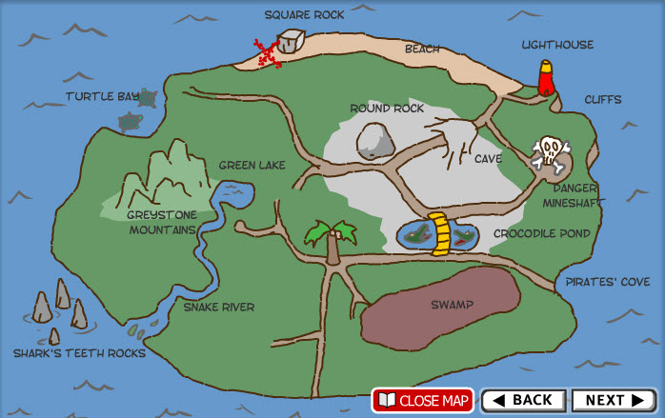
North
the treasure
start

