Look out, Angel! -- Answers

Part A
1. Which of these animals do you think are dangerous?
Answers: dangerous animals highlighted in red. Numbers = order in the story.

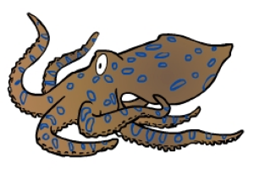
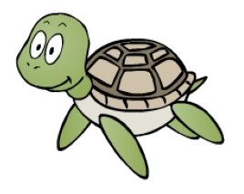
2. blue-ringed octopus 6. box jellyfish 3. stone fish 1. turtle

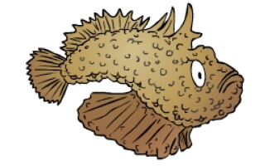

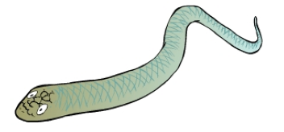
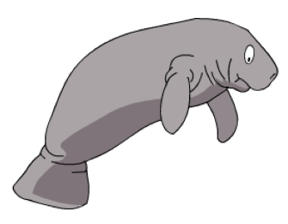
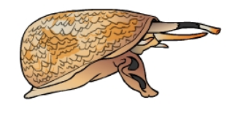
7. dugong 5. sea snake 4. cone shell

2. Use numbers to put the animals in the same order as Angel met them in the story.

Part B
1. Match up these rules for staying safe.

a. Always | keep your bag closed.
b. Never | talk to strangers.
c. Always | remember your address.
d. Never | run across the road.

2. Now write some more rules that you know.

a.

b.

c.

d.

