Look out, Angel!

Part A
1. Which of these animals do you think are dangerous?

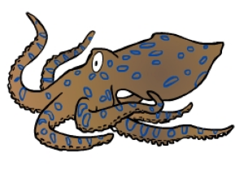
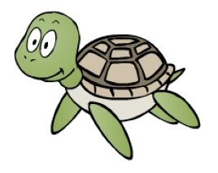
blue-ringed octopus box jellyfish stone fish turtle

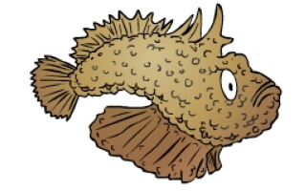

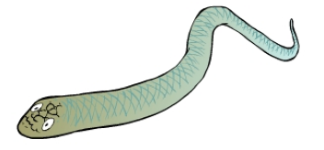
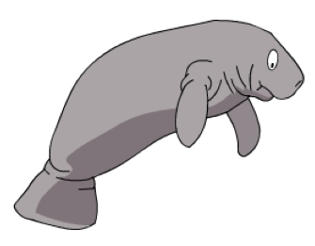
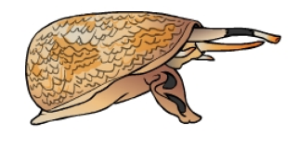
dugong sea snake cone shell

2. Use numbers to put the animals in the same order as Angel met them in the story.

Part B
1. Match up these rules for staying safe.

a. Always |  | - talk to strangers.
b. Never |  | - keep your bag closed.
c. Always |  | - run across the road.
d. Never |  | - remember your address.

2. Now write some more rules that you know.

a.

b.

c.

d.

