Everything under the Sea
Fill the gaps in the song with the correct words from those listed below.

Chorus:
There was a cod, there was a hake
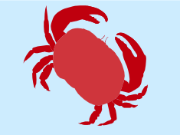
There was a lobster and a crab and a sea ^{1.} ____________
There was a squid and a whale
And sliding on the rocks there was a sea ^{2.} ____________

Everything beneath the sea
Gliding, sliding, swimming ^{3.} ____________
Jellyfish and things that glow
Swimming way down deep below
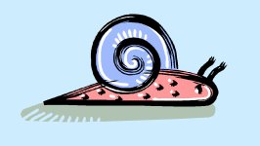
Chorus

Life is in the waves that land
Crashing on the rocks or ^{4.} ____________
Creatures moving everywhere
Would you like to join them ^{5.} ____________

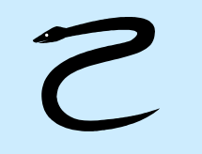
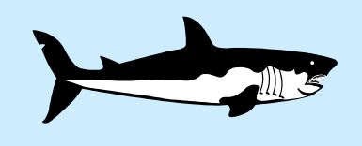
There is a cave, Oh so dark
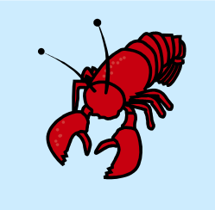
And hiding just inside there is a big ^{6.} ____________
He wants a meal but never fear
He can’t eat you if you don’t go ^{7.} ____________
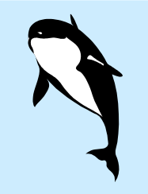
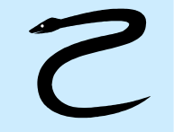
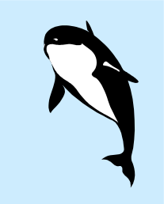
Everything beneath the sea
Gliding, sliding, swimming free
Jellyfish and things that ^{8.} ____________
Swimming way down deep below

There was a cod.
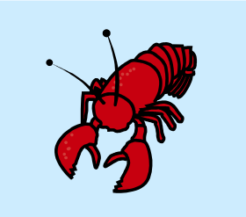
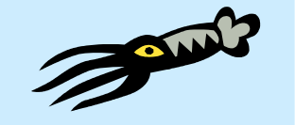
_ _ _ _ _ _ _ _ _ _ _ _ _ _ _ _ _ _ _ _ _ _ _ _ _ _ _ _ _ _ _ _ _ _ _ _ _ _ _ _ _
Fill the gaps using the words below.

sale snail snake three free sand send there here shock shark leer near go glow

