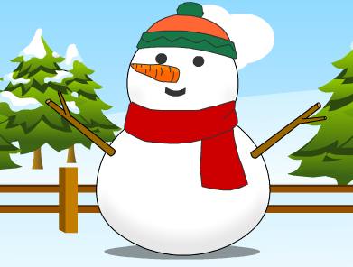
The Snowman (Answers)

Here is the Snowman story, but some of the verbs
are missing. Can you fill the gaps with the correct
verb in the correct tense?

Katie 1. woke up and found snow outside.

Katie and her brother Eddie, 2. made a huge snowman.

On Christmas Eve, the snowman 3. waved at them. “Would you like a present?” he asked.

Suddenly, it 4. started to snow. It was a very beautiful present.

Katie and Eddie 5. gave the snowman a present, too.
They 6. put a carrot on his face, a scarf around his neck and a hat on his head.

They all 7. wished each other “Happy Christmas!”

Then it 8. stopped snowing and the sun 9. came out. The snowman slowly 10. melted. “Goodbye!” he said. “Build me again next year!”

_ _ _ _ _ _ _ _ _ _ _ _ _ _ _ _ _ _ _ _ _ _ _ _ _ _ _ _ _ _ _ _ _ _ _ _ _ _ _ _ _

Verbs from the story. Three are not needed.

make give wave do wish stop melt come wake up
put snow say start

