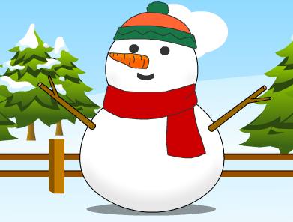
The Snowman

Here is the Snowman story, but some of the verbs
are missing. Can you fill the gaps with the correct
verb in the correct tense?

Katie 1. ____________ and found snow outside.

Katie and her brother Eddie, 2. ____________ a huge snowman.

On Christmas Eve, the snowman 3. ____________ at them. “Would you like a present?” he asked.

Suddenly, it 4. ____________ to snow. It was a very beautiful present.

Katie and Eddie 5. ____________the snowman a present, too.
They 6. ____________ a carrot on his face, a scarf around his neck and a hat on his head.

They all 7. ____________ each other “Happy Christmas!”

Then it 8. ____________ snowing and the sun 9. ____________ out. The snowman slowly 10. ____________. “Goodbye!” he said. “Build me again next year!”

_ _ _ _ _ _ _ _ _ _ _ _ _ _ _ _ _ _ _ _ _ _ _ _ _ _ _ _ _ _ _ _ _ _ _ _ _ _ _ _ _

Verbs from the story. Three are not needed.

make give wave do wish stop melt come wake up
put snow say start

