
The Great Race

A: Can you fill the gaps in the story?

Long ago in China the a. ____________ decided to have a race to name the years of the Zodiac. The b. ____________ and the cat couldn’t swim so they rode across the river on the back of the c. ____________ . The rat arrived first!

The d. ____________ was very tired from swimming. The e. ____________ was very intelligent and went across on a tree trunk. The f. ____________ was very late because he helped people on the way. The g. ____________ got a ride on the horse’s leg.

The goat, the monkey and the h. ____________ arrived together. The
i. ____________ was slow because he had a bath in the river. The last animal to arrive was the j. ____________ .

B: Answer the following questions in complete sentences.

- How did the rat come first in the race?
___________________________________________________________

___________________________________________________________

___________________________________________________________

- Do you think the Emperor’s decisions are fair? Why / why not?
__________________________________________________________

__________________________________________________________

__________________________________________________________

C: Here are the twelve animals that finished the race. Write the correct ordinal numbers under each picture.

 |  |  | 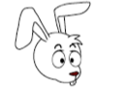
1st - first
 |  | 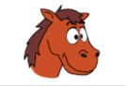 | 
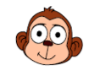 |  |  | 

Thirteen animals started the race. Which one is missing and why?

______________________________________________________________

______________________________________________________________

