**Our Precious Water Resources**

Student Version

**Situation:**

Water-wise Kids is a new club that aims at promoting water conservation in your school. You are chosen by your teacher to be a Water-wise Ambassador. Your task is to spread the message of saving water at school and at home.

In the following activities, you will learn about the importance of water, and realise that clean water is not free. You will also participate in role-play activities to learn how to tell others the importance of saving water and ways to do so.

**Part 1 – Warm-up Activities**

1. How much water does your family use every day? Read the sample water bill to get more ideas. Ask your parents for a water bill and complete the table below.

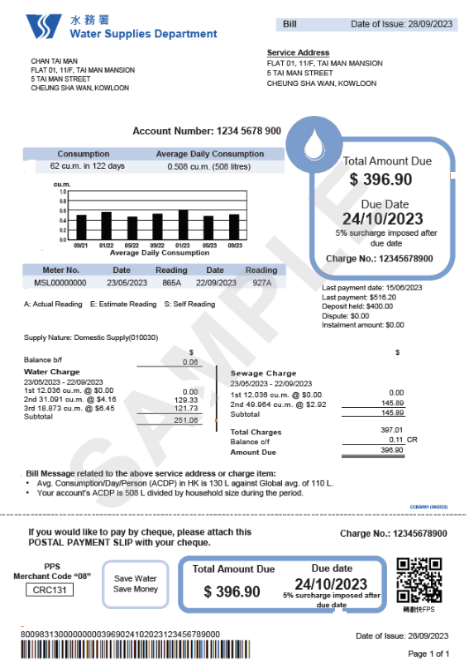

The [sample water bill](https://www.wsd.gov.hk/filemanager/en/content_1973/How%20to%20read%20water%20bill_2023.09.19%20-%20Domestic%20-%20ENG.pdf) is taken from the website of Water Supplies Department.

Supply Nature: Domestic Supply (010030)

Balance of

**Water Charge**

23/05/2023-22/09/2023

Period

Total amount

Number of days

Average daily consumption

Due date

|  |  |  |  |  |
| --- | --- | --- | --- | --- |
| **Water Bill** | **Period (days)** | **Average Daily Consumption** | **Total Amount** | **Due Date** |
| Sample | 23/05/2023 – 22/09/2023  (122 days) | 508 litres | $396.90 | 24 October 2023 |
| Your water bill |  |  |  |  |

1. We need water in our daily lives. What do you use water for? Complete the diagrams below by filling in the daily water use in your family and in the community. You may use the key words in the table below.

|  |
| --- |
| taking a shower producing clothes drinking washing clothes |
| keeping farm animals washing dishes putting out fires mopping the floor |
| washing the streets cooking growing vegetables |

**Domestic water use** (using water at home)

**Diet**

**Cleaning**

e.g. washing clothes

**Community water use** (using water in other places)

**In factories and farms**

**In the city**

**Part 2 – Reading a magazine article**

We use a lot of water every day. Do you know where the water comes from? Read the magazine article to find out the information.

|  |  |
| --- | --- |
| **Where Does Water Come from?**  Hong Kong is a city full of tall buildings and millions of people live in it. However, there are not any natural lakes, large rivers or underground water. It is challenging to ensure that there is a stable and adequate water supply to meet the needs of Hong Kong citizens.  Existing Water Resources  There are three ways of getting water in Hong Kong. Firstly, rainwater is collected and stored for use. Secondly, the government brings in water from Dongjiang River in Guangdong and it is the major source of water supply. Lastly, seawater is used for flushing toilets. | |
| Collecting Rainwater  People in Hong Kong used a lot of water—1,385 million cubic metres in 2022! To collect water, Hong Kong has developed water gathering grounds where rainwater is gathered and stored. Most of these areas are also part of our country parks, which help protect our precious natural environment. Even with all these efforts, the water we collect from local sources only meets about 19% of our water needs.  Importing Water from Dongjiang River |  |
| The fresh water we get from local sources is not enough. In the 1960s, there was a serious drought and the government had to exercise water rationing. Sometimes, the water supply to the public could only be made for four hours every four days. So, to make sure we have enough water, Hong Kong has been bringing in water from Dongjiang since 1965. It travels a long distance of more than 70 kilometres!  Using Seawater for Flushing  In many places around the world, fresh water is still used for flushing toilets. We are proud that Hong Kong is one of the few places extensively applying seawater for flushing. It is a sustainable way to manage water. In 2022, we used about 320 million cubic metres of seawater and saved the same amount of fresh water. It is an important way to conserve our precious water resources.  Water is something we all need. Let's remember to save water and use water wisely. We should also be grateful for the efforts made to bring water to our homes. Together, we can help protect our water resources in Hong Kong! | |

The reading text is adapted from the article “Water Resources in Hong Kong” of Water Supplies Department: <https://www.waterconservation.gov.hk/en/why-save-water/water-resources/index.html>

Answer questions 1 to 5. Choose the best answer by blackening the circle.

1. **Where does most of the water in Hong Kong come from?**

|  |  |  |
| --- | --- | --- |
|  | a. | From rainwater |
|  | b. | From Guangdong |
|  | c. | From local sources |
|  | d. | From seawater |

1. **Why did the government exercise water rationing in the 1960s?**

|  |  |  |
| --- | --- | --- |
|  | a. | The water supply was only available every four days. |
|  | b. | There was not enough seawater for toilet flushing. |
|  | c. | The water travelled from far away. |
|  | d. | There was no rain for a long time. |

1. **When did Hong Kong first import water from Guangdong?**

|  |  |  |
| --- | --- | --- |
|  | a. | In the 1950s |
|  | b. | In the 1960s |
|  | c. | In the 1990s |
|  | d. | In the 2020s |

1. **Why is it good to use seawater for flushing? (You can choose more than one option.)**

|  |  |  |
| --- | --- | --- |
|  | a. | Many places use fresh water for flushing. |
|  | b. | It can save the water resources in Hong Kong. |
|  | c. | Many people do not have water for flushing. |
|  | d. | It can reduce the use of fresh water. |

1. **What is the key message of the magazine article?**

We should

|  |  |  |
| --- | --- | --- |
|  | a. | appreciate the use of seawater for drinking and cooking. |
|  | b. | reduce the use of water and protect the water resources. |
|  | c. | visit and appreciate the water gathering areas and the natural environment. |
|  | d. | reduce the import of water from Dongjiang River. |

1. **You have read a lot of interesting figures and information about water sources and supply in Hong Kong. Jot down three interesting pieces of information in the spaces provided.**

|  |
| --- |
|  |
|  |
|  |

**Part 3 – Conducting role-plays**

Water is precious, and we should all save water. How can we spread this important message to other people?

In the script below, you will be meeting a few “water wasters” at school and at home. As a Water-wise Ambassador, you are going to talk to these people and give them ideas about ways to save water.

You may visit the following webpage of Water Supplies Department for tips on saving water at home: <https://www.waterconservation.gov.hk/filemanager/en/content_72/home-water-audit-home-water-saving-tips-e.pdf>

1. Read the script of Scene 1 below. Underline **FIVE** ways we can save water at school. Then read the tips on how to start a conversation and persuade people in the boxes on the right.

Use **facts** to support your opinions.

Ask a **rhetorical question** to make listeners think or take action. We do not expect them to answer it. Other examples:

* Would you want to live in a place without clean water?
* Did you know that Hong Kong uses more than 1,300 million cubic metres of water every year?

**Tips**

There are different ways to interrupt someone and **start an interaction**, e.g.:

* Do you have a moment/minute?
* Do you mind if I talk to you?

|  |  |  |  |  |  |  |  |  |  |  |  |  |  |  |  |  |  |  |  |  |  |  |  |  |  |  |  |  |  |  |  |  |  |  |  |  |  |  |
| --- | --- | --- | --- | --- | --- | --- | --- | --- | --- | --- | --- | --- | --- | --- | --- | --- | --- | --- | --- | --- | --- | --- | --- | --- | --- | --- | --- | --- | --- | --- | --- | --- | --- | --- | --- | --- | --- | --- |
| **Title: Water-wise Kids to the rescue – at school**  **Scene 1**  *Characters*  You : A Water-wise Ambassador Sam & Chris : Your classmates who love playing with water  *Setting*  Sam and Chris are splashing water at each other happily at the school toilet during recess. Both taps are running.   |  |  | | --- | --- | | You: | *(waves at Sam and Chris)* Hi Sam, Hi Chris, **can I talk to you for a moment?** | | Sam: | Okay, what’s up? | | Chris: | Do you want to join our water splashing game? | | You: | Let’s turn off the taps first… *(turns off both taps)* | | Chris: | *(puzzled)* What are you doing? | | You: | Saving water. Leaving the tap running will waste a lot of water. | | Chris: | *(crosses arm)* You’re so bossy. | | Sam: | Come on. It’s fun to play with water. | | You: | Well, **do you know where the tap water comes from**? | | Sam & Chris: | *(shrug together)* | | You: | **Most of the tap water is bought from Dongjiang, which is a river in Guangdong Province 70 km away.** | | Chris: | Wow, I didn’t know that. I thought water was free. | | You: | **Water resources are precious and many people in the world suffer from droughts**. We should not play with water. I’m sure there are other ways to play and have fun. **Let’s** play ball games instead. | | Sam: | That sounds like a good idea. | | Chris: | What else can we do to save water at school? | | You: | Do you see that leaking tap over there? We **can** report leaks to a teacher, so that the adults can fix them. | | Sam: | I have another idea. We **can** also use a cup or bucket when washing paintbrushes after our painting lessons. | | You: | That’s a great idea! **Why don’t you** both join the Water-wise Kids and save water together? | | Sam & Chris: | Okay, let’s do that! *(high five with you)* | |

There are many ways to **make** **suggestions**, e.g.

* Let’s…
* We can…
* We should…
* Why don’t we…

State your **opinion** clearly and support them with reasons or facts.

1. Act out Scene 1 above with your fellow ambassadors.
2. Now you will try to talk to your family about saving water at home. Complete Scene 2 of the script and act it out with your fellow ambassadors. If you want to be creative and challenge yourself, complete Scene 3 too.

|  |  |  |  |  |  |  |  |  |  |  |  |  |  |  |  |  |  |  |  |  |  |  |  |  |  |  |  |  |  |  |  |  |  |  |  |  |  |  |  |  |  |  |  |  |
| --- | --- | --- | --- | --- | --- | --- | --- | --- | --- | --- | --- | --- | --- | --- | --- | --- | --- | --- | --- | --- | --- | --- | --- | --- | --- | --- | --- | --- | --- | --- | --- | --- | --- | --- | --- | --- | --- | --- | --- | --- | --- | --- | --- | --- |
| **Title: Water-wise Kids to the rescue – at home**  **Scene 2**  *Characters*  You : A Water-wise Ambassador Sarah : Your sister who doesn’t care about saving water  *Setting*  Outside the bathroom at home. Sarah is walking out of the bathroom.   |  |  | | --- | --- | | Sarah: | *(drying hair with towel)* | | You: | Hey, Sarah. __________________________? | | Sarah: | Sure. | | You: | I think your showers are too long. | | Sarah: | *(a little annoyed)* It’s just one shower. It’s not a big deal. | | You: | Well, you know, taking long showers uses a lot of _______. Water is ______________. Without water, ________________________________. Have you thought about this? | | Sarah: | Oh no, I haven’t. | | You: | _______________________________________________________________________  _______________________________________________________________________ | | Sarah: | Okay. I’ll do that from now on. | | You: | There are also other ways to save water at home. We can ________________________  _______________________________________________________________________  _______________________________________________________________________ | | Sarah: | *(nods and smiles)* These are great ideas. Thanks for telling me. | | You: | No problem. Let’s save our precious water together. |   **Scene 3 (optional)**  *Characters*  You : A Water-wise Ambassador Martin : Your brother who doesn’t know much about saving water  *Setting*  The kitchen at home. Martin is ______________________________________________________.   |  |  | | --- | --- | | You: | Martin, _______________________________________________________________? | | Martin: | Of course, dear. What’s the matter? | | You: |  | |  |  | |  |  | |  |  | |  |  | |  |  | |  |  | |  |  | |

After these role-play activities, I’m sure you are more confident about talking to others about saving water. It’s now your turn to tell your family and friends. Good luck, ambassadors!