Example:

A Study of Paper Sizes

Objective: To investigate the relation between the lengths and the widths of commonly used papers

Key Stage: 3

Learning Unit: Rates, ratios and proportions; Formulae

Materials Required: A3, A4 and A5 paper and rulers

Prerequisite Knowledge: Ratio and Measurements

Description of the activity:

1. The teacher divides students in groups of 3 and distributes the worksheet and one sheet of A3, A4 and A5 paper to each group. The teacher reminds students to use the longer side of the paper as the length and the shorter side as the width.

2. Two students in each group measure the length and width of each sheet of paper and the third student records the measurements.

3. After completing Questions 1, 2 and 3, students draw the graph of the width against the length on the graph paper provided and note the relation between them.

4. After students have derived the formula, the teacher asks them to find the dimensions of paper of other sizes.

5. The teacher asks students to explore the relation between the areas of these papers.

6. In concluding the activity, the teacher discusses with students the use of these papers in daily life.

Worksheet: A study on paper sizes

All the measurements in the worksheet should be correct to the nearest integer.

1. Measure the dimensions of A3, A4 and A5 papers and record the measurements in Table 1 below.

Table 1
Paper | Length (mm) | Width (mm)
A3
A4
A5

2. From these measurements, what do you notice about the relation between the dimensions of paper of different sizes?

________________________________________________________________

________________________________________________________________

3. Copy the measurements obtained in Question 1 to Table 2. From these measurements, can you guess the dimensions of A0, A1 and A2 paper? Write down the possible dimensions in Table 2 below.

Table 2
Paper | Length (mm) | Width (mm)
A0
A1
A2
A3
A4
A5
4. Draw the graph of the width against the length of each paper on the graph paper below.
Let x mm be the length of the paper and y mm be the width of the paper.
y

100
200
300
700
800
900
x
400
500
600
Width
(mm)
Length (mm)
0
200
400
600
800
1000
1200
1400

5. By reading the graph, what is the relation between the lengths and the widths of these papers?

________________________________________________________________

________________________________________________________________

6. Derive a formula connecting the lengths and the widths of these papers.

________________________________________________________________

________________________________________________________________

________________________________________________________________

________________________________________________________________

________________________________________________________________

________________________________________________________________

________________________________________________________________

7. Using the formula derived in the above question, find the dimensions of A6 and A7 paper.

A6 Paper:________________________________________________________

________________________________________________________________

________________________________________________________________

A7 Paper: ________________________________________________________

________________________________________________________________

________________________________________________________________
8. Investigation on the areas of the papers
Find the areas of the papers in Table 2. Can you obtain a relation among the areas? What is it?

________________________________________________________________

________________________________________________________________

________________________________________________________________

________________________________________________________________

________________________________________________________________

Notes for teachers:

1. Answers to Question 1:

Table 1
Paper | Length (mm) | Width (mm)
A3 | 420 | 297
A4 | 297 | 210
A5 | 210 | 148

2. Answer to Question 2:
For any two consecutive rows in table 1, the width of the larger paper is equal to the length of the smaller paper and the length of the larger paper is approximately twice the width of the smaller paper.

3. Answer to Question 3:

Table 2
Paper | Length (mm) | Width (mm)
A0 | 1189 | 841
A1 | 841 | 594
A2 | 594 | 420
A3 | 420 | 297
A4 | 297 | 210
A5 | 210 | 148

4. Answer for Question 4:
The graph drawn is a straight line:
5. Answer to Question 5:
The ratio of the length to the width is a fixed value. The ratio is $\frac{\text{297}}{\text{210}}$ (using A4 as an example), i.e. 1.4 (correct to 1d.p.).

Some students may choose to say the other way round, i.e. the ratio of the width to the length is fixed. In this case, the ratio is $\frac{\text{210}}{\text{297}}$ (using A4 as an example), i.e. 0.7 (correct to 1 d.p.).

6. Answer to Question 6:
Let x mm be the length of the paper and y mm be the width of the paper.
(the slope of the line is actually the ratio found in Question 5)
x = 1.4y

For abler students, the formula could be derived in the following way:
Let x mm be the length and y mm be the width of the paper of A_{n} size. Cutting this paper in halves will get two pieces of A_{n+1} paper, and the dimensions of this A_{n+1} paper will be . Since these two papers are similar in shape, we have

x² = 2y²
$∴$ x = y

7. Answer to Question 7:
A6 paper : length = 148 mm
width = ( 210 ÷ 2 ) mm = 105 mm
A7 paper : length = 105mm
width = ( 148 ÷ 2 ) mm = 74 mm

8. Answer to Question 7:
The area of A0 paper 1 000 000 mm²
The area of A1 paper 499 554 mm²
The area of A2 paper 249 480 mm²
The area of A3 paper 124 740 mm²
The area of A4 paper 62 370 mm²
The area of A5 paper 31 080 mm²

From these values, it can be seen that the area of A4 is twice that of A5, the area of A3 is twice that of A4, etc. It can be observed from consecutive rows that the area of the larger paper twice that of the smaller paper. The relationship between the areas found here is not exactly twice because of errors in measurement and small adjustments of paper cutting in production.

9. Some real-life examples on the sizes of paper which are commonly used are given below. The teacher can demonstrate real objects in class.

(i) The size of the “School Mathematics Newsletter” is in A5.
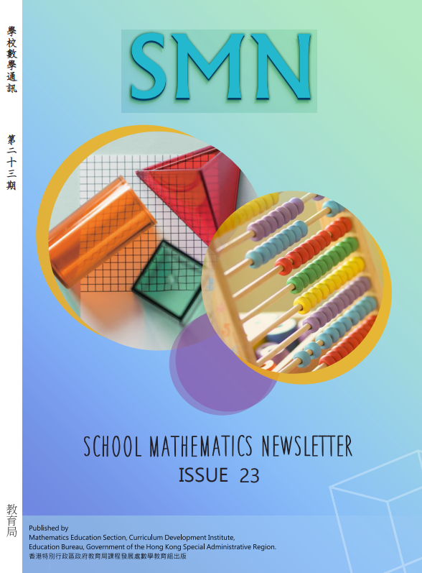
The picture shown is not in the exact size

(ii) The size of the “Explanatory Notes to Junior Secondary Mathematics Curriculum (2020)” is in A4.
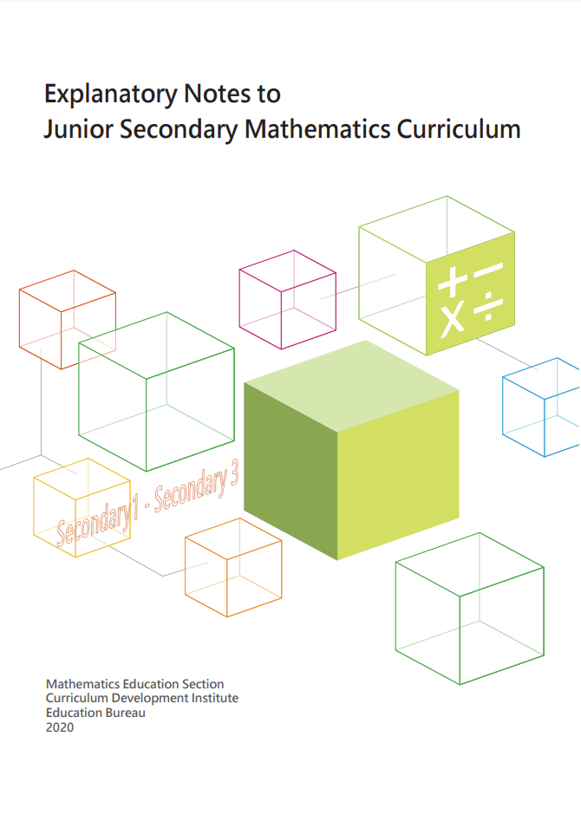
The picture shown is not in the exact size

10. The teacher can suggest students to further investigate the dimensions of the B and F papers as a follow-up activity.

