Example：

Cumulative Frequency Polygon

Objectives： (1) To construct a cumulative frequency polygon from a set of data
(2) To interpret a cumulative frequency polygon

Learning Unit： Presentation of data

Key Stage：3

Materials Required：Excel and the file dh01_e.xlsx

Prerequisite Knowledge： (1) Frequency distribution table
(2) Frequency polygon

Description of the Activity：

- The teacher distributes the worksheet and the file dh01_e.xlxs to students.

- The teacher briefly explains the problem to students and asks them to open the file and complete the Frequency Distribution Table (Table 1) on the spreadsheet. See the figure below.
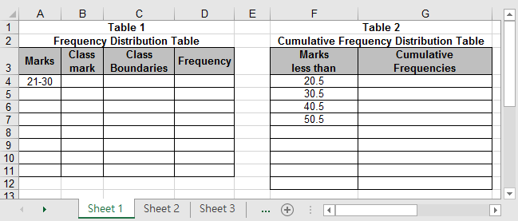

3. The teacher asks students to do the following investigations.
- How many students have marks less than 30.5?
- How many students have marks less than 40.5?
- How many students have marks less than 50.5?
- Can you observe any relationship between the frequencies in the Frequency Distribution Table (Table 1) and the answers obtained above?
The teacher introduces the meaning of cumulative frequency.
- The built-in function of addition in Excel is used to complete the column of cumulative frequency in Table 2. The term “cumulative frequency table” is then introduced.
- Students are guided to plot the cumulative frequency polygon by using the software. See the figure below.
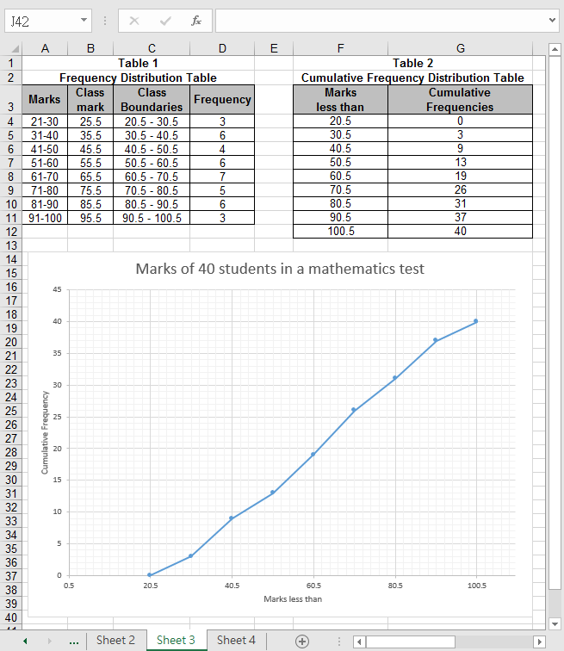

- Students are divided into groups and are asked to discuss the remaining problems in the worksheet.

- Each group is invited to present their answers and methods used. The teacher can make comments when appropriate.
Worksheet: Cumulative Frequency Polygon

Problem:
The following marks are obtained by 40 students of S1A in a Mathematics test.

77 | 81 | 74 | 56 | 63 | 52 | 87 | 90 | 34 | 29
57 | 68 | 29 | 34 | 98 | 58 | 43 | 51 | 74 | 64
68 | 39 | 45 | 83 | 62 | 94 | 36 | 61 | 88 | 89
38 | 54 | 46 | 73 | 67 | 31 | 27 | 45 | 99 | 79

- In the Excel file dh01_e.xlxs, a Frequency Distribution Table (Table 1) with eight class intervals of equal lengths is provided. Complete the table by using the marks provided with 21 – 30 as the lowest class interval.

- Answer the following questions by using Table 1.
- How many students have marks less than 30.5? _________________
- How many students have marks less than 40.5? _________________
- How many students have marks less than 50.5? _________________
- Explain briefly how you obtain these answers.
_____________________________________________________________

- By using the built in function “Addition” in Excel, complete Table 2 (Cumulative Frequency Distribution Table) on the spreadsheet.

- Use Table 2 to plot a scatter with straight lines and markers by Excel. The graph generated is called a cumulative frequency polygon.

- From the graph, answer the following questions:
(a) How many students have marks less than 50?
_____________________________________________________________
How do you find it from the graph? (Answer orally)

(b) If the pass mark is 60, how many students pass?
_____________________________________________________________
How do you find it from the graph? (Answer orally)

(c) How many students obtain marks between 65 and 85? Show your work on the graph.
_____________________________________________________________

(d) If 40% of the students pass this test, what is the pass mark?
_____________________________________________________________
How do you obtain your answer? Write down your work below.
_____________________________________________________________
_____________________________________________________________
_____________________________________________________________

(e) Find the percentage of students with marks less than 70.
_____________________________________________________________
_____________________________________________________________
_____________________________________________________________

Discussion
- Suppose the teacher finds that she has made a mistake and the original marks ‘72’ and ‘83’ were incorrectly typed as ‘27’ and ‘38’, suggest how you could obtain the correct graph. Discuss the procedures involved.

Exercise for consolidation
- Plot the cumulative frequency polygon for question 6 and answer question 5 again.
Notes for Teachers：

1. From questions 2 to 4, students are expected to learn the meaning of cumulative frequency and cumulative frequency polygon. The teacher should explain that the values in the left-hand column of the cumulative frequency distribution table are in fact the upper class boundaries of the class intervals.

2. The teacher should remind students to write down all the necessary labels (the horizontal axis, the vertical axis and the title of the graph) on the graph.

3. The teacher should tell students that the software does not provide a function to add a line in the cumulative frequency polygon. If a line is to be added manually, the Illustrations under the Insert toolbar should be selected. The Line under Shapes could be used.

4. The teacher may alter the graph by changing the data in the frequency table or provide another set of data and then ask students similar questions to consolidate their concepts on the cumulative frequency polygon. For instance, in question 7 of the worksheet, by changing certain values in the frequency distribution table, the corresponding cumulative frequencies and a new graph will be displayed immediately.

5. By Excel, students may appreciate the following advantages:
(a) A cumulative frequency polygon can be plotted easily.
(b) The cumulative frequency polygon will change automatically when the data is changed.
(c) It provides opportunities to make contrast and comparison between different graphs when some of the data are changed.

6. After completing the worksheet, the teacher can also introduce the cumulative frequency curve and ask students to try to plot it.

7. Suggested answers to the worksheet:
Question 1.

Table 1

Frequency Distribution Table
Marks | Class mark | Class Boundaries | Frequency
21-30 | 25.5 | 20.5 - 30.5 | 3
31-40 | 35.5 | 30.5 - 40.5 | 6
41-50 | 45.5 | 40.5 - 50.5 | 4
51-60 | 55.5 | 50.5 - 60.5 | 6
61-70 | 65.5 | 60.5 - 70.5 | 7
71-80 | 75.5 | 70.5 - 80.5 | 5
81-90 | 85.5 | 80.5 - 90.5 | 6
91-100 | 95.5 | 90.5 - 100.5 | 3

Question 2 (a) 3
(b) 9
(c) 13
(d) The answers in question 2(a) to 2(c) are obtained by adding each frequency to the sum of the previous frequencies.

Question 3

Table 2
Cumulative Frequency Distribution Table
Marks less than | Cumulative Frequencies
20.5 | 0
30.5 | 3
40.5 | 9
50.5 | 13
60.5 | 19
70.5 | 26
80.5 | 31
90.5 | 37
100.5 | 40

Question 5 (a) About 13
(b) About 21
(c) 34 – 22 = 12
(d) About 67.5
(e) = 65%

Question 6 Adjusting the frequencies in the Frequency Distribution Table (Table 1) automatically updates the corresponding cumulative frequencies and hence a new cumulative frequency polygon is drawn.

Question 7 (a) About 11
(b) About 23
(c) 33 – 20 = 13
(d) About 70
(e) = 60%
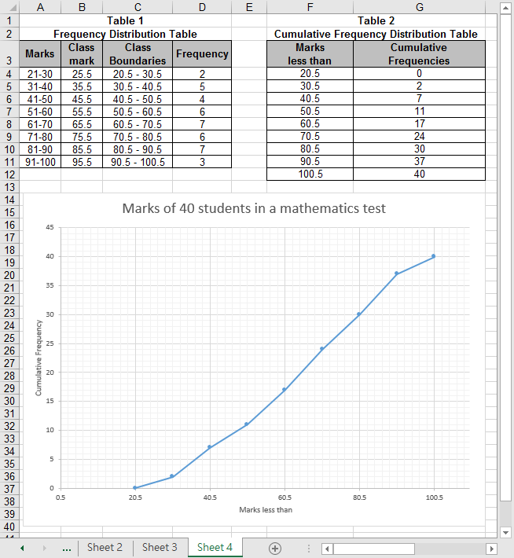
(See Sheet 4 of the teachers’ reference file dh01_e1.xlxs)

Operation Procedure：

- Construct the frequency table
Input the data of the frequency table from cell A4 to D11.

- Construct the cumulative frequency table
  - Key in the values from cell F4 to F12 in the “Marks less than” column. Key in “0” in cell G4 directly.
  - Key in the formula “=G4+D4” in cell G5.
  - Select cell G5. Move the mouse pointer to the bottom right hand corner of this cell. Hold down the left button of the mouse and drag the pointer down to cell G12 to copy the formula in cell G5 to cell G6 to G12.

- Draw the cumulative frequency polygon
  - Highlight cell F4 to G12.
  - Click Insert Charts and select the Scatter with Straight Lines and Markers under Scatter.
- Click the Chart and click the Chart Elements, i.e. symbol, on the top right corner of the Chart. Select Axes, Axis Titles, Chart Title and Gridlines under Chart Elements. Select the appropriate options in the followings.
Axes: Select Primary Horizontal and Primary Vertical. After selecting More Options, a dialog box Format Axis will appear on the screen.
Select the Axis Options and enter as follows:
Minimum Bounds : 0.5
Maximum Bounds : 110
Major Units : 20
Minor Units : 2
Select the Tick Marks and enter as follows:
Major type : Outside
Minor type : None
Select the Labels and enter as follows:
Label Position : Next to Axis
Click the Close button.

Axis Titles: Select Primary Horizontal and Primary Vertical.
Chart Title: Select Above Chart
Gridlines: Click Primary Major Horizontal, Primary Major Vertical, Primary Minor Horizontal and Primary Minor Vertical

Amend the following three titles on the Chart.
Chart title : Marks of 40 students in a mathematics test
Horizontal (Value) Axis Title : Marks less than
Vertical (Value) Axis Title : Cumulative Frequency

- Edit the Vertical (Value) Axis
Double-click the values of the Vertical (Value) Axis. Then a dialog box Format Axis will appear on the screen. Input the followings.
Select the Axis Options, enter as follows:
Minimum Bounds : 0
Maximum Bounds : 45
Major Units : 5
Minor Units : 1
Select the Tick Marks and enter as follows:
Major type : Outside
Minor type : None
Select the Labels and enter as follows:
Label Position : Next to Axis
Click the Close button.

(V) Modify the appearance of the graph
    - To change the background colour of the chart, double-click the background of the chart.
    - To change the colour of the polygon, double-click the polygon.
    - To move a label to another position, double-click and drag the label.

(VI) Modify the layout of the graph
Right-click a clear region on the graph. A small dialog box will appear:
1. To change the chart type:
Click Change Chart type. The dialog box Change Chart type will appear. Select any chart type and chart sub-type. The graph will be changed accordingly.
2. To change the source data:
Right-click the polygon and choose Select Data Source. The dialog box Select Data Source will appear. Select the Chart data range and enter the new range of data.

(VII) Draw horizontal and vertical lines to show a point on the cumulative frequency graph
- Click the Illustrations under the Insert toolbar. Select the Line under Shapes to draw a line at the desired position on the graph to show the point on the cumulative frequency graph.
2. Highlight the line drawn. Right-click the line and choose appropriate Style or Outline.

