Example:

Slopes of Straight Lines

Objectives: (1) To explore the concept of steepness of staircase
- To understand the concept of the slope of a straight line

Key Stage: 3

Learning Unit: Rectangular Coordinate System

Materials Required: Dynamic Software such as Geometer’s Sketchpad (later referred as Sketchpad) and the file slope01.gsp

Prerequisite Knowledge: (1) Simple concept of Ratio
(2) Similarity of figures

Description of the Activities:

Activity 1: Steepness of a staircase
- The teacher shows photos of some stairs with different steepness to arouse students’ interest in the activity. Students are then divided into 8 groups. The teacher distributes Worksheet 1.1 to Worksheet 1.4 to these 8 groups of students. That is, students of every two groups work on the same type of worksheets.
- Students need to observe the character of the staircases in the worksheet, compare the steepness of the staircases and determine the factors affecting the steepness.
- The teacher invites a representative of each group to present their answers to the whole class. Other students can comment on them. During discussion, the teacher can guide students to arrive at the conclusion that the Rise and the Run are the two factors that determine the steepness of the staircases. In Worksheet 1.1, as the Rise of all staircases is the same, the staircase with smallest Run will be the steepest one. In Worksheet 1.2, as the Run is the same, the staircase with the greatest Rise will be the steepest one. In Worksheet 1.3, the steepness of the staircases is the same.
- There may be some problems in using the concept stated in point 4 above to compare the steepness of staircases. The teacher can use Worksheet 1.4 to go on the discussion and guides students to use the ratio to compare the steepness for different Rise and Run of staircases. The teacher can explain that the greater the ratio, the steeper the staircase.
- The teacher shows the following figure to students and holds a discussion on the similarity between the steepness of a road and a staircase built on the road. In fact, both have the same Rise and Run. So the steepness is the same.
Road
Staircase
Rise
Run

- The teacher introduces the term “slope” of a road or a straight line and explains its meaning to students.
Worksheet 1.1: Investigation of the steepness of a staircase

(i) |  |  |  |  |  |  | (ii)
(iii)

- Which one has the greatest steep? Which one has the least? Give reasons.
Which staircase is the most difficult to climb? Why?
_________________________________________________________________
________________________________________________________________
- How do you determine the result in (a)? Please state any factor(s) affecting the steepness.
_________________________________________________________________
_________________________________________________________________
Worksheet 1.2: Investigation of the steepness of a staircase

(i) |  |  |  |  |  |  | (ii)
(iii)

- Which one has the greatest steep? Which one has the least? Give reasons.
Which staircase is the most difficult to climb? Why?
________________________________________________________________
________________________________________________________________
- How do you determine the result in (a)? Please state any factor(s) affecting the steepness.
________________________________________________________________
________________________________________________________________
Worksheet 1.3: Investigation of the steepness of a staircase

(i) |  |  |  |  |  |  | (ii)
(iii) |  |  |  |  |  |  | (iv)

- Which one has the greatest steep? Which one has the least? Give reasons.
Which staircase is the most difficult to climb? Why?
_________________________________________________________________
_________________________________________________________________
_________________________________________________________________
- How do you determine the result in (a)? Please state any factor(s) affecting the steepness.
_________________________________________________________________
_________________________________________________________________
_________________________________________________________________
Worksheet 1.4: Investigation of the steepness of a staircase

(i) |  |  |  |  |  |  | (ii)
(iii) |  |  |  |  |  |  | (iv)
- Which one has the greatest steep? Which one has the least? Give reasons.
Which staircase is the most difficult to climb? Why?
_________________________________________________________________
_________________________________________________________________
- How do you determine the result in (a)? Please state any factor(s) affecting the steepness.
_________________________________________________________________
Activity 2: Exploration of the slope of a going up straight line using Geometer's Sketchpad
- The teacher draws a going up line segment showing a part of a road on the blackboard and asks students how the slope of the road can be found. The teacher invites a student to come out and write down the Rise and Run correspondingly on the same diagram (see the figure below).
Rise
Run

- The teacher goes on asking students whether the Rise and Run can be uniquely determined.
- The teacher gives Worksheet 2.1 to students. Students use the Sketchpad file slope01.gsp to explore the slope of a line.
- After students have finished Worksheet 2.1, the teacher asks some students to present their findings to the whole class. The teacher guides students to conclude that the slope of a straight line is independent of the size of the right-angled triangle formed and is always the same. The teacher may use the following diagram to illustrate that as all the right-angled triangles formed are similar, the ratio (i.e. the slope) remains unchanged.
Worksheet 2.1: Slope of a straight line
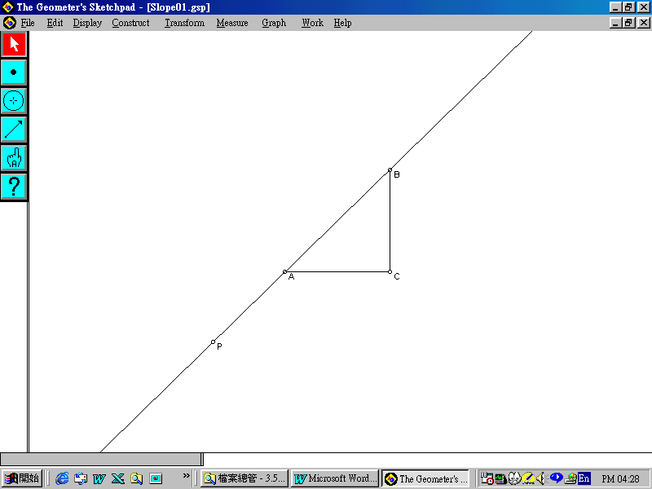
- Open the Sketchpad file slope01.gsp. You will find a straight line passing through the point P. A and B are two points lying on the straight line. AC is a horizontal line segment whereas BC is a vertical line segment (see figure below).
- Drag the points A, B and C respectively to see that ΔABC is really a right-angled triangle with right angle at C.
(Hint: You may measure ∠BCA. The procedures in measuring angles can be referred to the Annex.)
- Measure the lengths of AC and BC. Also calculate (refer to the Annex for the measuring instruction).
- Drag the point A or B along the line.
What can you observe from the changes in the values of AC, BC and ? Write down your observation(s) below.
_________________________________________________________________
_________________________________________________________________
_________________________________________________________________
- Drag the point P to change the direction of the straight line. Do your findings in point 4 still hold? Why? Give your reason(s).
_________________________________________________________________
_________________________________________________________________
_________________________________________________________________
_________________________________________________________________
_________________________________________________________________
_________________________________________________________________
Notes for Teachers:
- As students quite often walk upstairs and downstairs, Activity 1 is a daily life example of steepness. As a result, the term “steepness” is used. After students are capable of using the ratio to describe the steepness of a staircase or even a straight road, the mathematical term “slope” should then be introduced. The teacher may also introduce the other usual term “gradient” to students instead of “slope”.
- Each worksheet in Activity 1 composes of stairs in different characters. It is summarized as follows.
Worksheet | Rise | Run
1.1 | the same | all different
1.2 | all different | the same
1.3 | the same | the same
1.4 | all different | all different
Note: (1) Rise refers to the total vertical distance of all the steps whereas Run refers to the total horizontal distance of all the steps.
- Worksheet 1.4 is the most difficult one because the Rise and the Run for the staircases are all different.
- In activity 2, only the going up straight line is being considered. The objective of this activity is to let students understand that the slope is independent of the size of the right-angled triangle formed. We do not employ the coordinate plane at this moment in order to avoid confusion.
- The teacher may design further activity to introduce the meaning of slope in the coordinate plane. There are two usual methods to find the slope of a straight line.

- First method:
Rise (+)
Rise (+)
Run (+)
Run (-)
x

O
y

(b) Second method:
y
Rise (+)
Run (+)
x

O
Rise (+)
Run (-)

The teacher may give two examples to students to demonstrate the concepts of Rise and Run in a coordinate plane (with one of Rise and Run positive and the other negative).
Then, the teacher guides students to derive the formula for the slope of the line segment joining two points A(x₁, y₁) and B(x₂, y₂).

Annex

The following Operation Procedure is a guide for measuring angles, lengths and calculating the ratio of the two line segments.

- Measure the ∠ABC:
- Hold down the Shift key. Select points A, B and C sequentially. (Or points C, B and A sequentially.) Select Measure⎪Length.
- Measure the length of a line segment:
- Click the line segment AC.
- Select Measure⎪Length in the pull down menu to measure the length of AC.
- Similarly for measuring the length of BC.
- Calculate the ratio of the two line segments:
- Hold down the Shift Key. Select AC and BC.
- Select Measure⎪Calculate in the pull down menu.
- In the calculator, select Length (Segment BC) in the pull down menu Values. Click the “ / ” sign. Then select Length (Segment AC) in the pull down menu Values. Press OK.

