 | 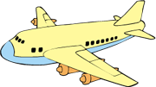
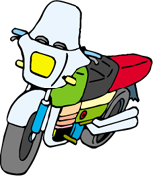
 |  | 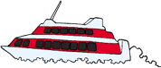 | 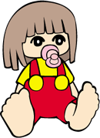

1. | This statistical chart is a .
2. | There are types of toys involved in the study.
3. | The most favourite toy is ( motor-bicycle / aeroplane / hovercraft / doll ).
4. | There are _____________ pupils taking part in the study.
5. | If Class 2B does the same study, the result will be ( the same / not the same ). It is because _____________________________________________  _____________________________________________________________.
6. | I think the types of toys involved in the study is (enough / not enough).  It is because ___________________________________________________.

