Unit : 3D1 Block graphs
Topic : Mock Election
Key Stage : 1

Learning Objectives:
- Collect data and construct frequency tables
- Construct block graphs using a one-to-one representation
- Enhance pupils’ awareness on election through the process of collecting and recording statistical data

Prerequisite Knowledge:
Read block graphs

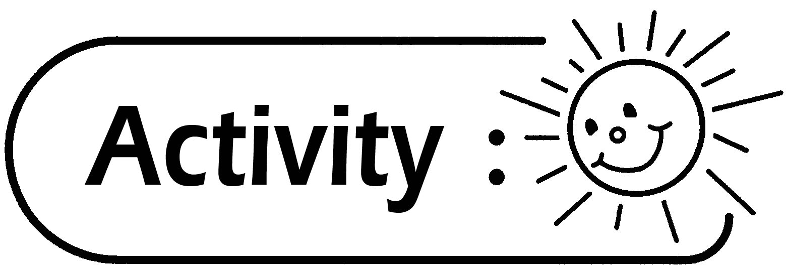
Election for Activity Leader
- Pupils nominate 5 classmates to be voted for the Activity Leader.
- Pupils vote by secret ballot and record the results in a frequency table.
- Pupils write down the name of their nominee on a piece of paper and put it in a voting box.
- Read aloud the names of the nominee.
- 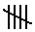To develop collaboration among pupils, record the names read by using
in the frequency table as shown below.

Name | A | B | C | D | E
Tally
Frequency | 10 | 5 | 4 | 7 | 6

- On completing the entries, pupils can discuss and compare the characteristics of the different ways in collecting data. For example:
- By raising hand; or
- Each group makes a vote first and the group leader collects the data from the other groups.
- Based on the voting result, construct a block graph using a one-to-one representation.
- Pupils discuss and compare the block graphs constructed by the groups.
Questions for Discussion:
- What is the title of the block graph?
- How many classmates are nominated?
- How many classmates take part in the voting?
- Who is elected as the Activity Leader? How many votes does he receive?
- If a block graph is used for presentation, how many classmates does each block represent?
- If the number of votes is less than the total number of classmates, what are the possible reasons? Explain.
The possible reasons for the number of votes to be less than the total number of classmates are:
- Some pupils did not vote;
- Counting mistakes;
- Absentee; or
- Other appropriate reasons.
- What are the good points of using symbols for recording the counts? Do you know why?
Easy to read, and one can record in a more systematic way.
Can monitor the counting process and result while reading the names of the nominees.

Generic Skills Fostered:
- Collaboration Skills
- Communication Skills
- Critical Thinking Skills
- Self Management Skills

