Unit : 2D1 Pictograms (I)
Topic : Our Favourite Animals
Key Stage : 1

Learning Objective:
Construct pictograms, using a one-to-one representation

Prerequisite Knowledge:
Able to read and discuss simple pictograms

Teaching Resources:
- Pictures of animals (see Appendix)
- Blu-Tack
- Scissors


Our Favourite Animals
- Each group is provided with several pictures of animals.
- Pupils choose the pictures of animals they like and cut out the pictures. (To save time, pupils can cut the pictures in advance.)
- Discuss the aim and method in constructing the pictogram.
- The teacher draws the pictogram on the blackboard.

Our Favourite Animals

- Pupils stick the pictures of animals which they like on the pictogram.

Questions for Discussion:
- Which is the better way for pupils to stick the pictures on the blackboard, from top to bottom or from bottom to top?
- Should the gap between the pictures be the same? Why?
- Which is the most popular animal? How do you know it?
- How many pupils in the class take part in the study?
- How many more/fewer pupils like dogs than cats?
- What is the name of this type of chart?
- What does 1 picture stands for?

Remarks:
- Pictures of animals are printed in the Appendix (dogs, cats, rabbits, tortoises) (each one is about 7cm×10cm).
- To increase the interest of the activity, the teacher uses one colour for the same type of animals.
- The teacher needs not comment immediately if the distance between the pictures are not the same. It provides an useful point for discussion.
- The completed pictogram is shown below.

Our Favourite Animals

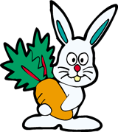
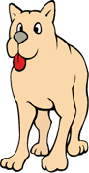
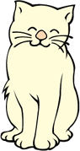
Generic Skills Fostered:
- Collaboration Skills
- Creativity
- Critical Thinking Skills

